# Team Portfolio Documentation

Cleckhudderfax Online Megastore

**Team Name: Team A**

**Project Manager: Rohit Raj Pandey**

***Team Members***

**Dikson Rajbanshi (Team Leader)**

Prasansa Dahal

Surya Shrestha

Susan Khatri

Alok Raj

# Overview

Cleckhudderfax Online Megastore is an online grocery store, which is being developed as a solution to the competition given by the national chains to the small local independent businesses at Cleckhudderfax. Given the fact that currently we are living in the information age where technologies are blooming, online markets are growing widely due to ease of use and better accessibility. Cleckhudderfax Online Megastore aims to be the solution for tackling the current issue at hand and provide the local shops with wider range of usage along with providing the customers with better shopping experience.

Table of Contents

Team Portfolio Documentation 1

Overview 2

Product Initiation 7

Project Charter 7

Team Contract 10

Project Planning 14

Belbin Analysis (Team) 14

Belbin Analysis (Individual) 22

Skill Audit (Team) 24

Skill Audit (Individual) 25

Microsoft Project 26

Task Sheet 26

Gantt Chart 31

Calendar 35

Network Diagram 37

Resource Sheet 40

Timeline 40

Team Meetings 41

Team Meetings (Virtual) 44

Communication and Collaboration Tools Used 48

Trello 48

Slack 48

GitHub 49

Project Execution 50

Requirements 50

Entity Relationship Diagram (ERD) 54

Extended Entity Relationship Diagram (EERD) 55

Composite ERD 56

Logical Design 57

Use Case 58

Wireframes 60

Home 60

About Us 61

Our Clients 62

FAQs 62

Our Blog 63

Shop 64

Single Product Page 65

Search 66

Basket 66

Login 67

Manage Account 67

Add Product 68

Product Details 68

Risk Register 69

Risk Register (Team) 69

Risk Profile (Team) 69

Risk Register (Individual) 70

Risk Profile (Individual) 70

WEBSITE 71

Homepage 71

About Us 72

Shop 73

Products 73

Filter 74

Product 76

Product Search 76

Product Search Result 77

Product Information 78

Basket 79

Basket Empty 79

Add to Basket 79

Product Added 80

Delivery Date 80

Order 81

Order Details 81

Order Confirmation Receipt 81

PayPal Payment 82

Payment Method 82

Confirm Payments 82

Payment Success 83

Registration 84

Registration Form 84

Account Creation 85

Confirmation Email 86

Form Validation 87

Login 89

Login Form 89

Form Validation 90

Login Success 95

Forgot Password 96

Account Management 98

Profile 98

Edit/Update Profile 98

Profile Update Success 99

Profile Update Notification Email 99

Admin (PHP) 100

Trader Details 100

Trader Status Update 100

Trader Type Details 101

Trader Type Status Update 101

Collection Slot Details 102

Collection Slot 103

Collection Slot Added 103

Trader (PHP) 104

Add Product 104

Product Added 105

Product Details 106

Add Trader Type 107

Trader Type Details 107

Add Shop 108

Shop Added 108

Shop Details 109

Update Profile 109

Profile Update Success 110

Admin (Oracle) 111

Login 111

Login(Invalid) 111

Dashboard 112

Products 113

Trader Details 114

Customer Information 115

Sales Report 116

Trader (Oracle) 118

Dashboard 118

Shop/Product Details 119

Product/Product Comment 120

Product Type Details 121

Order Details 121

Monthly Sales Report 122

Monthly Sales Report Chart 123

# Product Initiation

## Project Charter

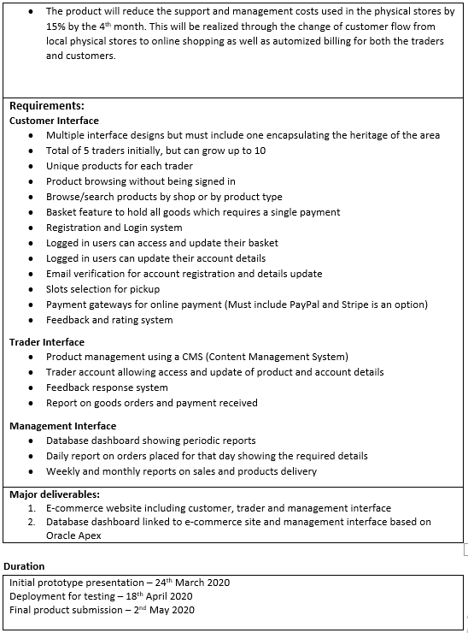

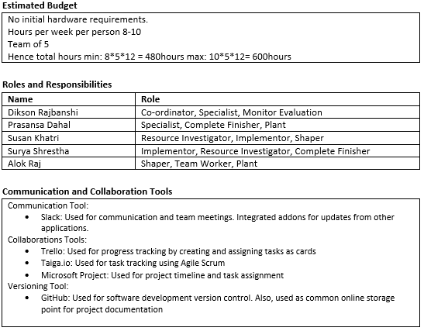

## Team Contract

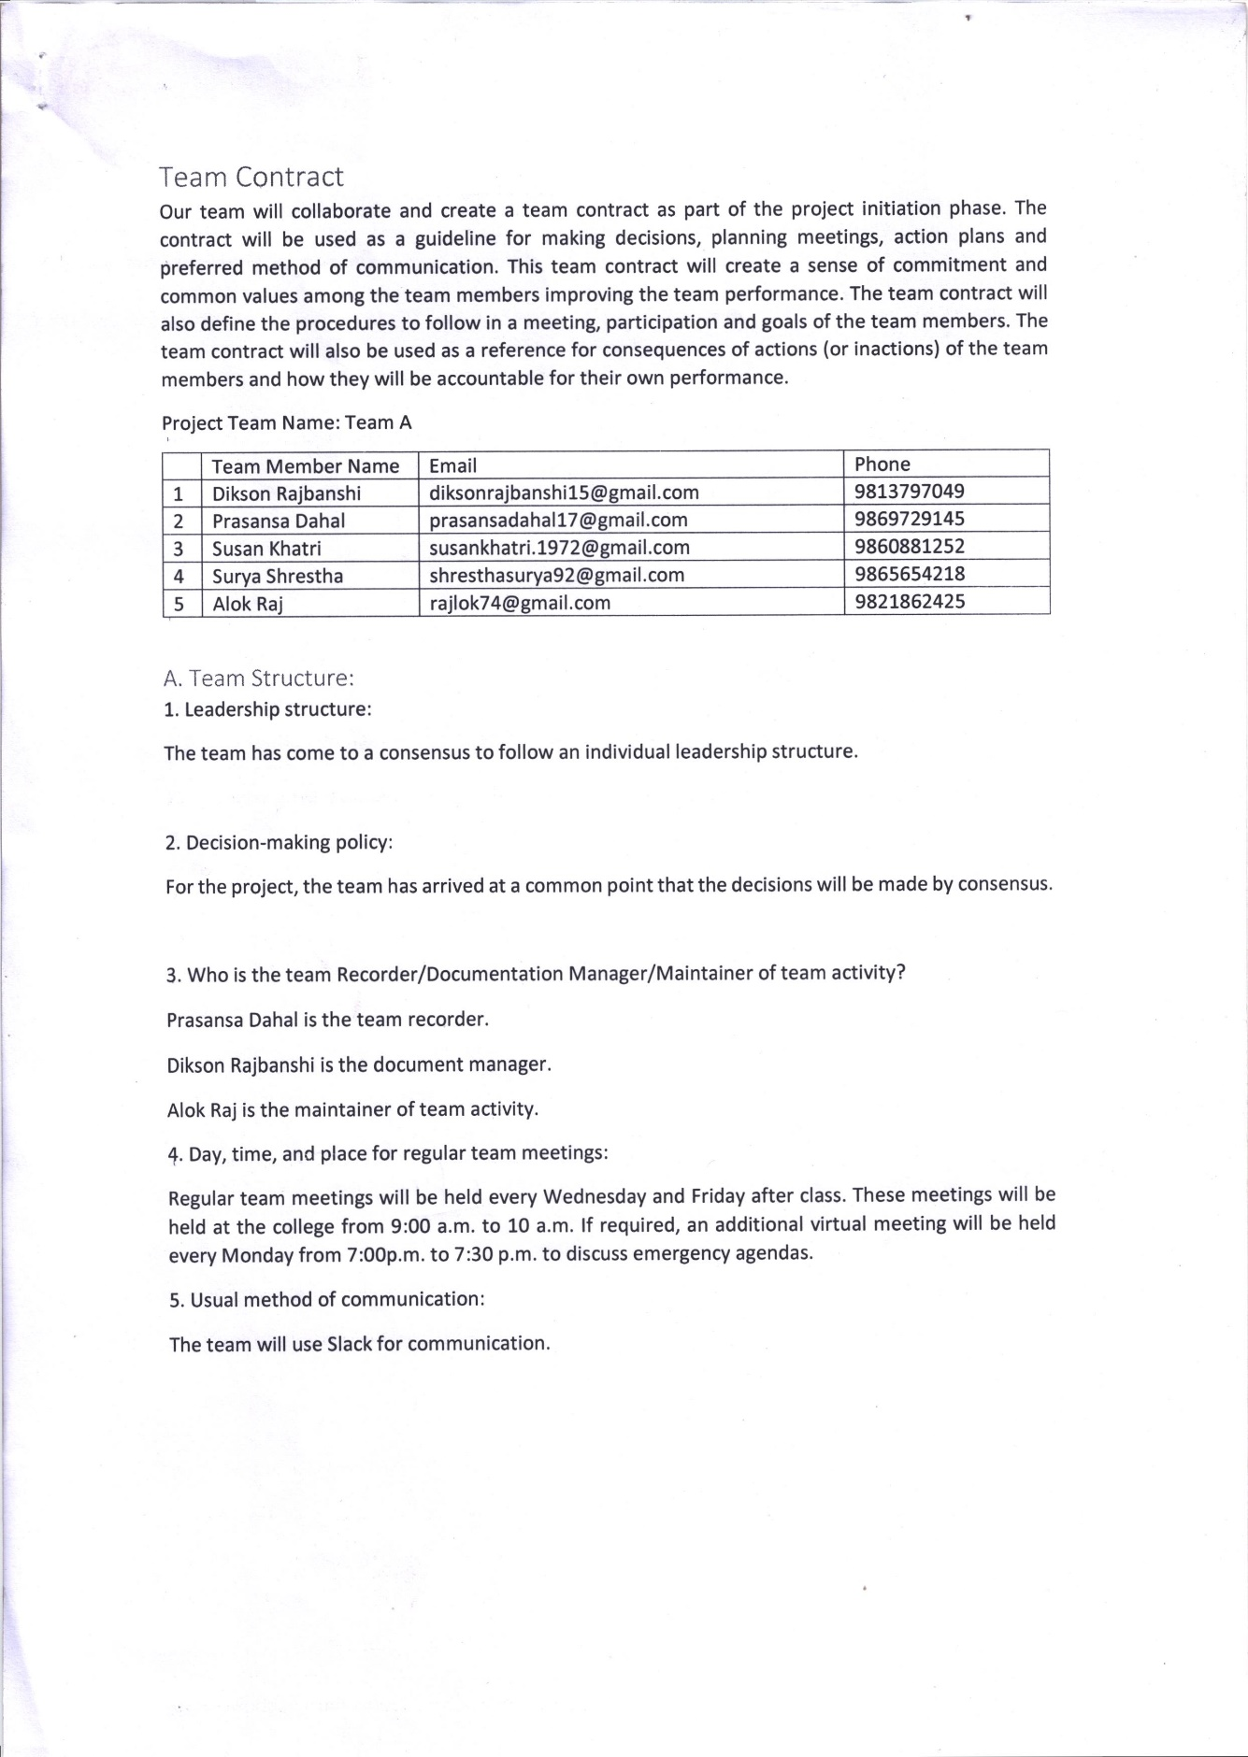

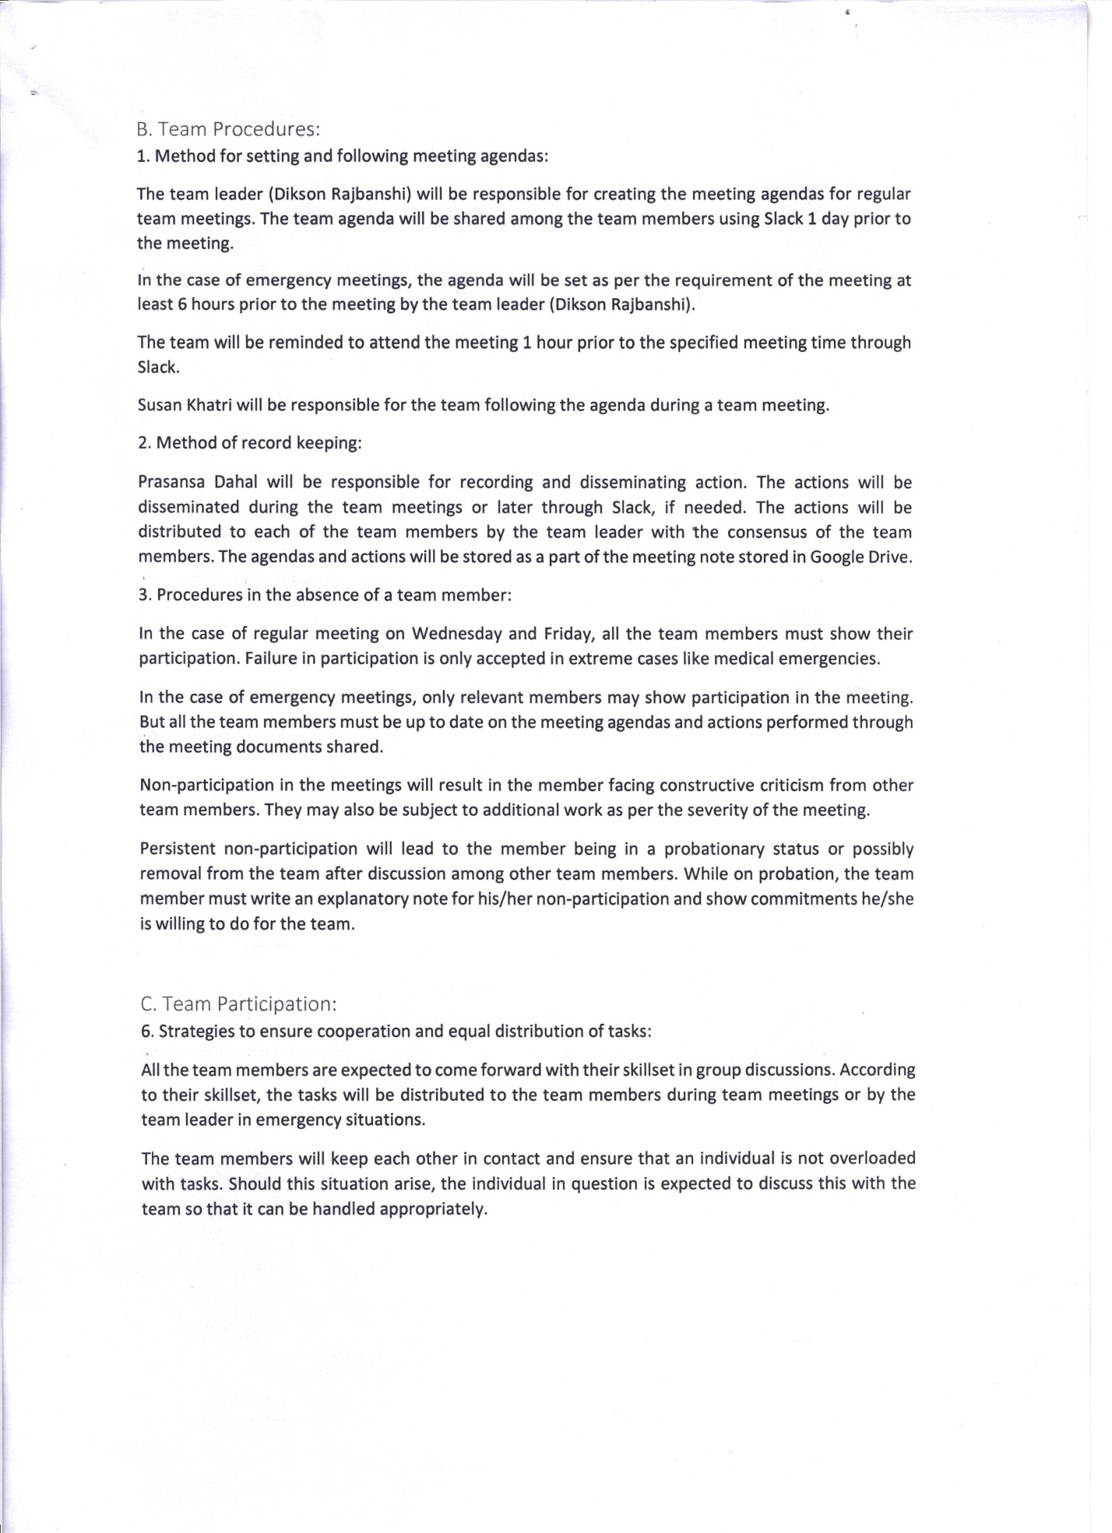

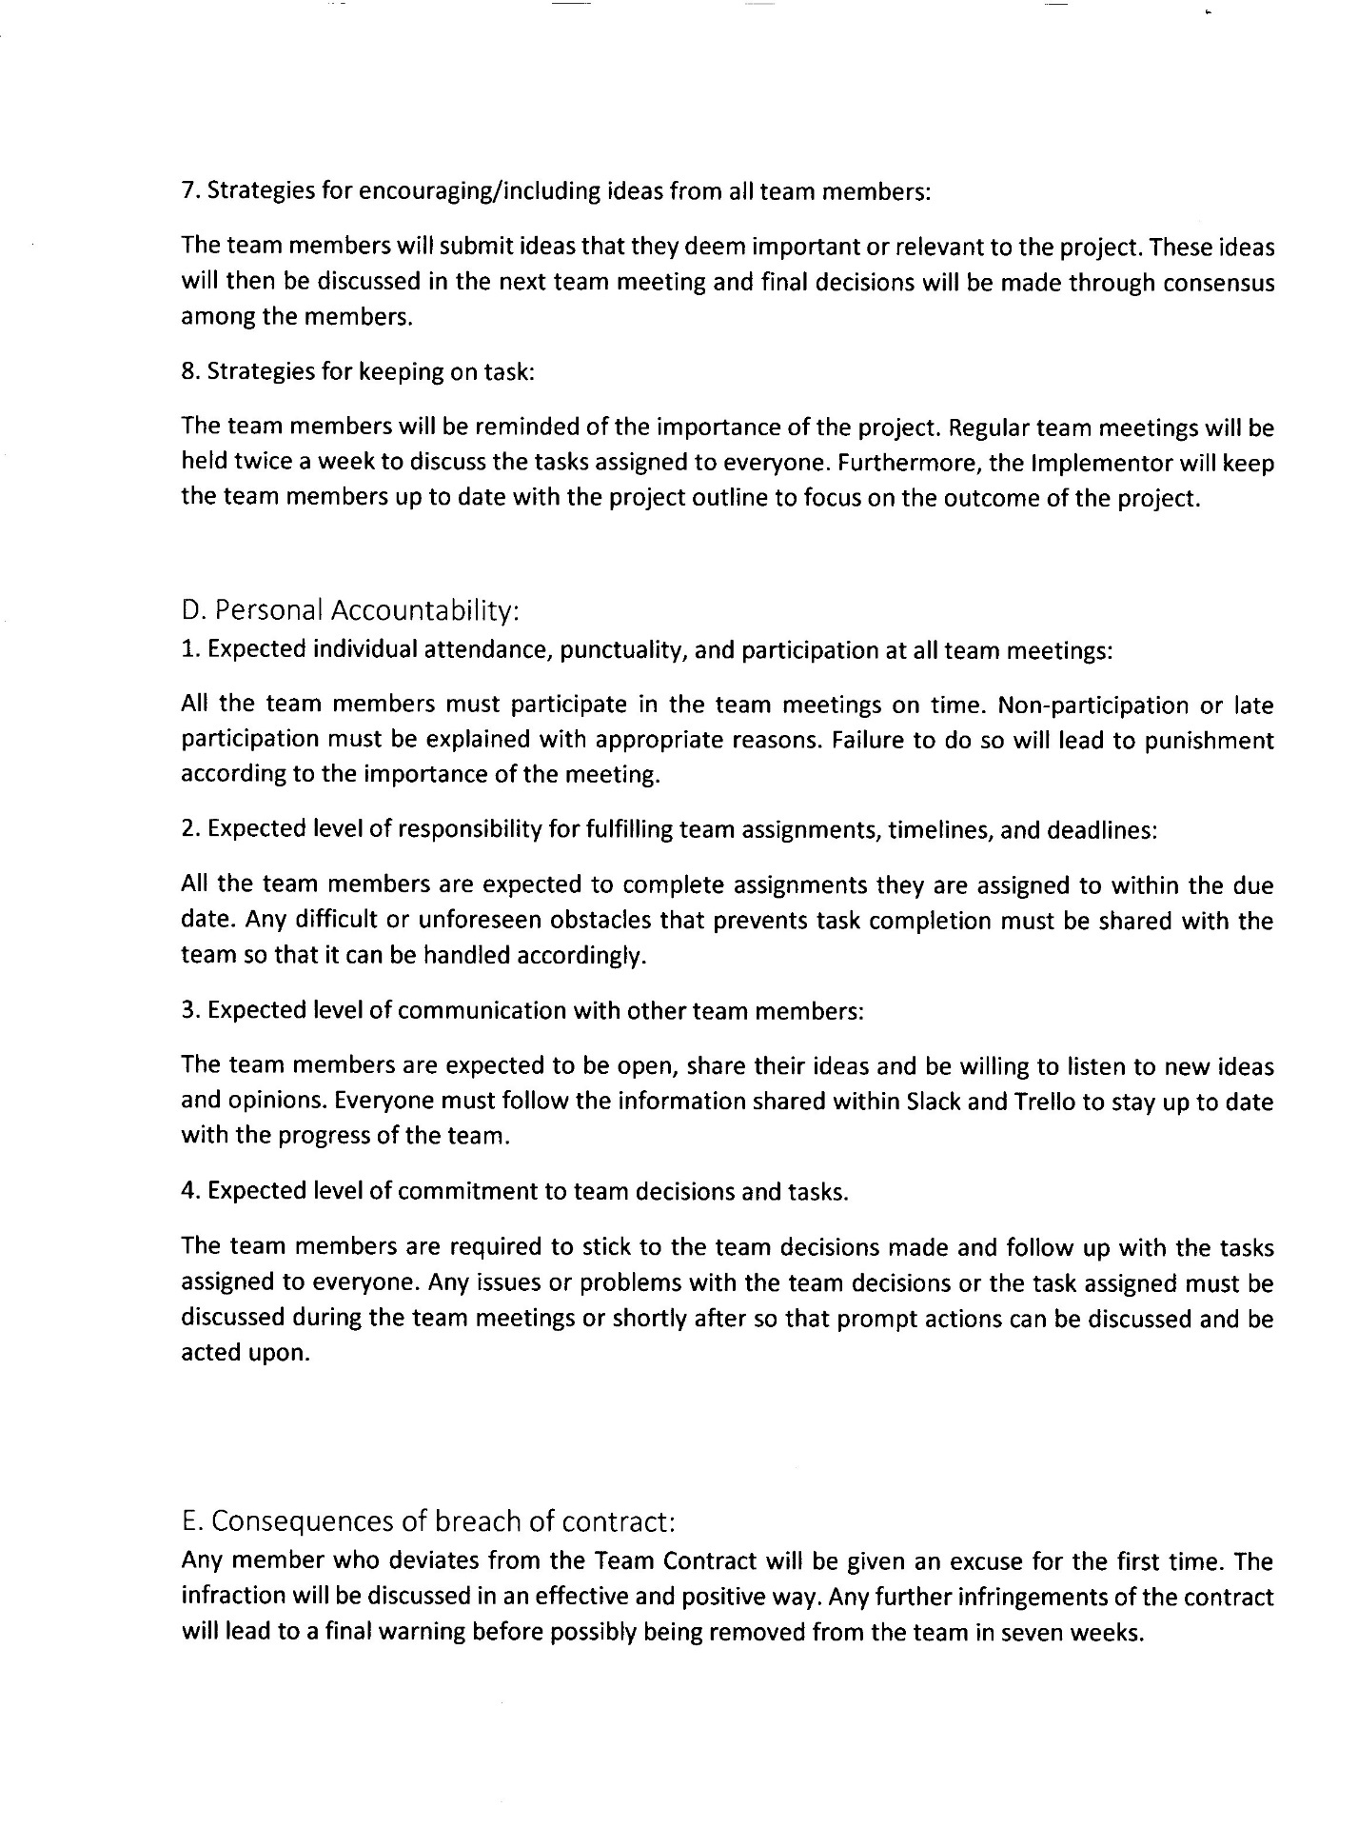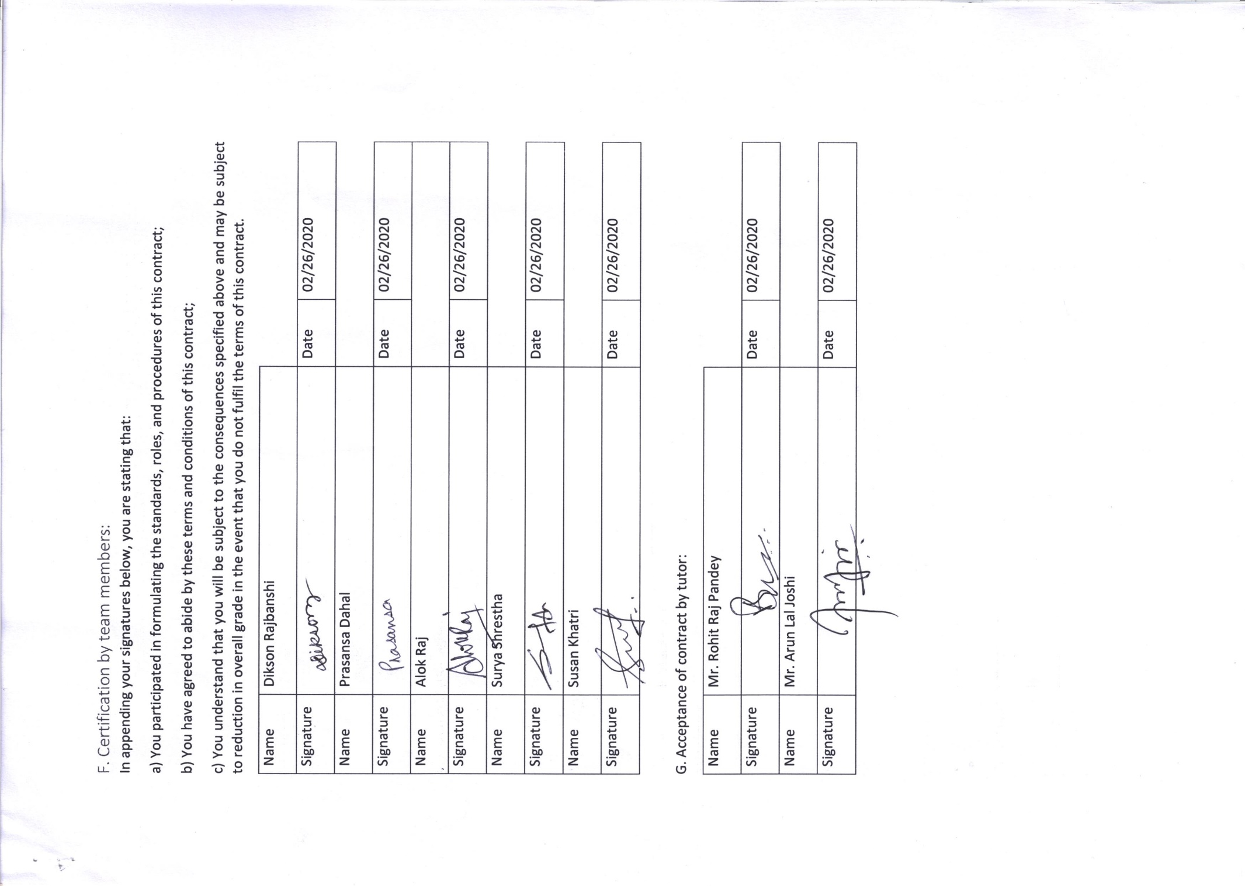

# Project Planning

## Belbin Analysis (Team)

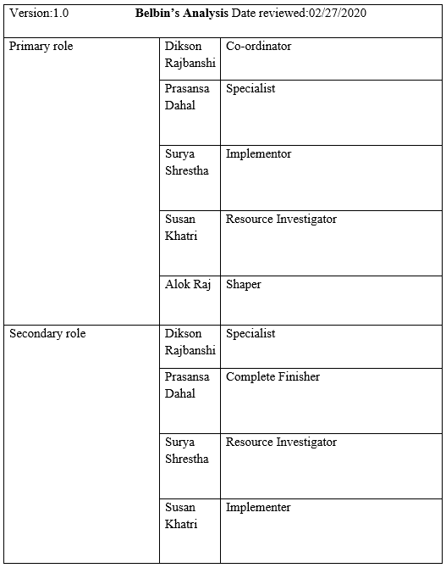

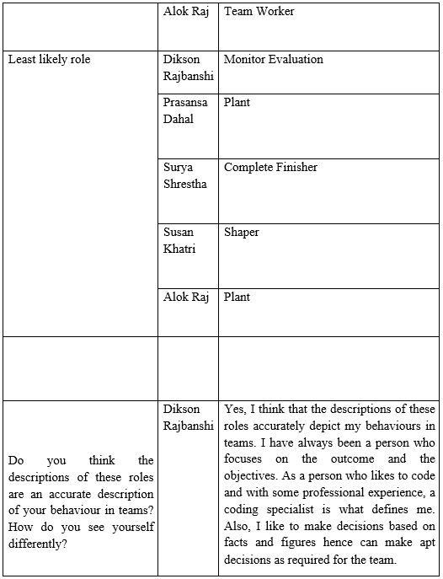

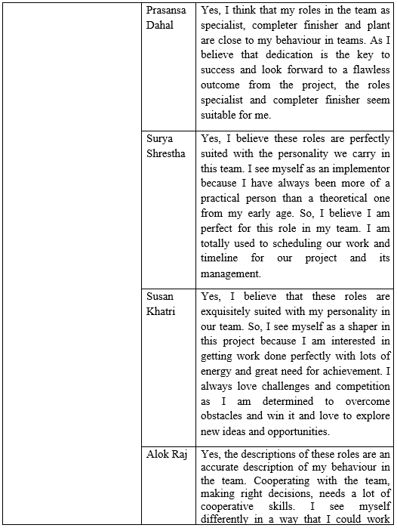

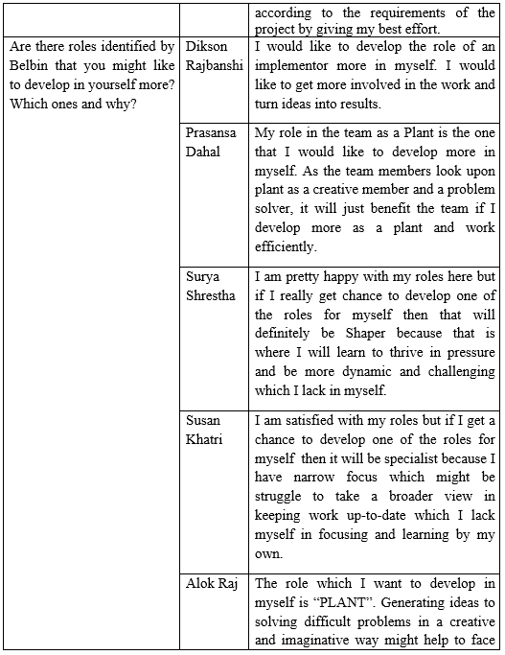

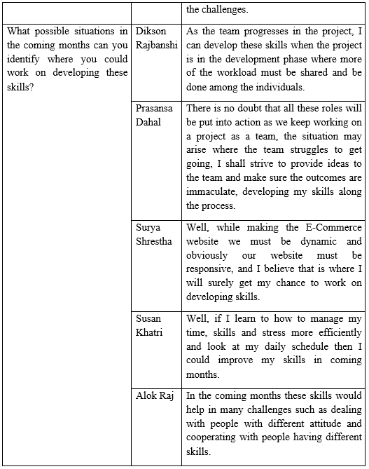

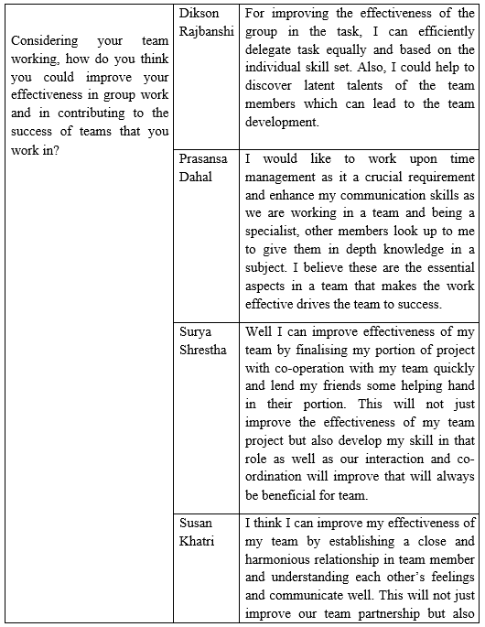

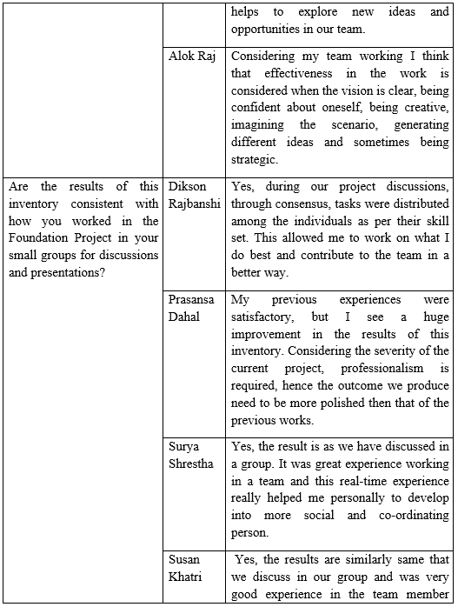

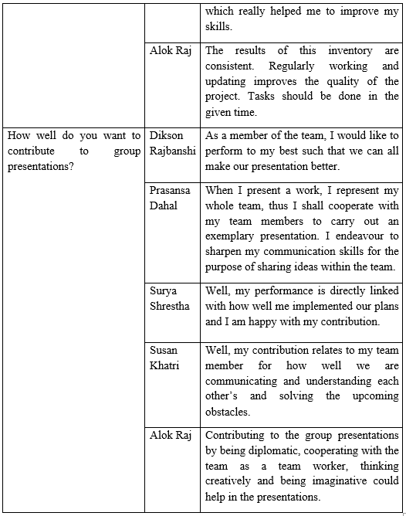

## Belbin Analysis (Individual)

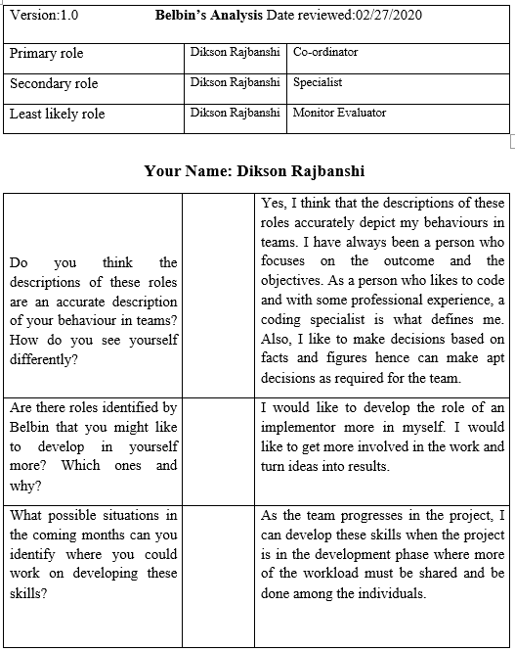

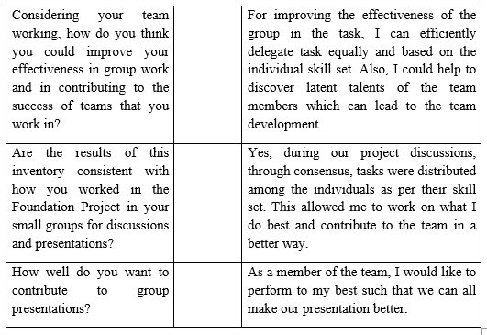

## Skill Audit (Team)



## Skill Audit (Individual)



## Microsoft Project

### Task Sheet

|  |  |  |  |  |  |
| --- | --- | --- | --- | --- | --- |
| Task Name | Duration | Start | Finish | Predecessors | Resource Names |
| **Team A** | **87 days** | **Tue 2/18/20** | **Thu 6/18/20** |  |  |
| **Initial Phase** | **3 days** | **Tue 2/18/20** | **Thu 2/20/20** |  |  |
| Team Formation | 1 day | Tue 2/18/20 | Tue 2/18/20 |  | Rohit Raj Pandey |
| Start Case Study | 1 day | Wed 2/19/20 | Wed 2/19/20 | 3 | Alok Raj, Dikson Rajbanshi, Prasansa Dahal, Surya Shrestha, Susan Khatri |
| **Project Charter** | **2 days** | **Wed 2/19/20** | **Thu 2/20/20** |  |  |
| Finalize Project Name | 0.1 hrs. | Wed 2/19/20 | Wed 2/19/20 |  | Alok Raj, Dikson Rajbanshi, Prasansa Dahal, Surya Shrestha, Susan Khatri |
| Version Control | 0.1 hrs. | Wed 2/19/20 | Wed 2/19/20 | 6 |  |
| Finalize Team Name | 0.1 hrs. | Wed 2/19/20 | Wed 2/19/20 |  | Alok Raj, Dikson Rajbanshi, Prasansa Dahal, Surya Shrestha, Susan Khatri |
| Roles and Responsibilities Distribution | 1 hr. | Wed 2/19/20 | Wed 2/19/20 |  | Dikson Rajbanshi |
| Project Justification Draft | 0.75 days | Wed 2/19/20 | Wed 2/19/20 |  | Prasansa Dahal |
| Project Scope | 0.25 days | Thu 2/20/20 | Thu 2/20/20 | 9 | Alok Raj |
| Set Project Goals | 0.25 days | Thu 2/20/20 | Thu 2/20/20 | 11 | Surya Shrestha, Susan Khatri |
| Project Charter Documentation | 0.25 days | Thu 2/20/20 | Thu 2/20/20 |  | Dikson Rajbanshi |
| **Planning Phase** | **8 days** | **Fri 2/21/20** | **Tue 3/3/20** | **2** |  |
| **Create Team Contract** | **1 day** | **Fri 2/21/20** | **Fri 2/21/20** |  |  |
| Contract Description | 0.25 days | Fri 2/21/20 | Fri 2/21/20 |  | Dikson Rajbanshi |
| Team Structure | 0.25 days | Fri 2/21/20 | Fri 2/21/20 | 16SS | Alok Raj, Surya Shrestha |
| Team Procedures | 0.25 days | Fri 2/21/20 | Fri 2/21/20 | 17SS | Prasansa Dahal, Susan Khatri |
| Team Participation | 0.25 days | Fri 2/21/20 | Fri 2/21/20 | 18SS | Dikson Rajbanshi, Susan Khatri |
| Personal Accountability | 0.25 days | Fri 2/21/20 | Fri 2/21/20 |  | Alok Raj, Dikson Rajbanshi, Prasansa Dahal, Surya Shrestha, Susan Khatri |
| Contract Breach Consequences | 0.25 days | Fri 2/21/20 | Fri 2/21/20 | 20,19 | Alok Raj, Surya Shrestha |
| Certification by Team Members | 0.25 days | Fri 2/21/20 | Fri 2/21/20 | 21 | Alok Raj, Dikson Rajbanshi, Prasansa Dahal, Surya Shrestha, Susan Khatri |
| Finalize Contract | 0.25 days | Fri 2/21/20 | Fri 2/21/20 | 22FF | Alok Raj, Dikson Rajbanshi, Prasansa Dahal, Surya Shrestha, Susan Khatri |
| **Belbin Analysis** | **2 days** | **Mon 2/24/20** | **Tue 2/25/20** |  |  |
| Individual Belbin | 1 day | Mon 2/24/20 | Mon 2/24/20 |  | Alok Raj, Dikson Rajbanshi, Prasansa Dahal, Surya Shrestha, Susan Khatri |
| Team Belbin | 0.5 days | Tue 2/25/20 | Tue 2/25/20 | 25 | Dikson Rajbanshi |
| Documentation for Submission | 0.5 days | Tue 2/25/20 | Tue 2/25/20 | 25 | Dikson Rajbanshi |
| **Skills Audit** | **2 days** | **Wed 2/26/20** | **Thu 2/27/20** |  |  |
| Individual Skills Audit | 1 day | Wed 2/26/20 | Wed 2/26/20 |  | Alok Raj, Dikson Rajbanshi, Prasansa Dahal, Surya Shrestha, Susan Khatri |
| Team Skills Audit | 0.5 days | Thu 2/27/20 | Thu 2/27/20 | 29 | Susan Khatri |
| Documentation for Submission | 0.5 days | Thu 2/27/20 | Thu 2/27/20 | 29 | Dikson Rajbanshi |
| **Website Outline** | **1 day** | **Fri 2/28/20** | **Fri 2/28/20** |  |  |
| Create Website Outline | 0.5 days | Fri 2/28/20 | Fri 2/28/20 |  | Alok Raj, Dikson Rajbanshi, Prasansa Dahal, Surya Shrestha, Susan Khatri |
| Finalize Website Outline | 0.5 days | Fri 2/28/20 | Fri 2/28/20 | 33 | Alok Raj, Dikson Rajbanshi, Surya Shrestha, Susan Khatri, Prasansa Dahal |
| **Organize MS Project** | **2 days** | **Mon 3/2/20** | **Tue 3/3/20** | **32** |  |
| Training | 0.5 days | Mon 3/2/20 | Mon 3/2/20 |  | Prasansa Dahal |
| Set Tasks | 1 day | Mon 3/2/20 | Mon 3/2/20 | 36SS | Prasansa Dahal, Dikson Rajbanshi |
| Create Team Calendar | 0.1 hrs. | Tue 3/3/20 | Tue 3/3/20 | 36 | Prasansa Dahal |
| Change Working Time | 0.1 hrs. | Tue 3/3/20 | Tue 3/3/20 | 36 | Prasansa Dahal |
| Create Timeline | 0.1 hrs. | Tue 3/3/20 | Tue 3/3/20 | 36 | Prasansa Dahal |
| Edit Work Breakdown Structure | 0.1 hrs. | Tue 3/3/20 | Tue 3/3/20 | 36 | Prasansa Dahal, Dikson Rajbanshi |
| Manage Gantt Chart | 0.1 hrs. | Tue 3/3/20 | Tue 3/3/20 | 36 | Prasansa Dahal |
| Set Resources | 0.1 hrs. | Tue 3/3/20 | Tue 3/3/20 | 36 | Prasansa Dahal |
| **Execution Phase** | **57 days** | **Wed 3/4/20** | **Fri 5/22/20** |  |  |
| **Requirement Catalogue** | **1 day** | **Wed 3/4/20** | **Wed 3/4/20** |  |  |
| Functional Requirement | 0.5 days | Wed 3/4/20 | Wed 3/4/20 |  | Alok Raj, Prasansa Dahal |
| Non-functional Requirement | 0.5 days | Wed 3/4/20 | Wed 3/4/20 | 46 | Alok Raj, Prasansa Dahal |
| **Entity Relationship Diagram** | **2 days** | **Thu 3/5/20** | **Fri 3/6/20** | **45** |  |
| Create Entity Relationship Diagram | 1 day | Thu 3/5/20 | Thu 3/5/20 |  | Dikson Rajbanshi, Susan Khatri |
| Create Composite ERD | 0.5 days | Fri 3/6/20 | Fri 3/6/20 | 49SS | Alok Raj |
| Create Extended Entity Relationship Diagram | 0.25 days | Fri 3/6/20 | Fri 3/6/20 | 49SS | Surya Shrestha, Dikson Rajbanshi |
| Create Logical Design | 0.25 days | Fri 3/6/20 | Fri 3/6/20 | 50 | Prasansa Dahal |
| **Use Case Diagram** | **2 days** | **Fri 3/6/20** | **Tue 3/10/20** |  |  |
| Overview | 0.5 days | Fri 3/6/20 | Fri 3/6/20 |  | Dikson Rajbanshi |
| Admin Access | 1 day | Fri 3/6/20 | Fri 3/6/20 | 54SS | Alok Raj, Prasansa Dahal |
| Trader Access | 1 day | Fri 3/6/20 | Fri 3/6/20 | 55SS | Surya Shrestha |
| Customer Access | 1 day | Mon 3/9/20 | Mon 3/9/20 | 56 | Susan Khatri |
| Finalize Use Case Diagram | 0.5 days | Tue 3/10/20 | Tue 3/10/20 | 57 | Alok Raj, Dikson Rajbanshi, Prasansa Dahal, Surya Shrestha, Susan Khatri |
| **Logo Design** | **1 day** | **Tue 3/10/20** | **Tue 3/10/20** |  |  |
| Research Designs | 0.5 days | Tue 3/10/20 | Tue 3/10/20 |  | Susan Khatri |
| Create Sample Logo | 0.5 days | Tue 3/10/20 | Tue 3/10/20 | 60SS | Dikson Rajbanshi |
| **Wireframe Design** | **3 days** | **Wed 3/11/20** | **Fri 3/13/20** |  |  |
| Create Wireframe | 2 days | Wed 3/11/20 | Thu 3/12/20 |  | Alok Raj |
| Frontend Training | 1 day | Fri 3/13/20 | Fri 3/13/20 |  | Alok Raj, Dikson Rajbanshi, Prasansa Dahal, Surya Shrestha, Susan Khatri |
| Website Coding Frontend | 4 days | Mon 3/16/20 | Thu 3/19/20 | 64SS | Surya Shrestha, Prasansa Dahal |
| **Work in Progress** | **4 days** | **Thu 3/19/20** | **Tue 3/24/20** |  |  |
| Documentation | 2 days | Thu 3/19/20 | Fri 3/20/20 |  | Dikson Rajbanshi |
| Create Presentation | 1 day | Mon 3/23/20 | Mon 3/23/20 | 67 | Surya Shrestha |
| Presentation Submission | 1 day | Tue 3/24/20 | Tue 3/24/20 | 68 | Alok Raj, Dikson Rajbanshi, Prasansa Dahal, Surya Shrestha, Susan Khatri |
| Finalize Website Frontend | 8 days | Wed 3/25/20 | Fri 4/3/20 | 65 | Dikson Rajbanshi, Surya Shrestha, Prasansa Dahal |
| **Website Backend** | **36 days** | **Fri 4/3/20** | **Fri 5/22/20** | **70** |  |
| Backend Training | 2 days | Fri 4/3/20 | Mon 4/6/20 |  | Alok Raj, Dikson Rajbanshi, Prasansa Dahal, Surya Shrestha, Susan Khatri |
| Initiate Coding | 15 days | Tue 4/7/20 | Mon 4/27/20 | 72SS | Dikson Rajbanshi, Alok Raj |
| Coding Continue | 15 days | Tue 4/28/20 | Thu 5/21/20 | 73 | Alok Raj, Susan Khatri, Dikson Rajbanshi |
| **Monitoring and Controlling Phase** | **7 days** | **Mon 5/25/20** | **Tue 6/2/20** |  |  |
| **Testing and Evaluation** | **6 days** | **Mon 5/25/20** | **Mon 6/1/20** |  |  |
| Test Website | 1 day | Mon 5/25/20 | Mon 5/25/20 |  | Alok Raj, Dikson Rajbanshi, Prasansa Dahal, Surya Shrestha, Susan Khatri |
| Edit Website | 3 days | Tue 5/26/20 | Thu 5/28/20 | 77 | Dikson Rajbanshi, Prasansa Dahal |
| Finalize Website | 2 days | Fri 5/29/20 | Mon 6/1/20 | 78 | Alok Raj, Dikson Rajbanshi, Prasansa Dahal, Surya Shrestha, Susan Khatri |
| **Set Up User Installation Manual** | **1 day** | **Tue 6/2/20** | **Tue 6/2/20** |  |  |
| Register and Login | 0.25 days | Tue 6/2/20 | Tue 6/2/20 |  | Prasansa Dahal |
| Admin Manual | 0.25 days | Tue 6/2/20 | Tue 6/2/20 | 81 | Alok Raj |
| Trader Manual | 0.25 days | Tue 6/2/20 | Tue 6/2/20 | 82 | Dikson Rajbanshi |
| Customer Manual | 0.25 days | Tue 6/2/20 | Tue 6/2/20 | 83 | Surya Shrestha |
| **Closing Phase** | **12 days** | **Wed 6/3/20** | **Thu 6/18/20** |  |  |
| Set Up User Installation Manual | 1 day | Wed 6/3/20 | Wed 6/3/20 |  | Susan Khatri |
| Create Presentation Plan | 1 day | Thu 6/4/20 | Thu 6/4/20 | 86 | Surya Shrestha |
| Create Final Presentation | 1 day | Fri 6/5/20 | Fri 6/5/20 | 87 | Susan Khatri |
| Start Team Portfolio Documentation | 5 days | Mon 6/8/20 | Fri 6/12/20 | 88 | Dikson Rajbanshi, Alok Raj |
| Final Presentation Submission | 1 day | Mon 6/15/20 | Mon 6/15/20 | 89 | Alok Raj, Dikson Rajbanshi, Prasansa Dahal, Susan Khatri, Surya Shrestha |
| Finish Team Portfolio Documentation | 2 days | Tue 6/16/20 | Wed 6/17/20 | 90 | Susan Khatri, Surya Shrestha |
| Team Portfolio Submission | 1 day | Thu 6/18/20 | Thu 6/18/20 | 88,89,91 | Alok Raj, Dikson Rajbanshi, Prasansa Dahal, Surya Shrestha, Susan Khatri |

### Gantt Chart

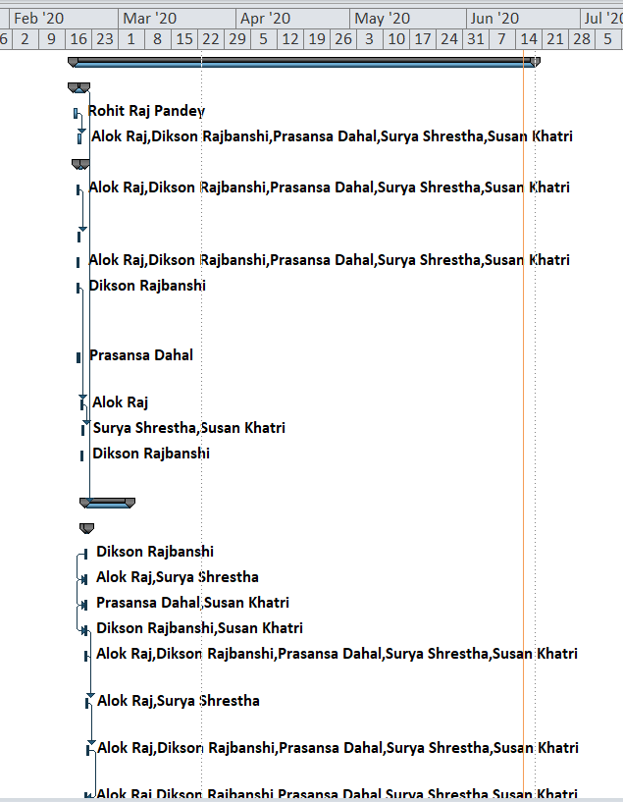

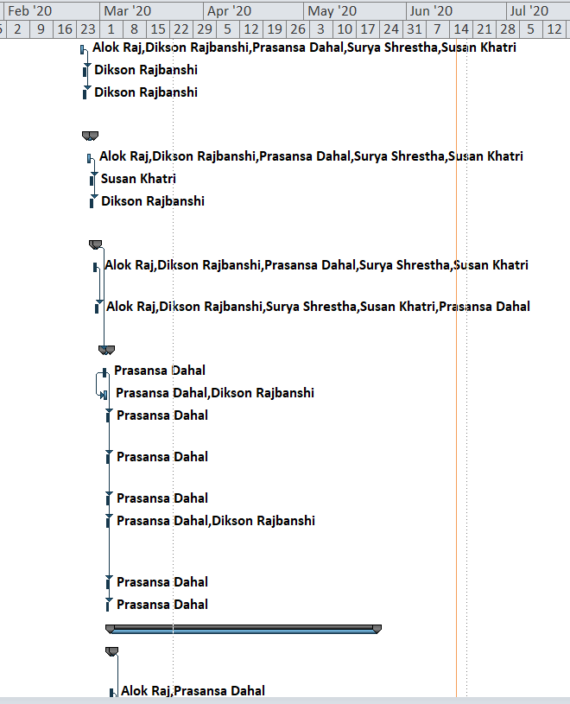

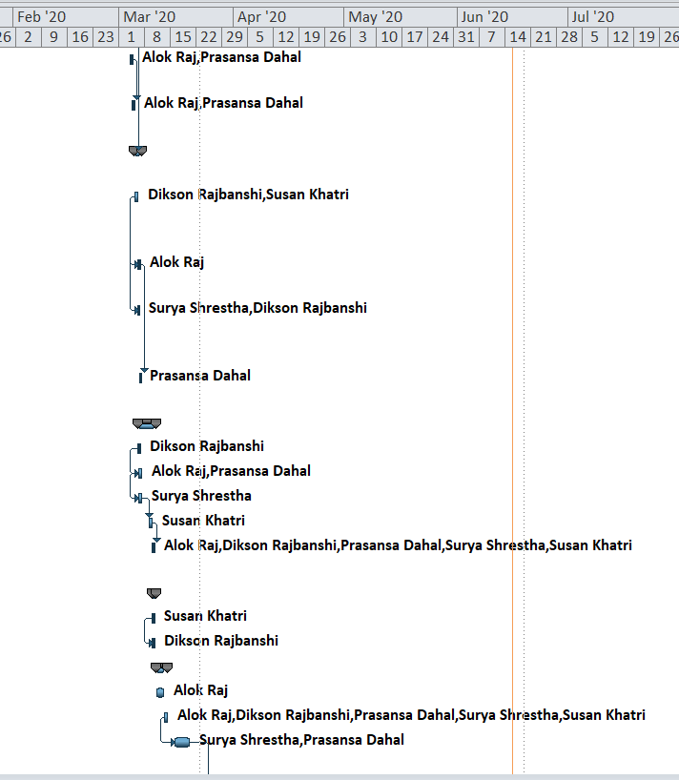

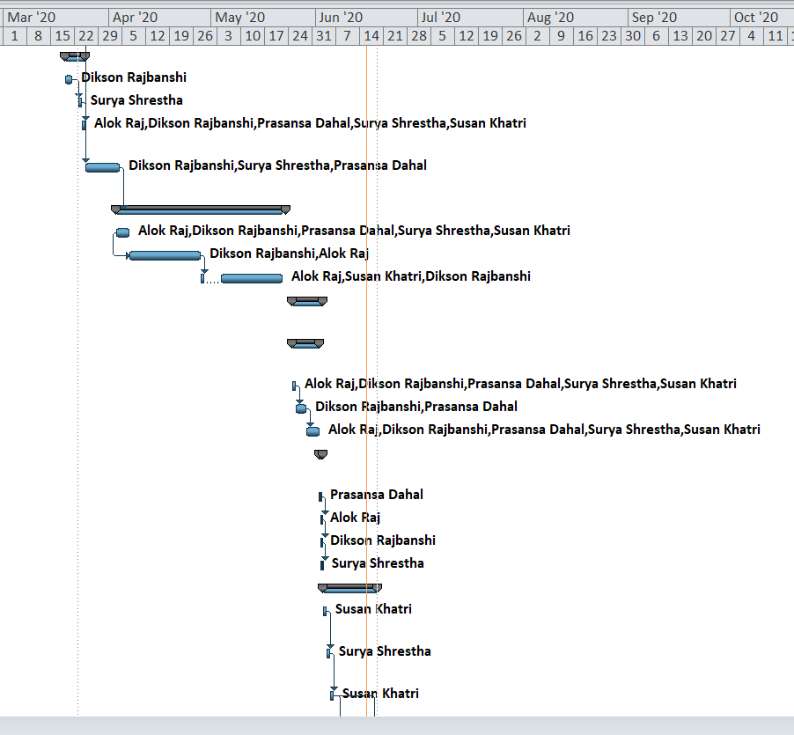

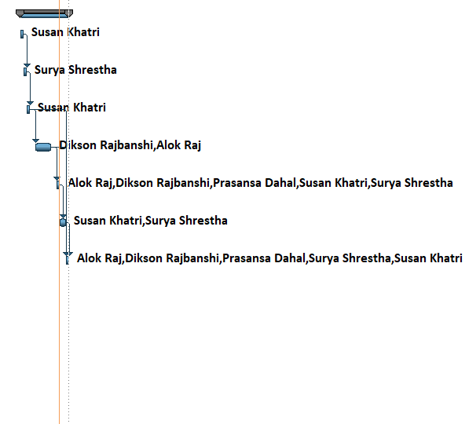

### Calendar

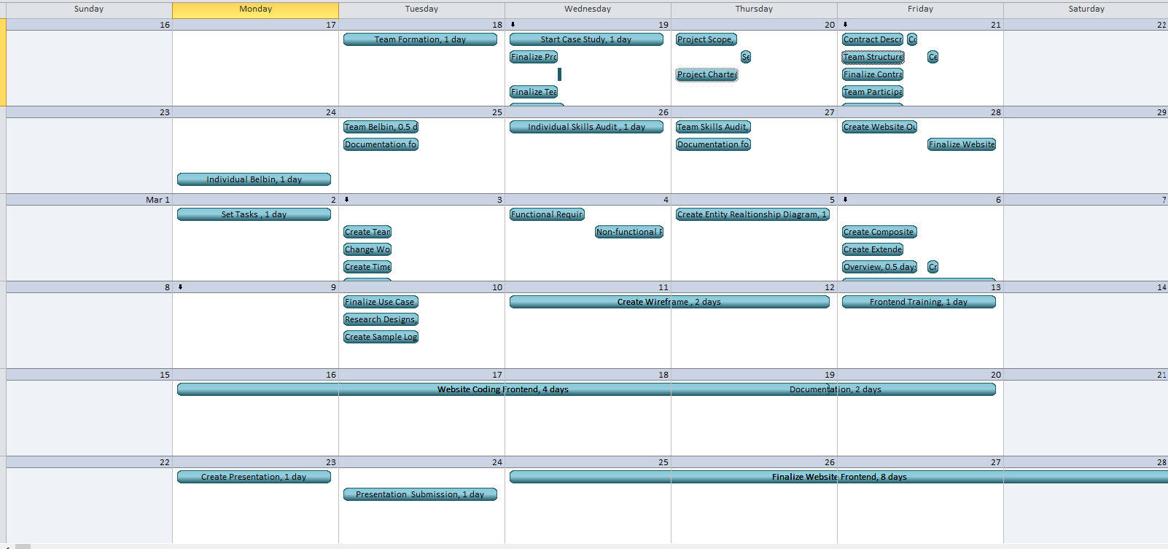

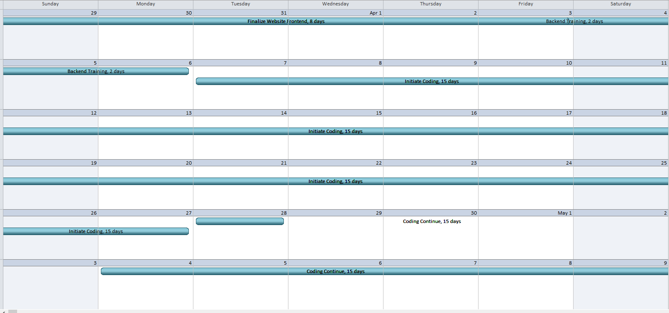

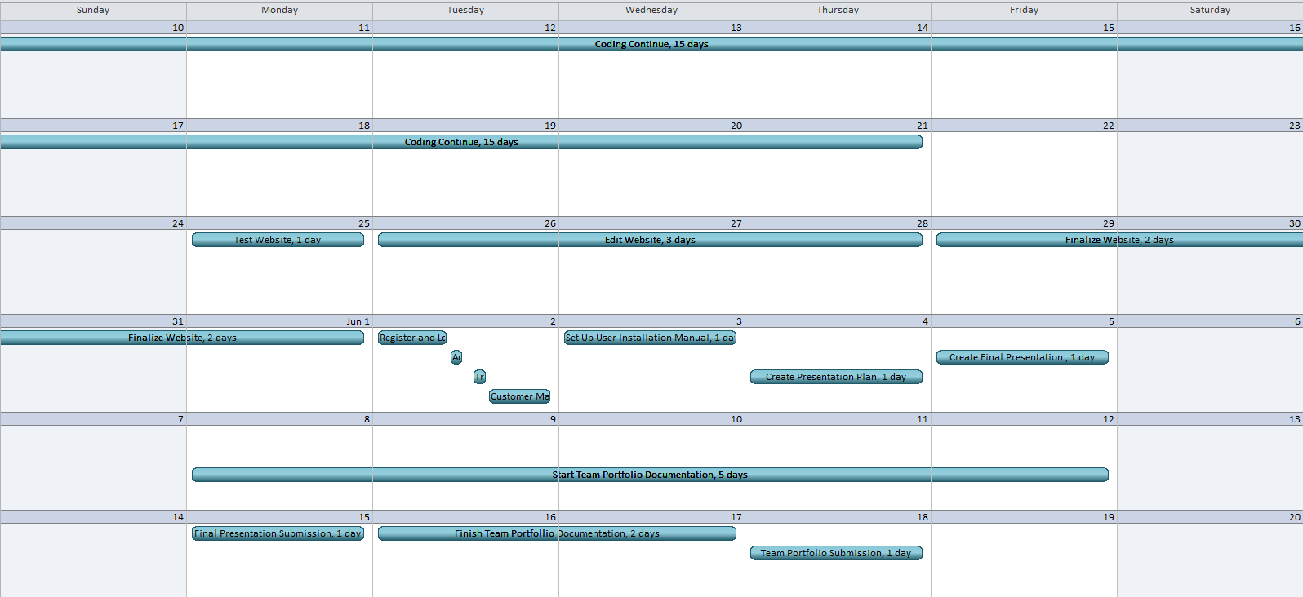

### Network Diagram

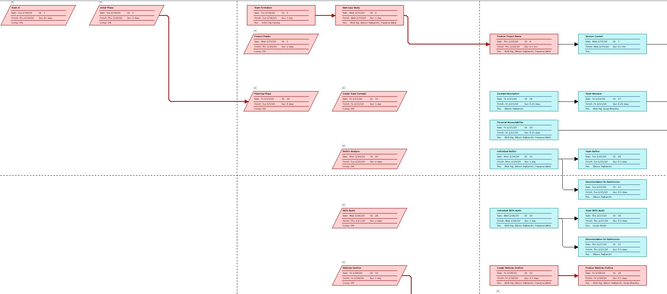

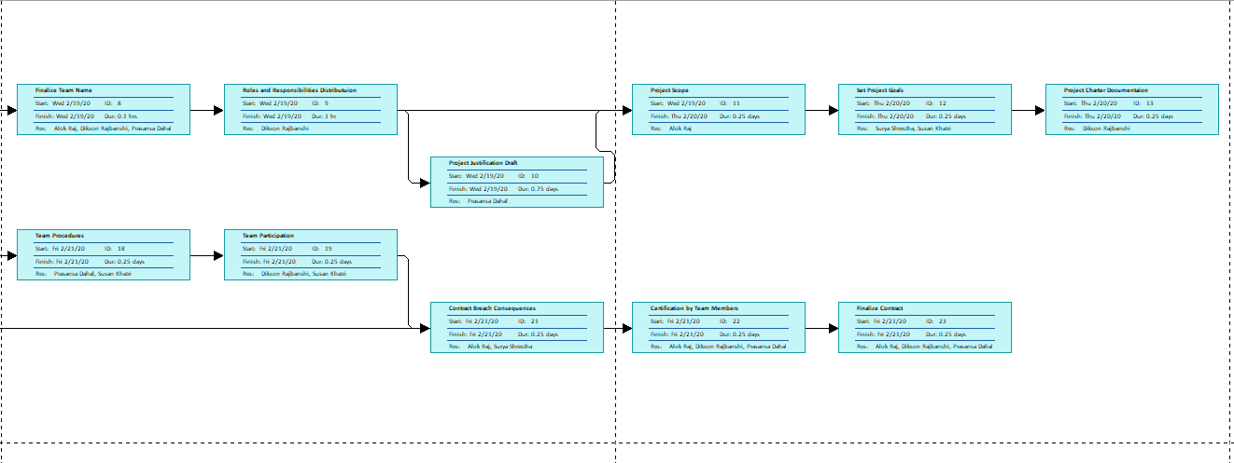

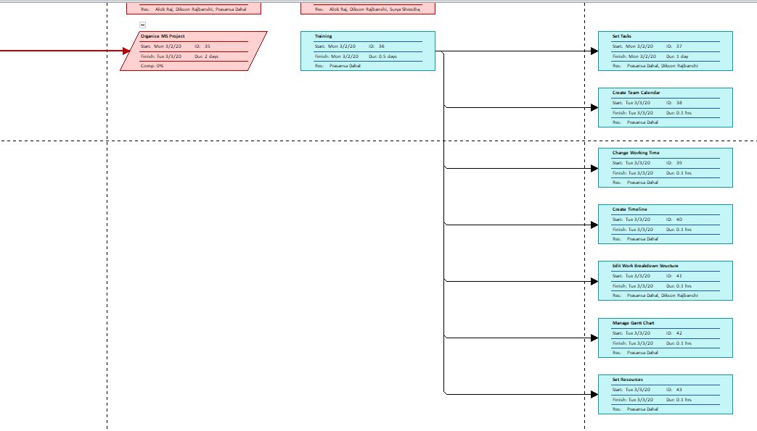

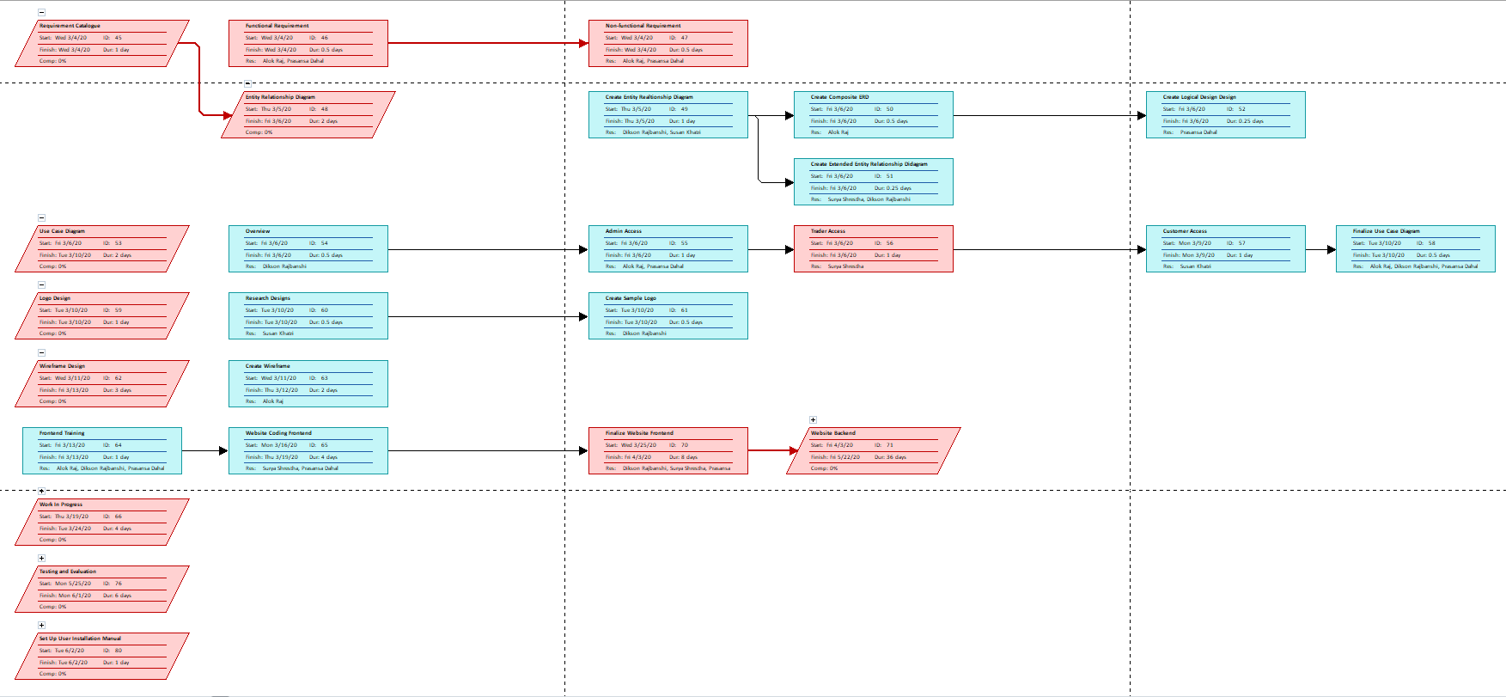

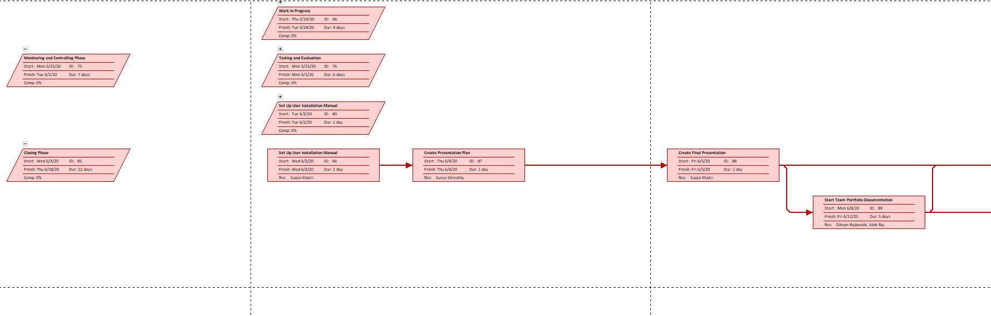

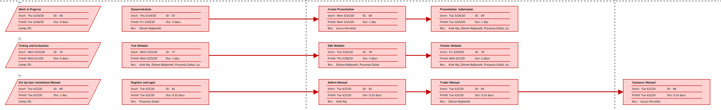

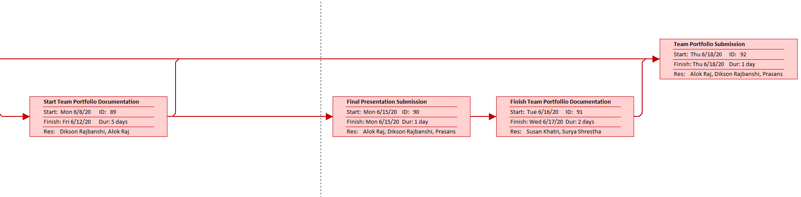

### Resource Sheet

|  |  |  |  |  |  |  |  |  |  |  |
| --- | --- | --- | --- | --- | --- | --- | --- | --- | --- | --- |
| Resource Name | Type | Material Label | Initials | Group | Max. Units | Std. Rate | Ovt. Rate | Cost/Use | Accrue At | Base Calendar |
| Writer | Work |  | W |  | 100% | $0.00/hr | $0.00/hr | $0.00 | Prorated | Team A |
| Editor | Work |  | E |  | 100% | $0.00/hr | $0.00/hr | $0.00 | Prorated | Team A |
| Arun Joshi | Work |  | A |  | 100% | $0.00/hr | $0.00/hr | $0.00 | Prorated | Team A |
| Rohit Raj Pandey | Work |  | R |  | 100% | $0.00/hr | $0.00/hr | $0.00 | Prorated | Team A |
| Dikson Rajbanshi | Work |  | D |  | 100% | $0.00/hr | $0.00/hr | $0.00 | Prorated | Team A |
| Prasansa Dahal | Work |  | P |  | 100% | $0.00/hr | $0.00/hr | $0.00 | Prorated | Team A |
| Surya Shrestha | Work |  | S |  | 100% | $0.00/hr | $0.00/hr | $0.00 | Prorated | Team A |
| Susan Khatri | Work |  | S |  | 100% | $0.00/hr | $0.00/hr | $0.00 | Prorated | Team A |
| Alok Raj | Work |  | A |  | 100% | $0.00/hr | $0.00/hr | $0.00 | Prorated | Team A |
| Glossy Paper | Material | Xerox | G |  |  | $0.00 |  | $0.00 | Prorated | Team A |
| Printer | Work |  | P |  | 100% | $0.00/hr | $0.00/hr | $0.00 | Prorated | Team A |
| Pen | Material | Cello | P |  |  | $0.00 |  | $0.00 | Prorated |  |
| Laptop | Work |  | L |  | 100% | $0.00/hr | $0.00/hr | $0.00 | Prorated | Team A |
| QSEE | Material | QSEE Technologies | Q |  |  | $0.00 |  | $0.00 | Prorated | Team A |
| MS Project Professional | Material | Microsoft | M |  |  | $0.00 |  | $0.00 | Prorated | Team A |
| MS Word | Material | Microsoft | M |  |  | $0.00 |  | $0.00 | Prorated | Team A |
| Oracle Database | Material | Oracle | O |  |  | $0.00 |  | $0.00 | Prorated | Team A |

### Timeline

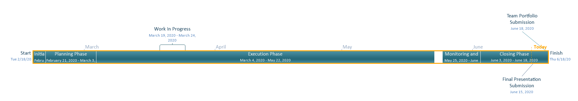

## Team Meetings

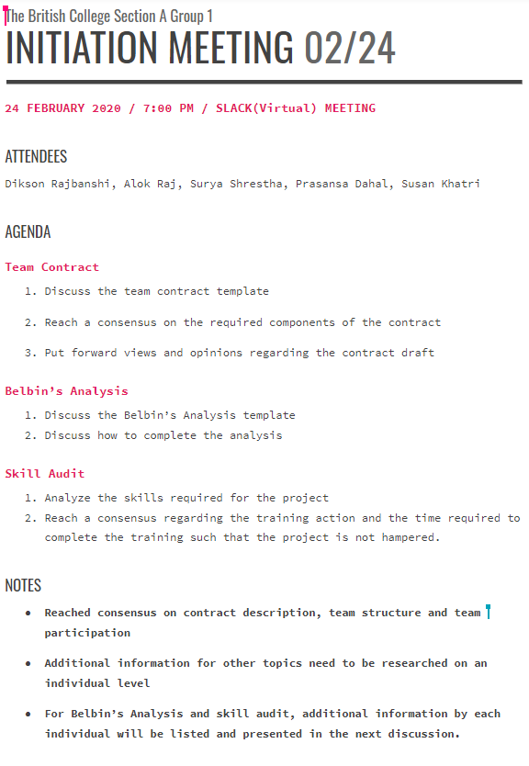

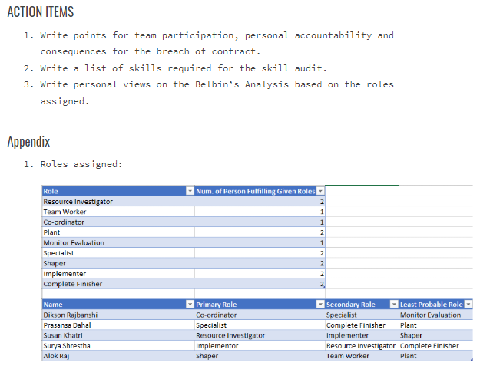

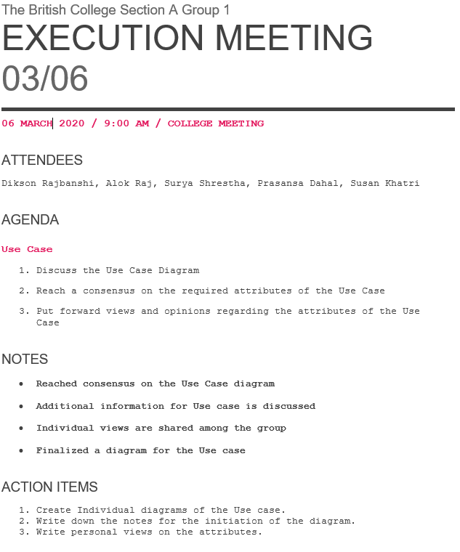

## Team Meetings (Virtual)

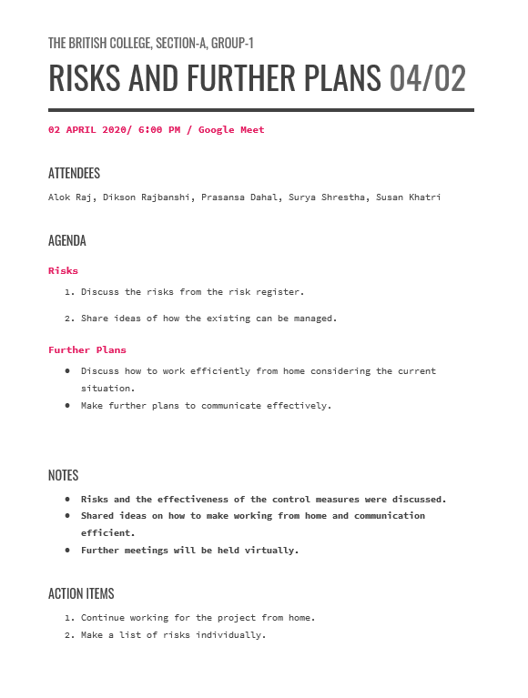

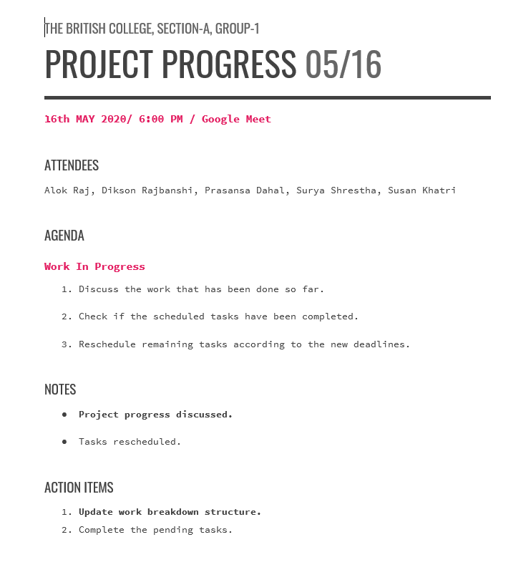

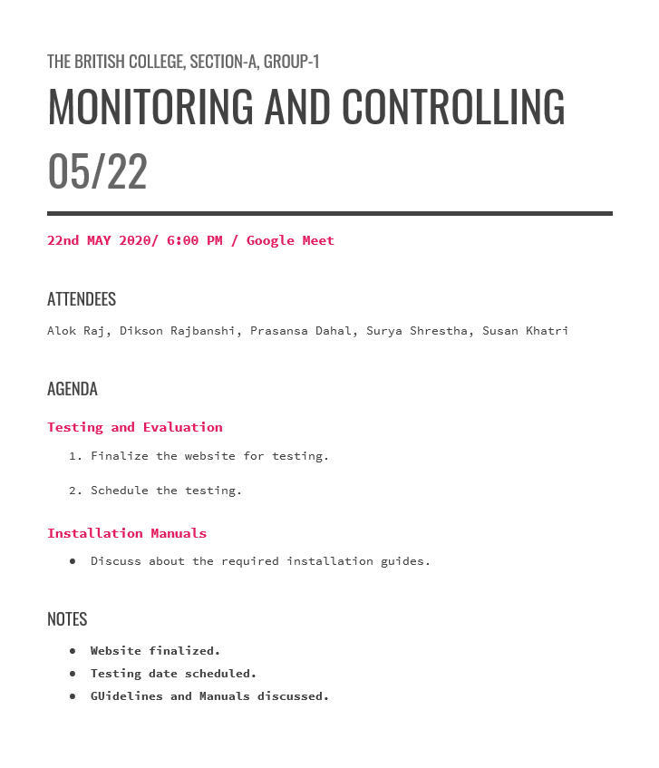

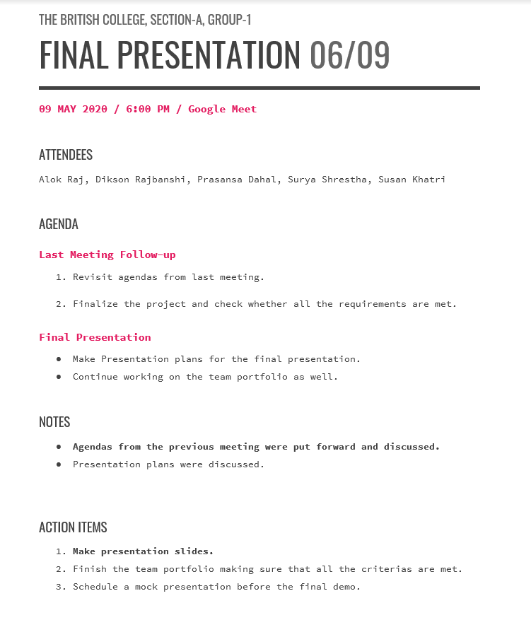

## Communication and Collaboration Tools Used

### Trello

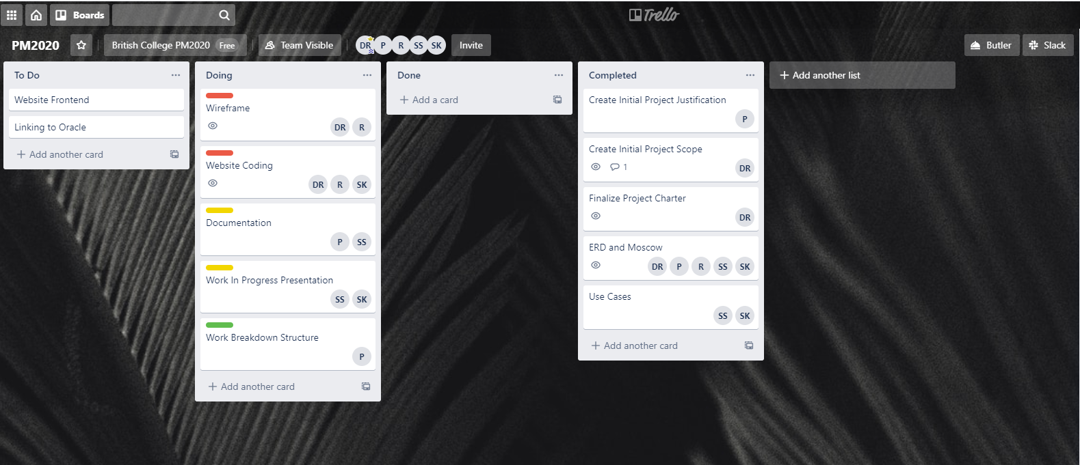

### Slack

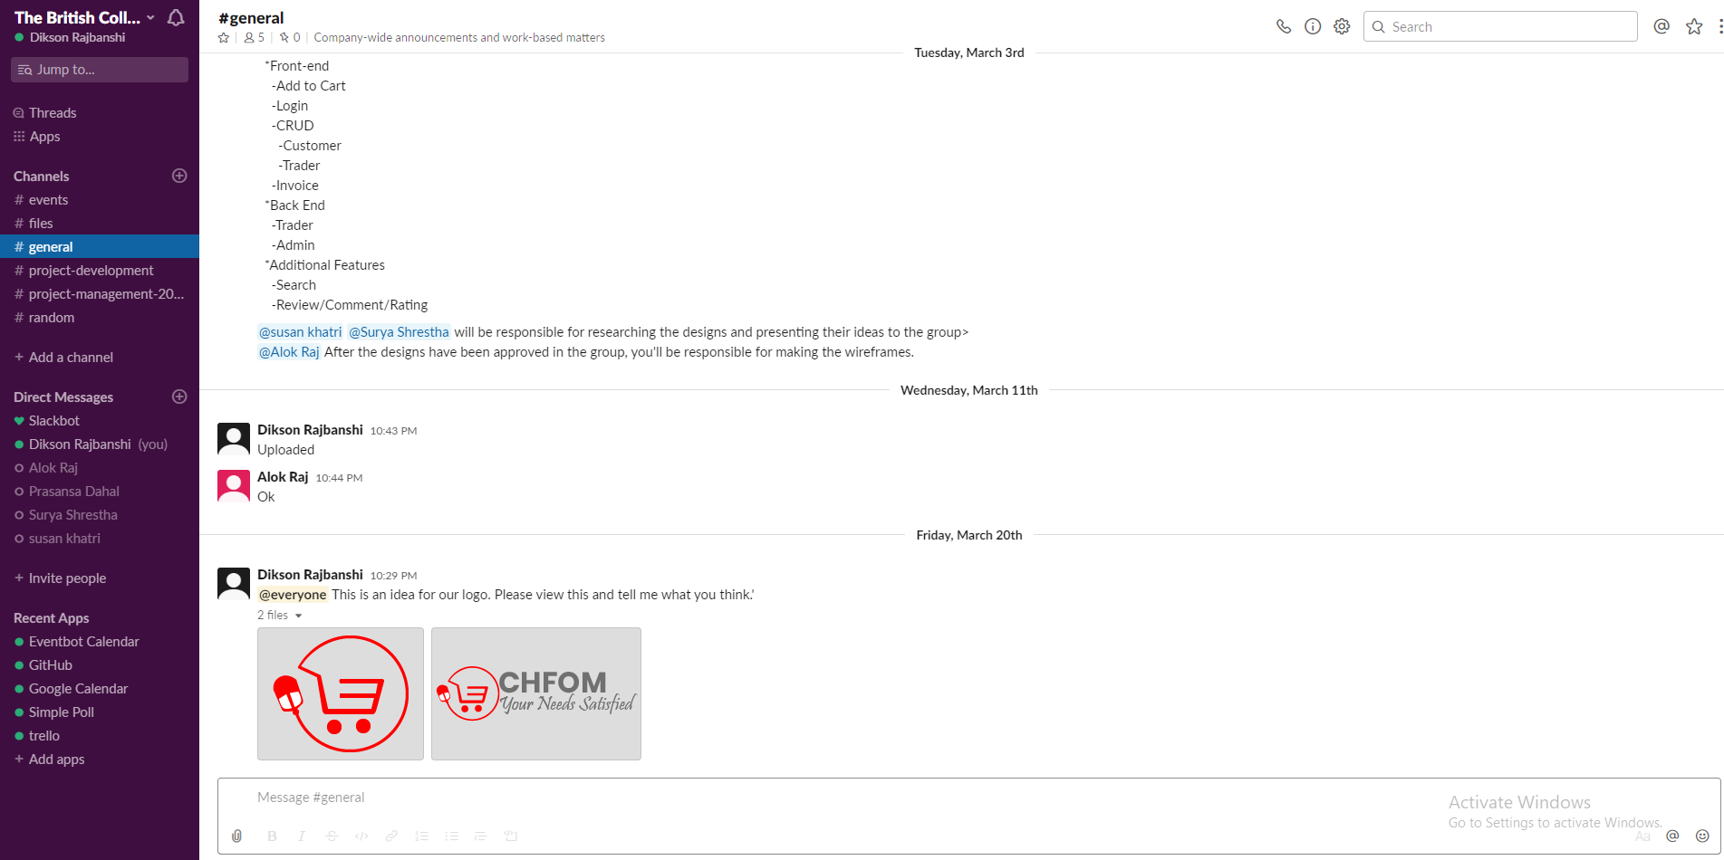

### GitHub

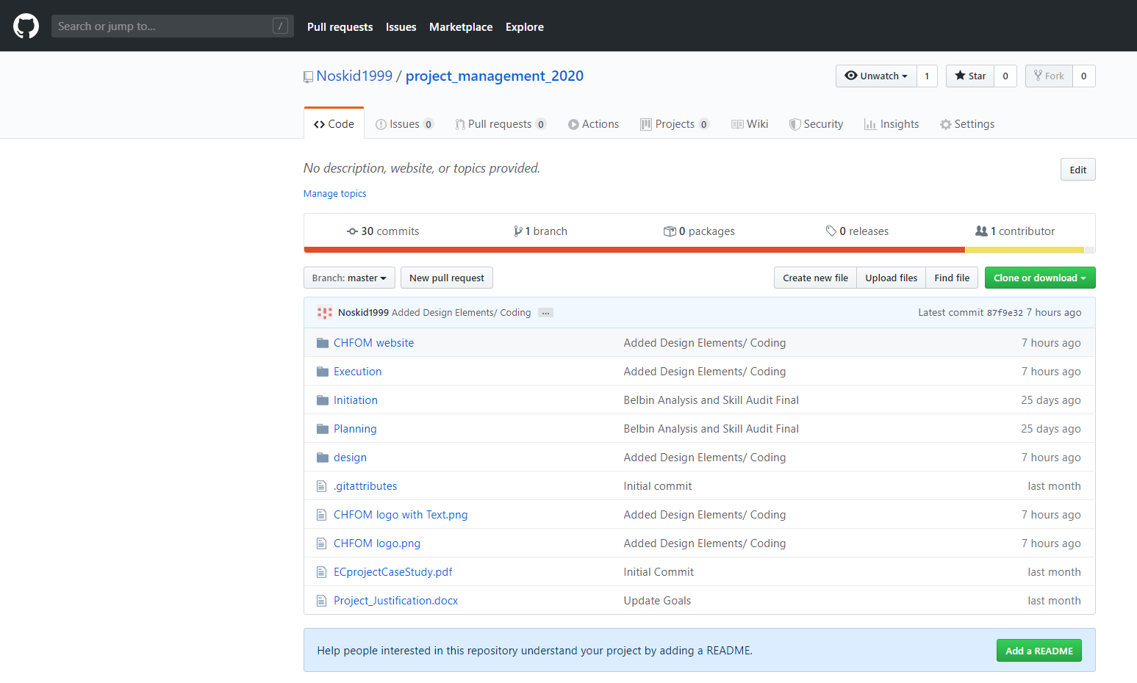

# Project Execution

## Requirements

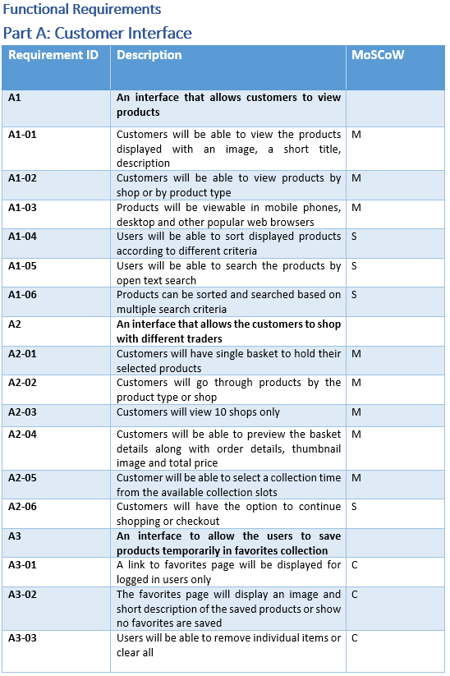

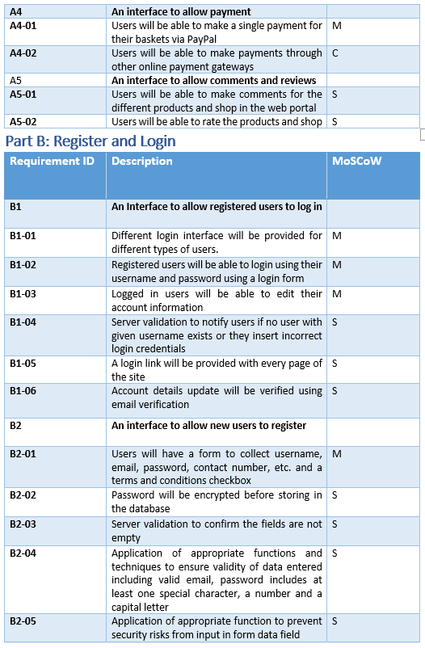

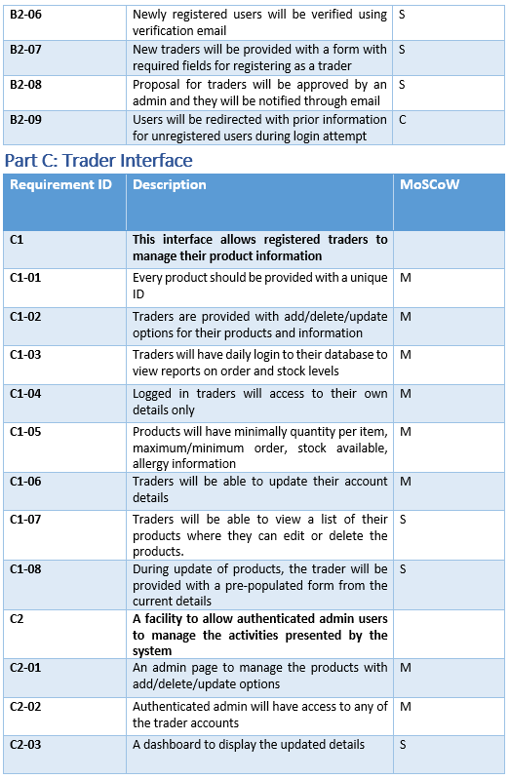

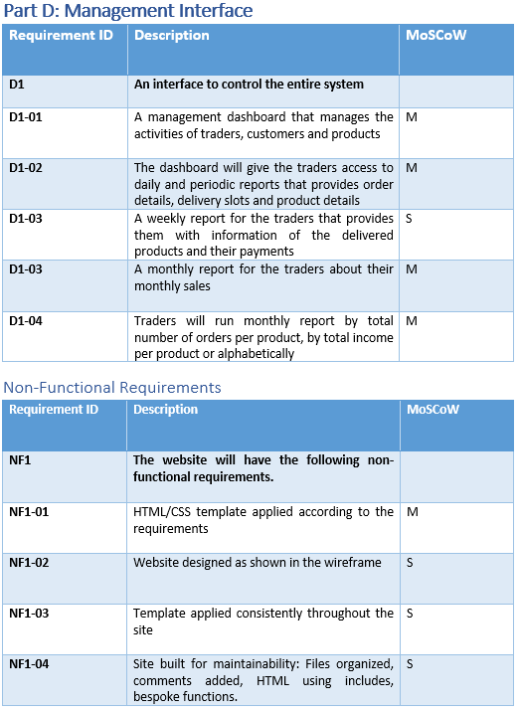

## Entity Relationship Diagram (ERD)

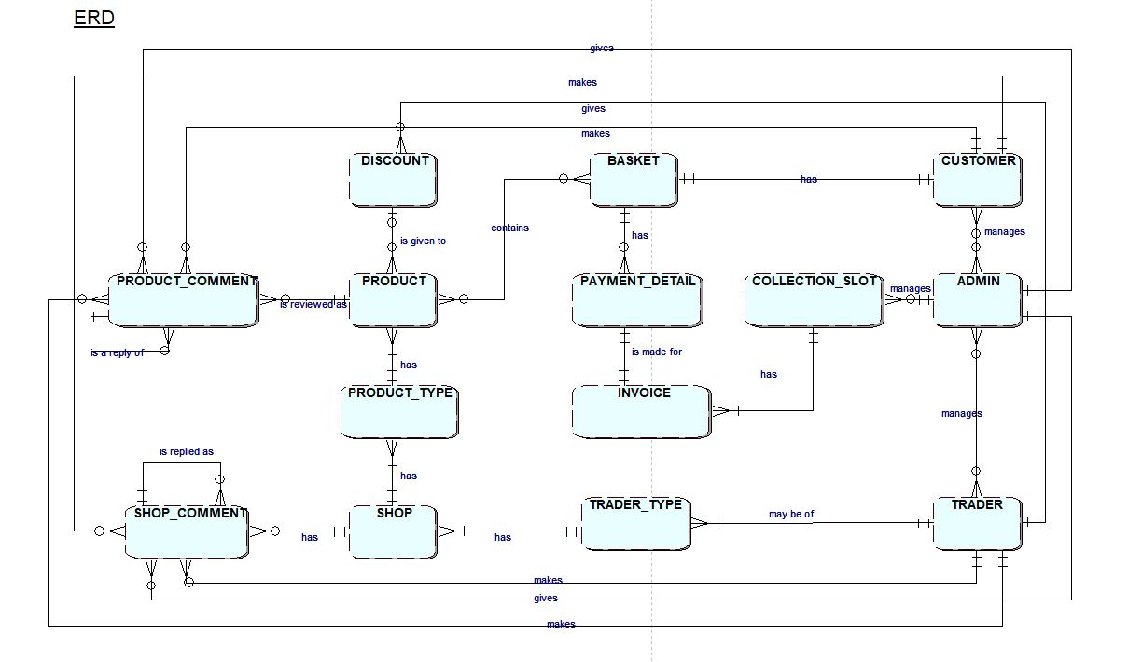

## Extended Entity Relationship Diagram (EERD)

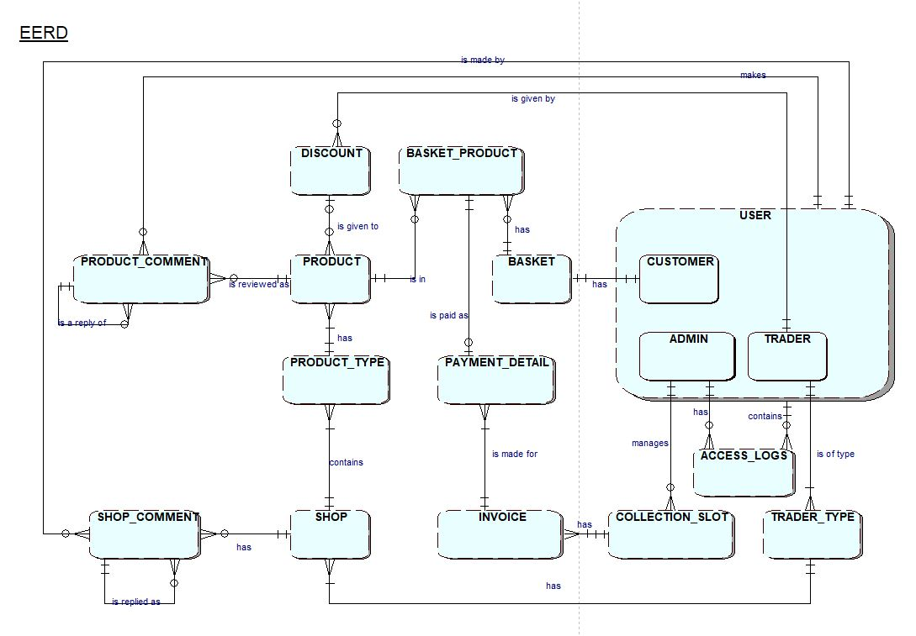

## Composite ERD

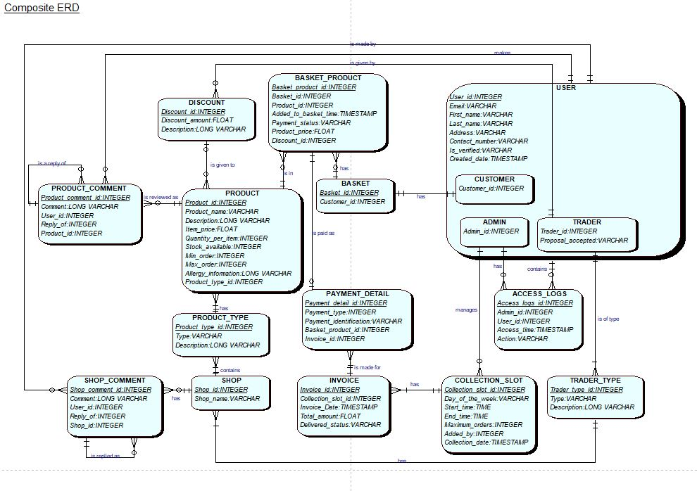

## Logical Design

* USER (User_id, Email, First_name, Last_name, Address, Contact_number, Is_verified, Created_date)
* CUSTOMER (Customer_id, *User_id*)
* ADMIN (Admin_id, *User_id)*
* TRADER (Trader_id, Proposal_accepted, *User_id)*
* PRODUCT (Product_id, Product_name, Description, Item_price, Quantity_per_item, Stock_available, Min_order, Max_order, Allergy_information, *Product_type_id, Discount_id*)
* BASKET (Basket_id, *Customer_id*)
* BASKET_PRODUCT (Basket_product_id, *Basket_id, Product_id*, Added_to_basket_time, Payment_status, Product_price, *Discount_id*)
* PAYMENT_DETAIL (Payment_detail_id, Payment_type, Payment_identification, *Basket_product_id, Invoice_id*)
* INVOICE (Invoice_id, *Collection_slot_id,* Invoice_date, Total_amount, Delivered_status)
* COLLECTION_SLOT (Collection_slot_id, Day_of_the_week, Start_time, End_time, Maximum_orders, *Added_by*, Collection_date)
* ACCESS_LOGS (Access_logs_id, *Admin_id, User_id,* Access_time, Action)
* TRADER_TYPE (Trader_type_id, Type, Description)
* SHOP (Shop_id, Shop_name)
* PRODUCT_TYPE (Product_type_id, Type, Description, *Shop_id*)
* DISCOUNT (Discount_id, Discount_amount, Description)
* SHOP_COMMENT (Shop_comment_id, Comment, *User_id, Reply_of, Product_id*)
* PRODUCT_COMMENT (Product_comment_id, Comment, *User_id, Reply_of, Shop_id*)

## Use Case

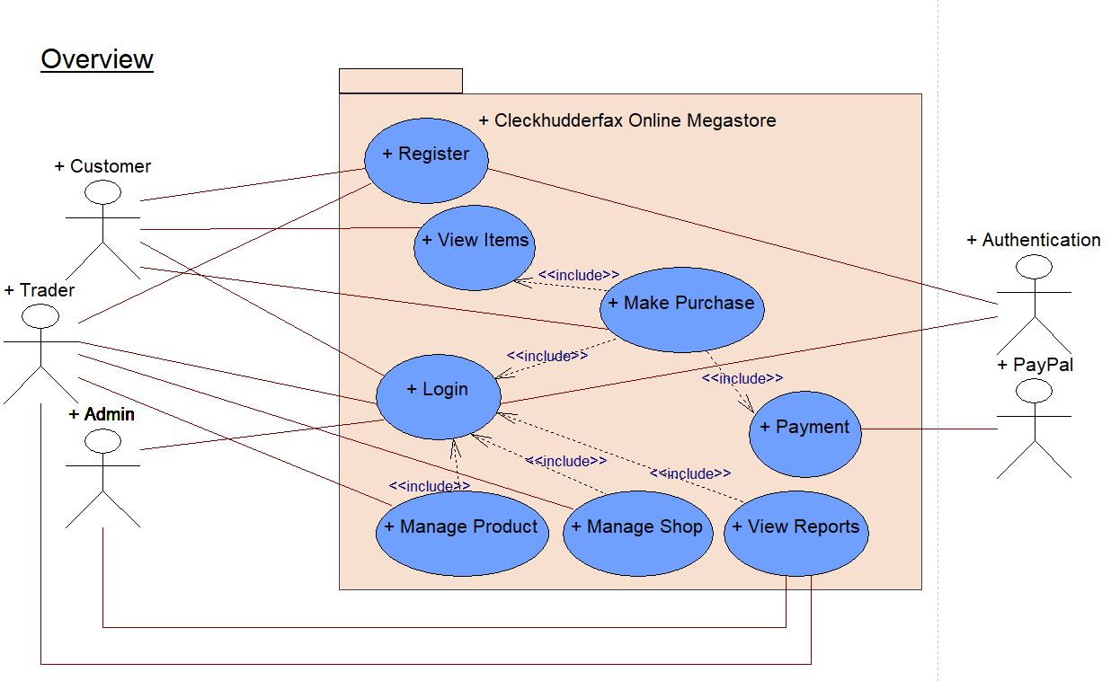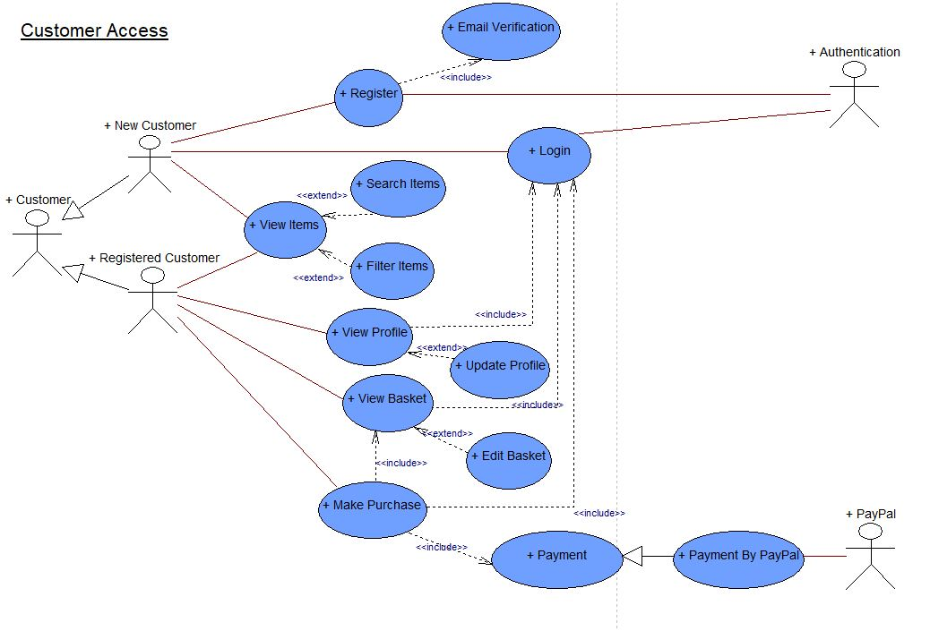

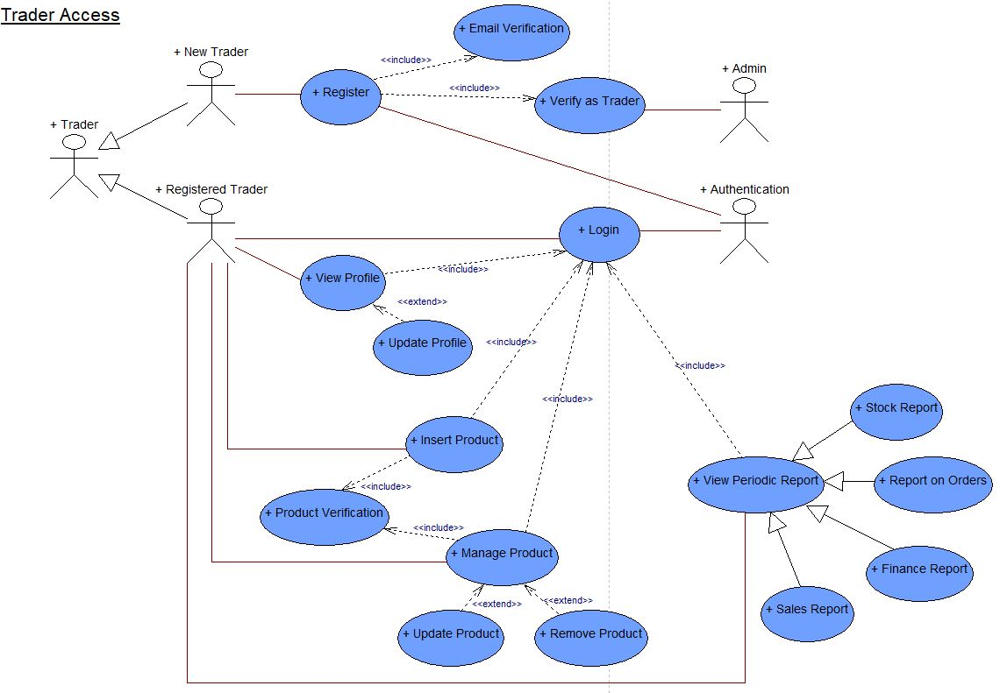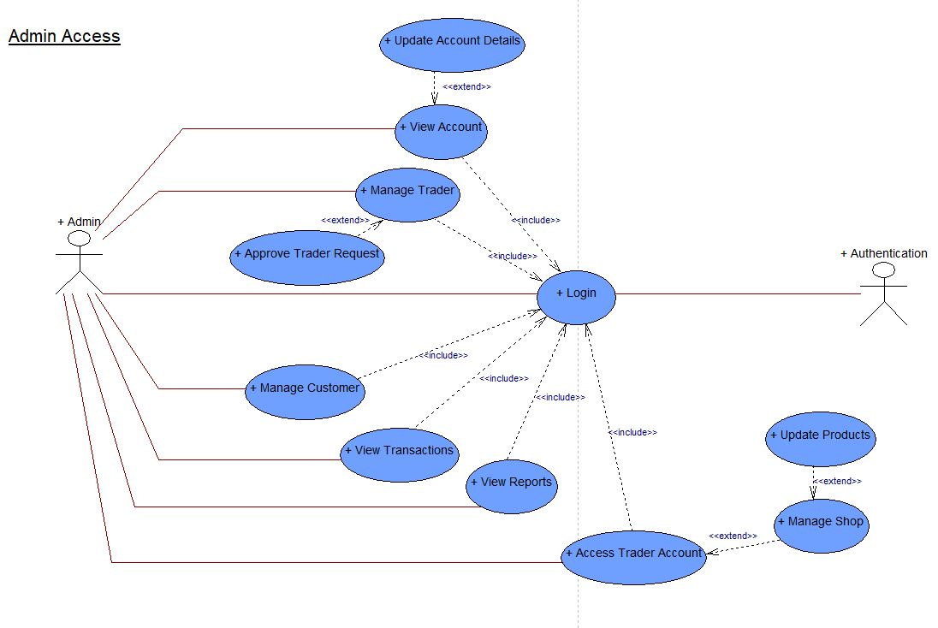

## Wireframes

### Home

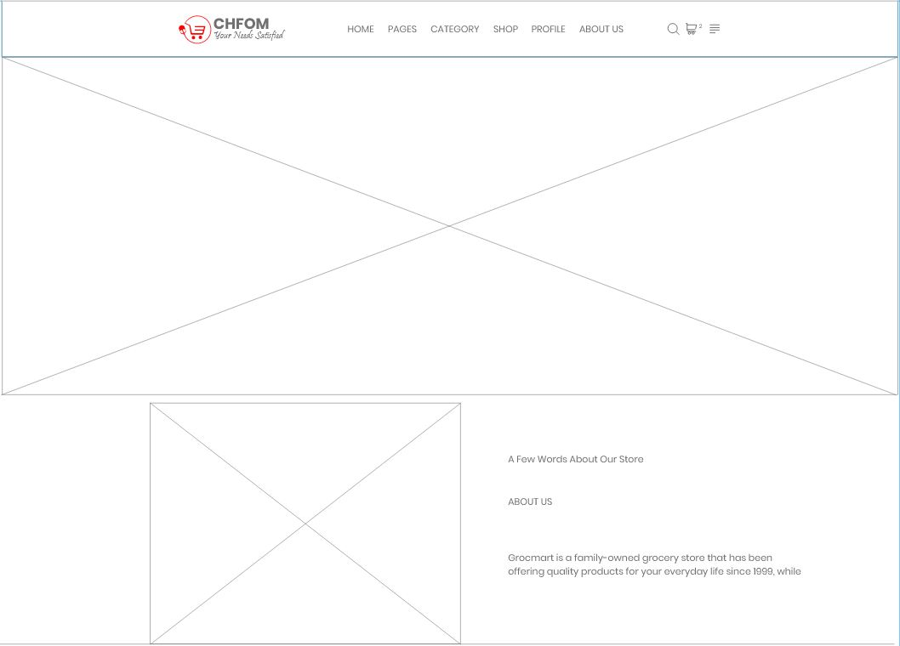

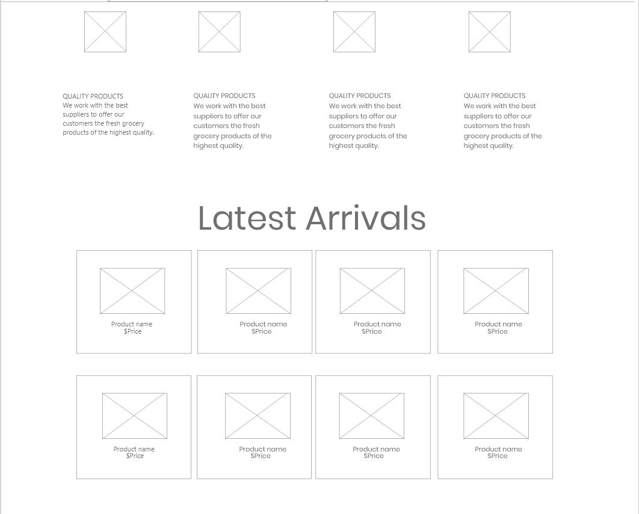

### About Us

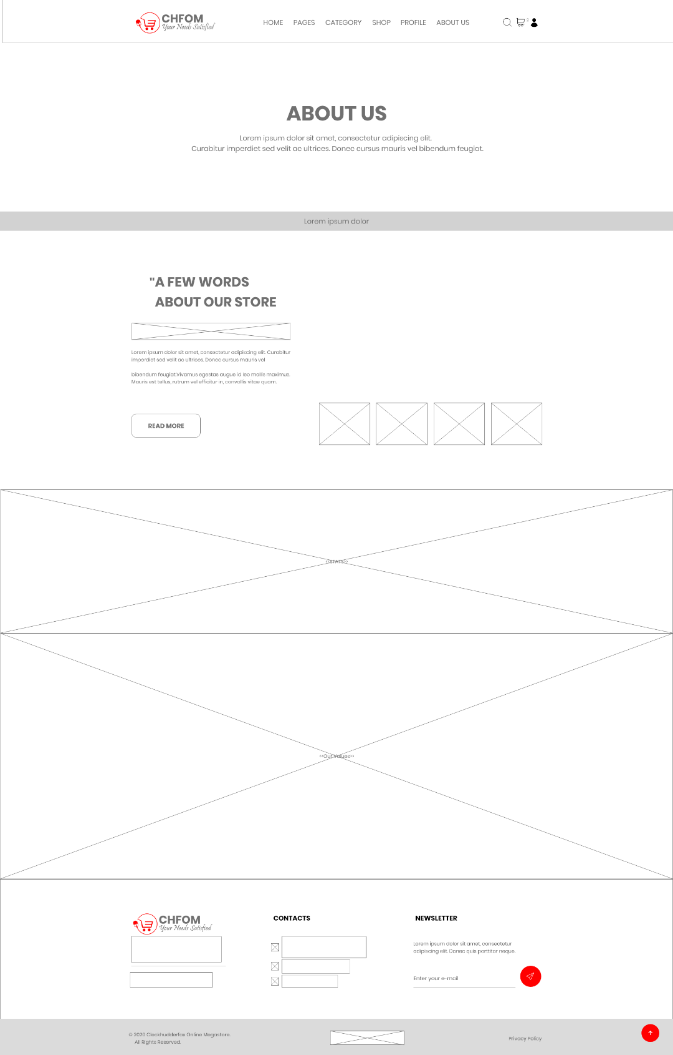

### Our Clients

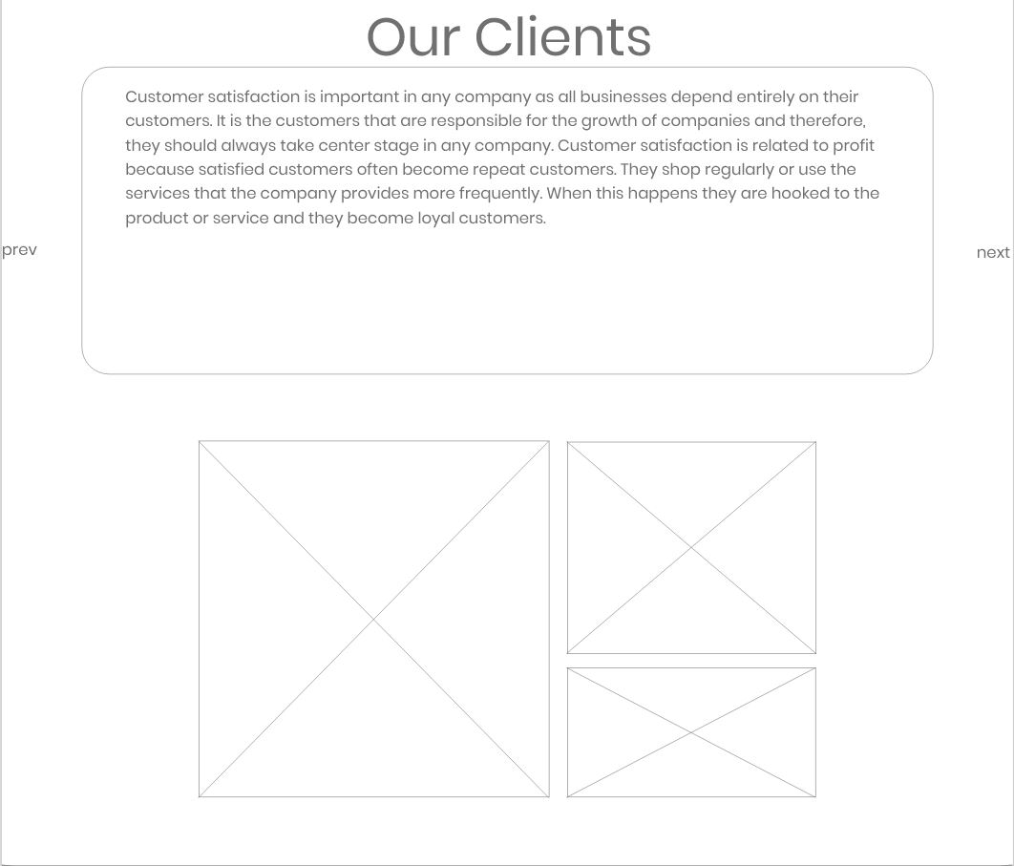

### FAQs

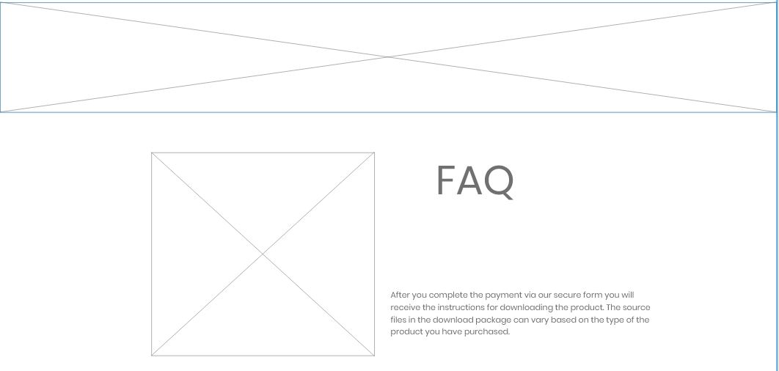

### Our Blog

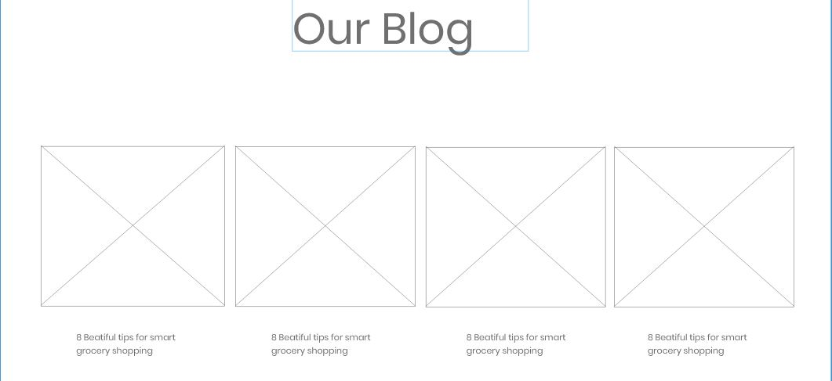

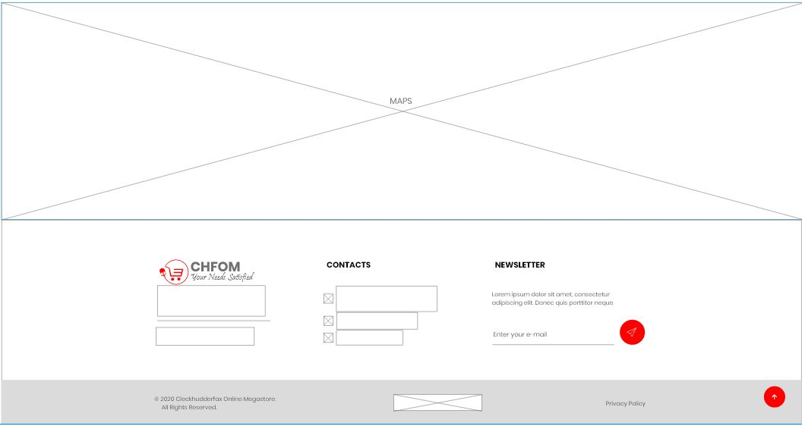

### Shop

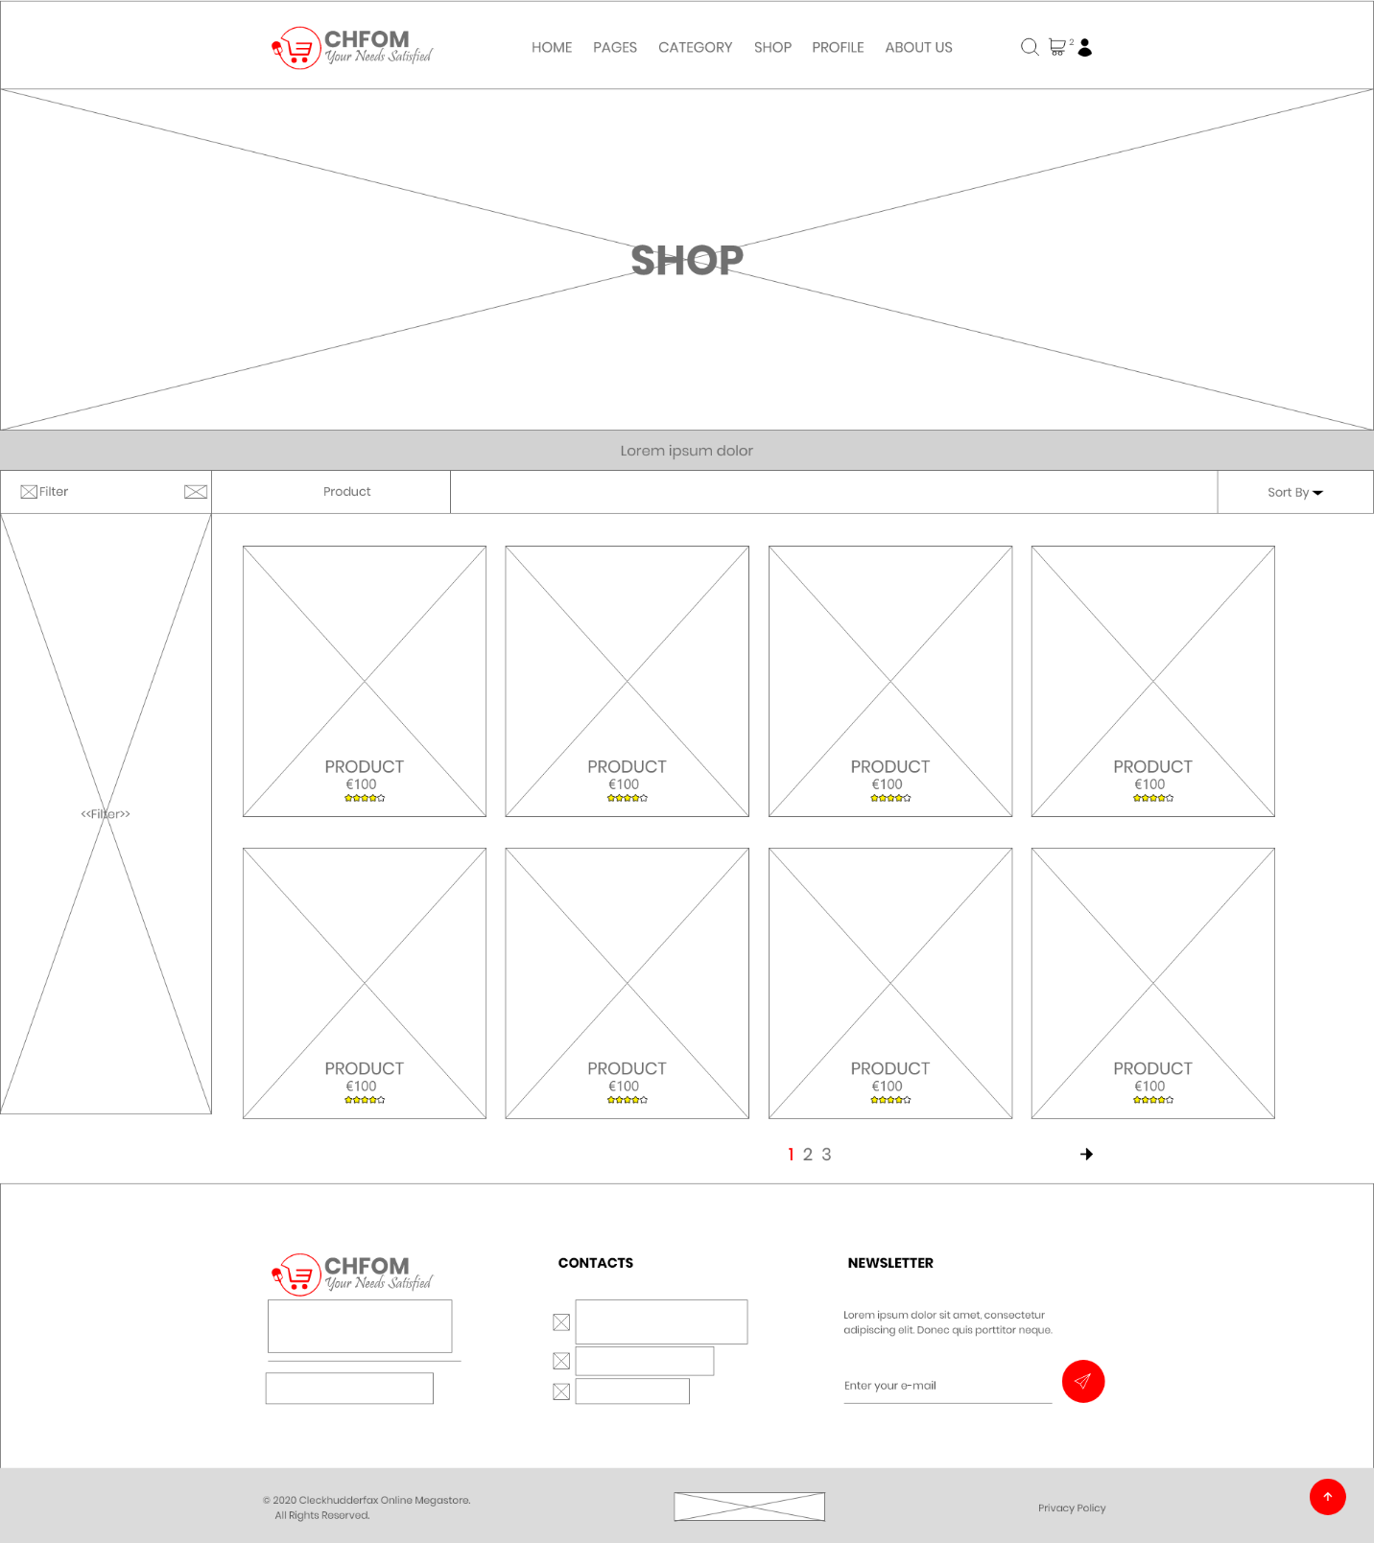

### Single Product Page

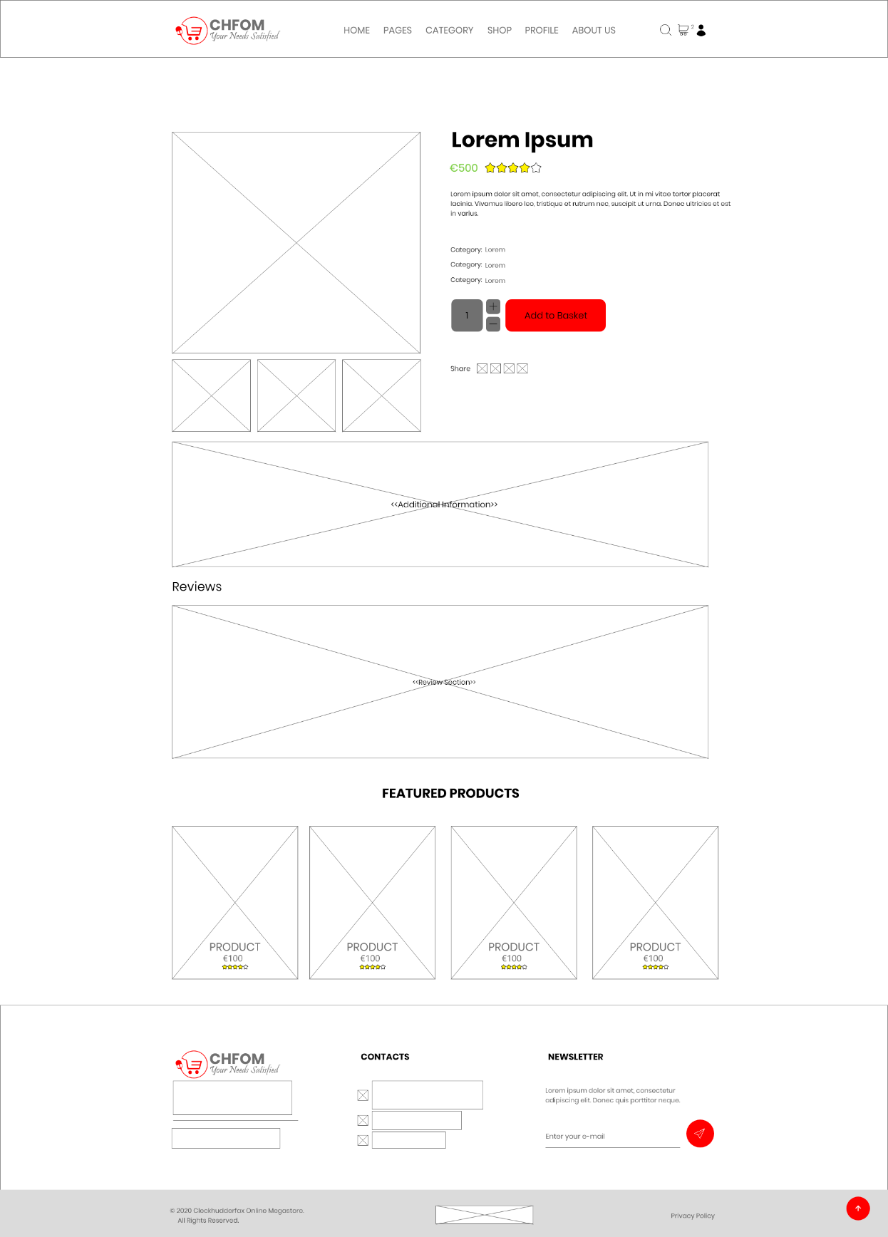

### Search

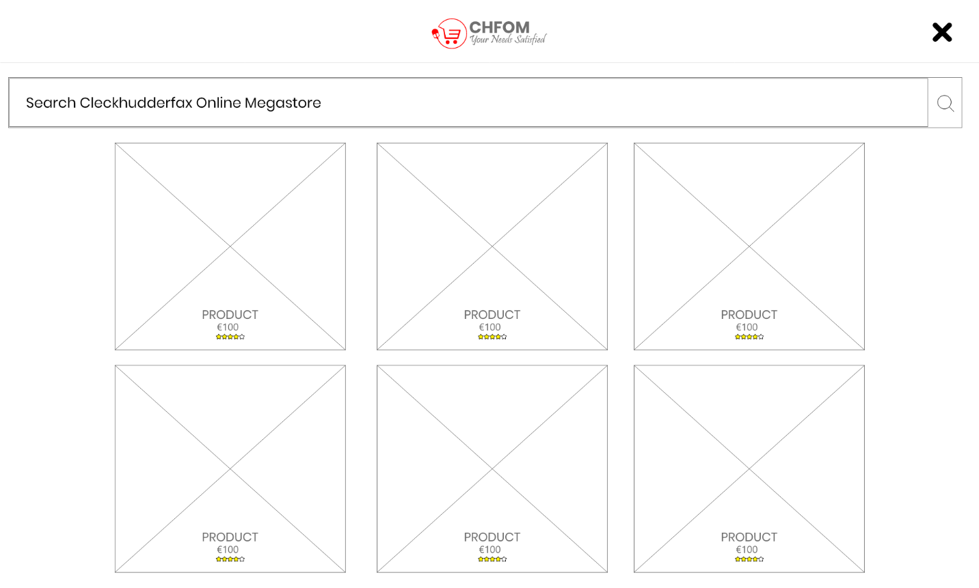

### Basket

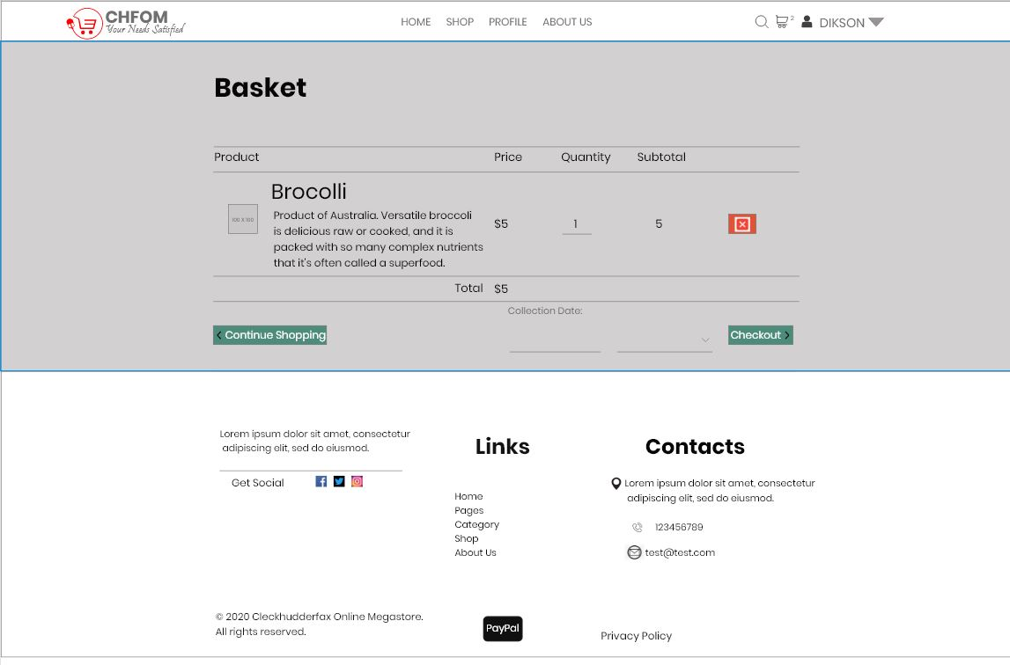

### Login

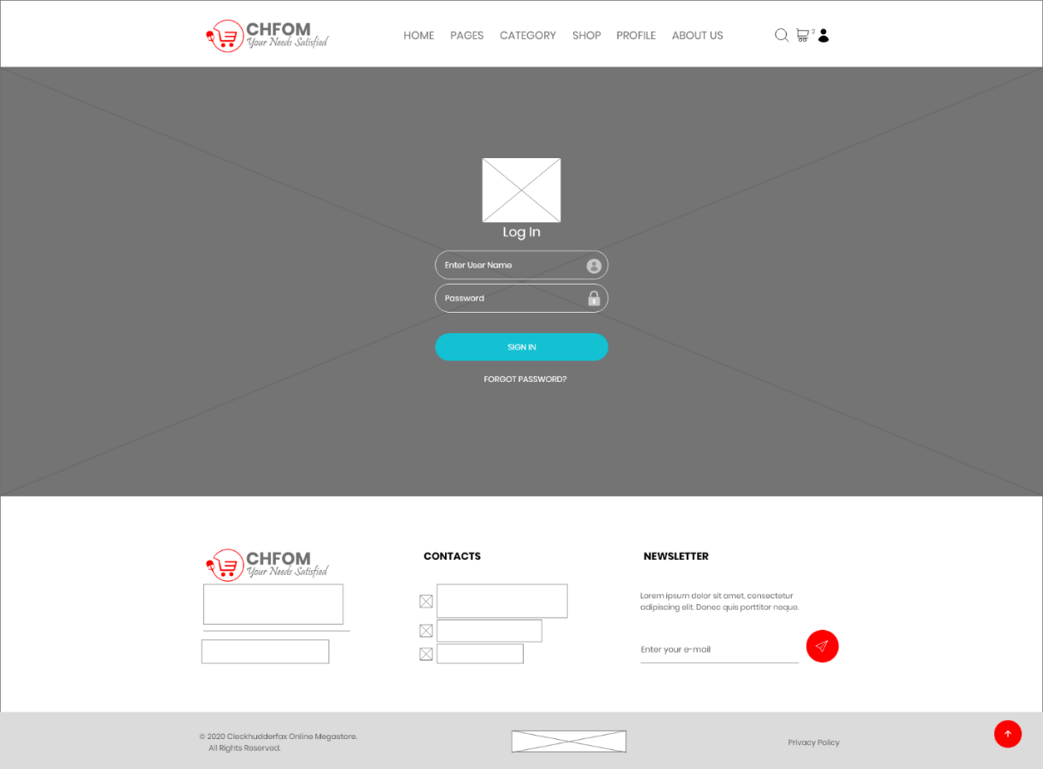

### Manage Account

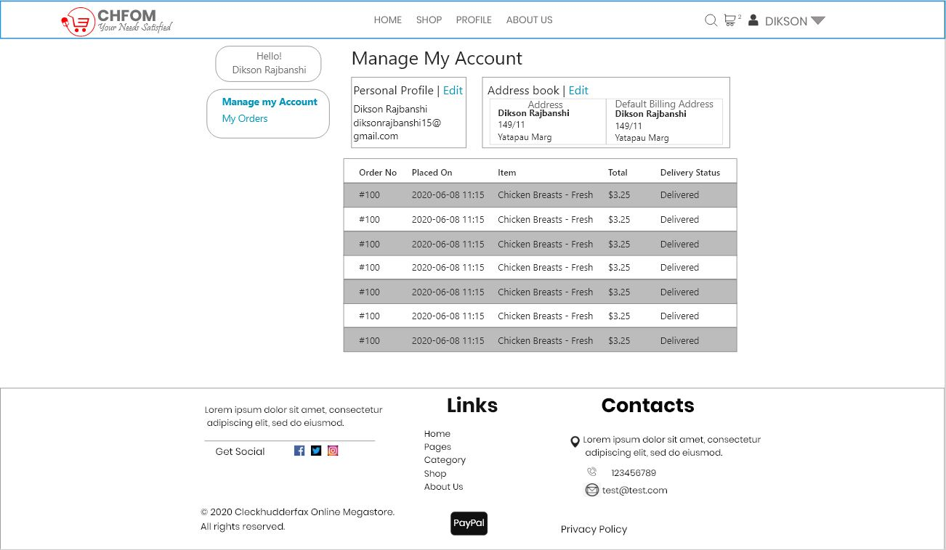

### Add Product

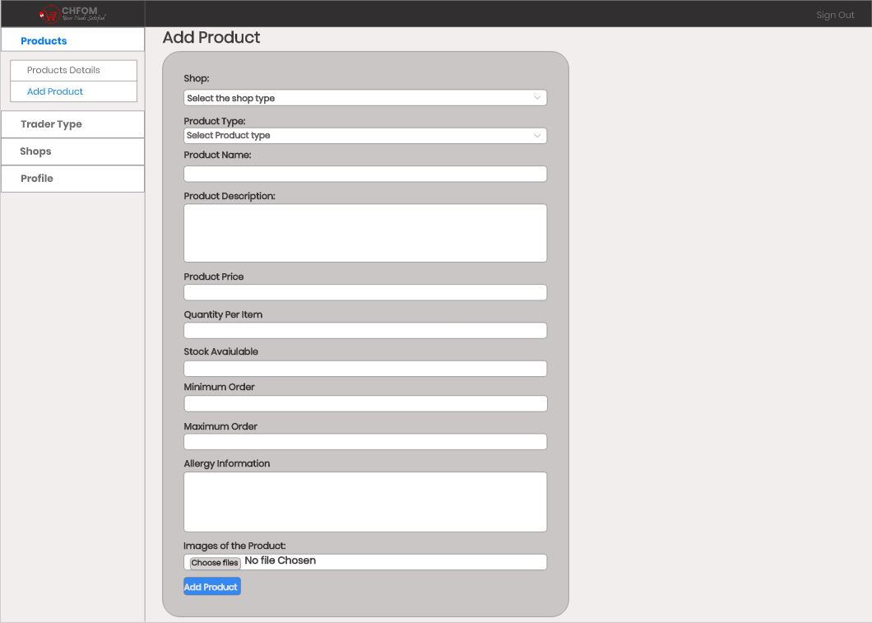

### Product Details

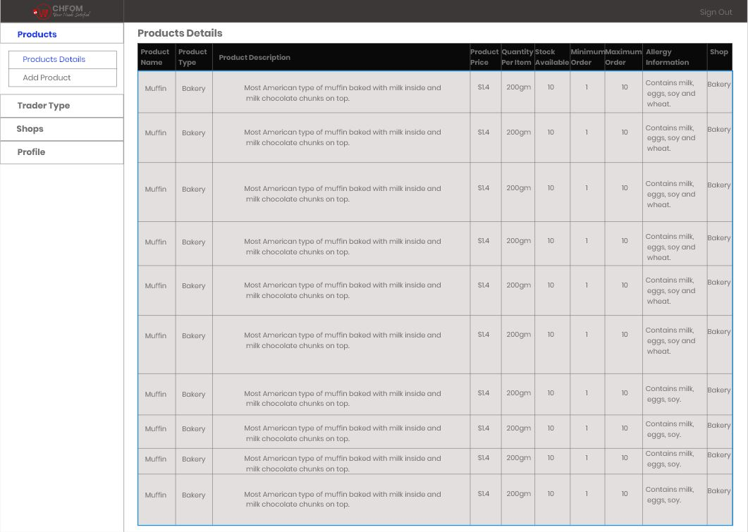

## Risk Register

### Risk Register (Team)

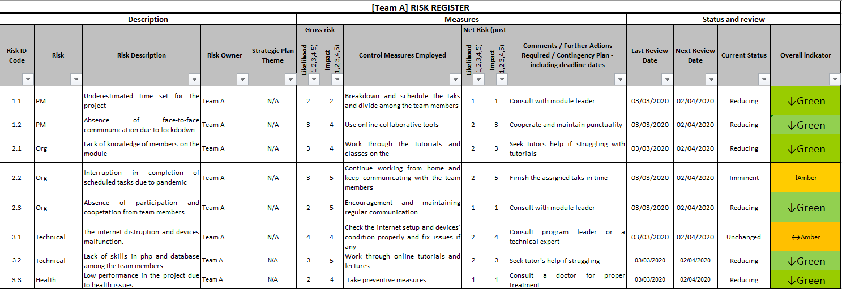

### Risk Profile (Team)

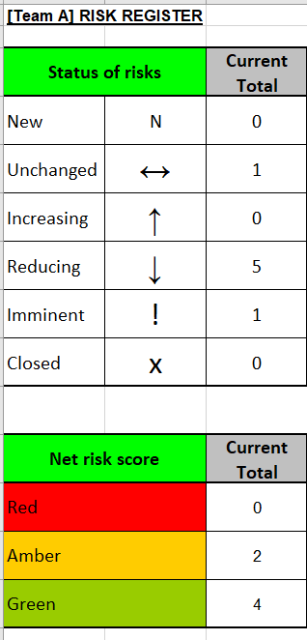

### Risk Register (Individual)



### Risk Profile (Individual)



# WEBSITE

## Homepage

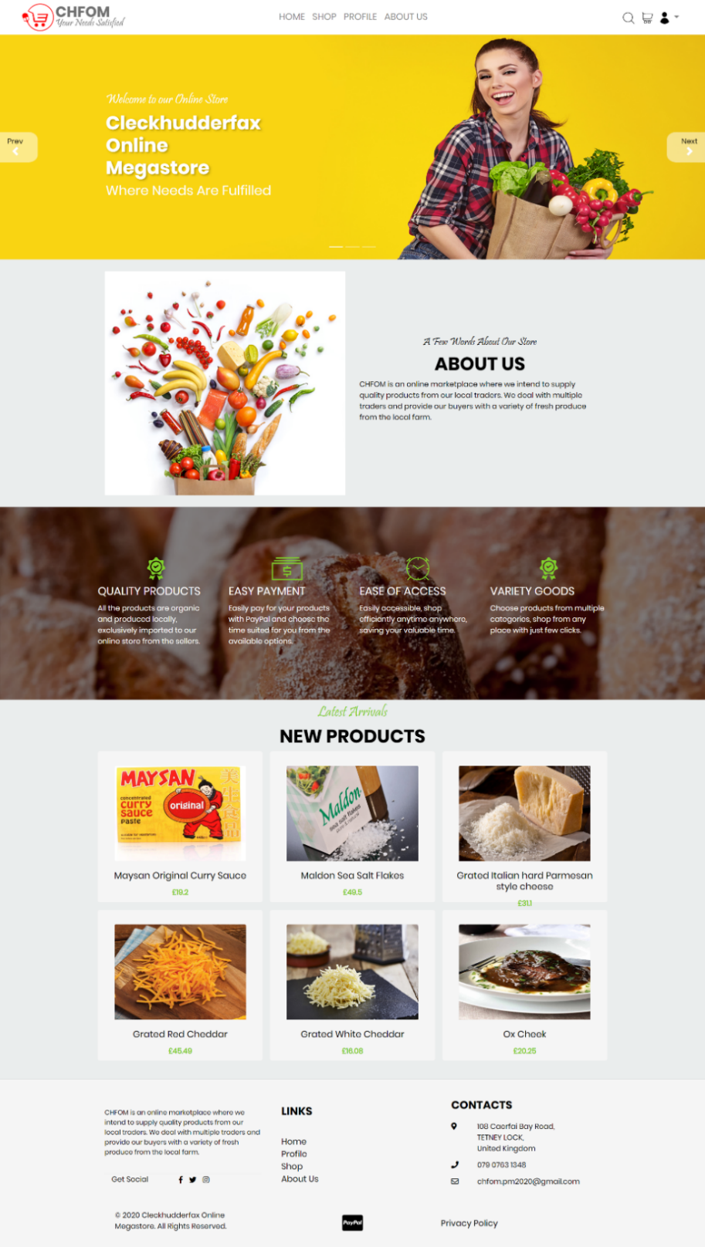

## About Us

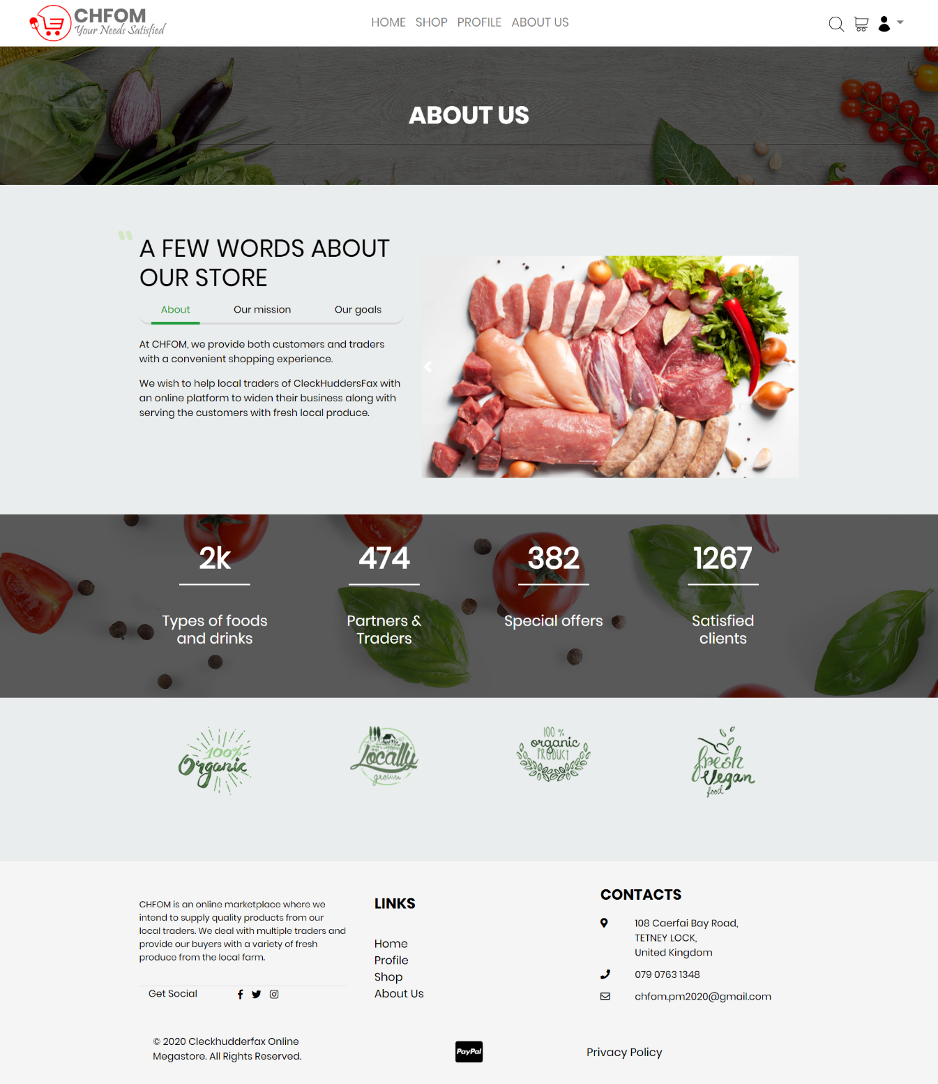

## Shop

### Products

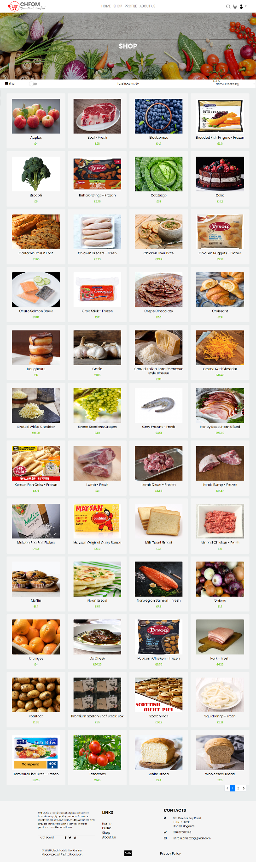

### Filter

#### Filter: Product type

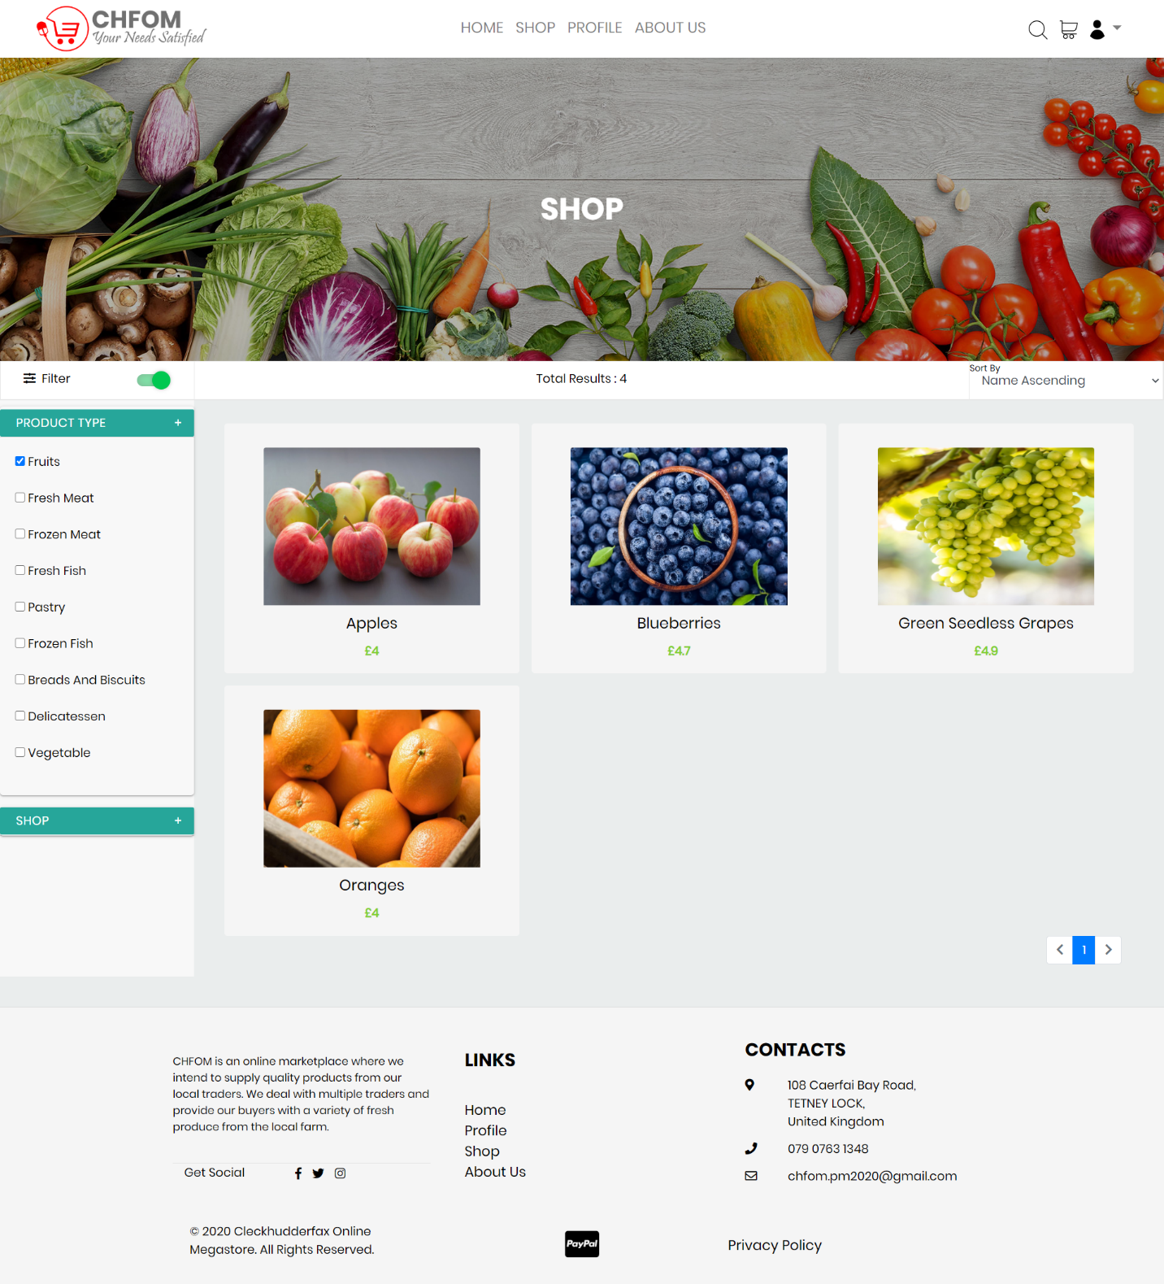

#### Filter: Shop

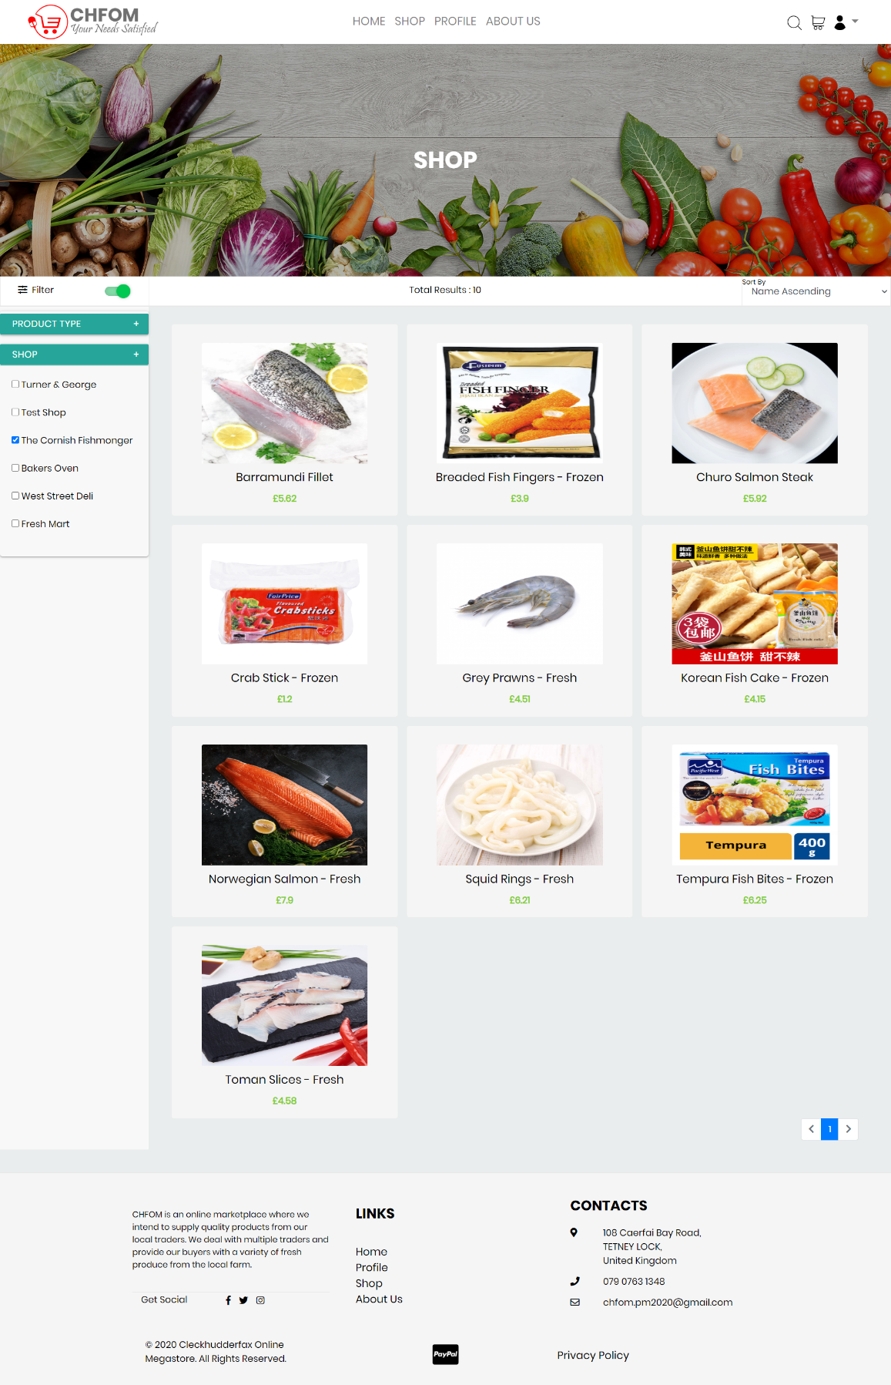

## Product

### Product Search

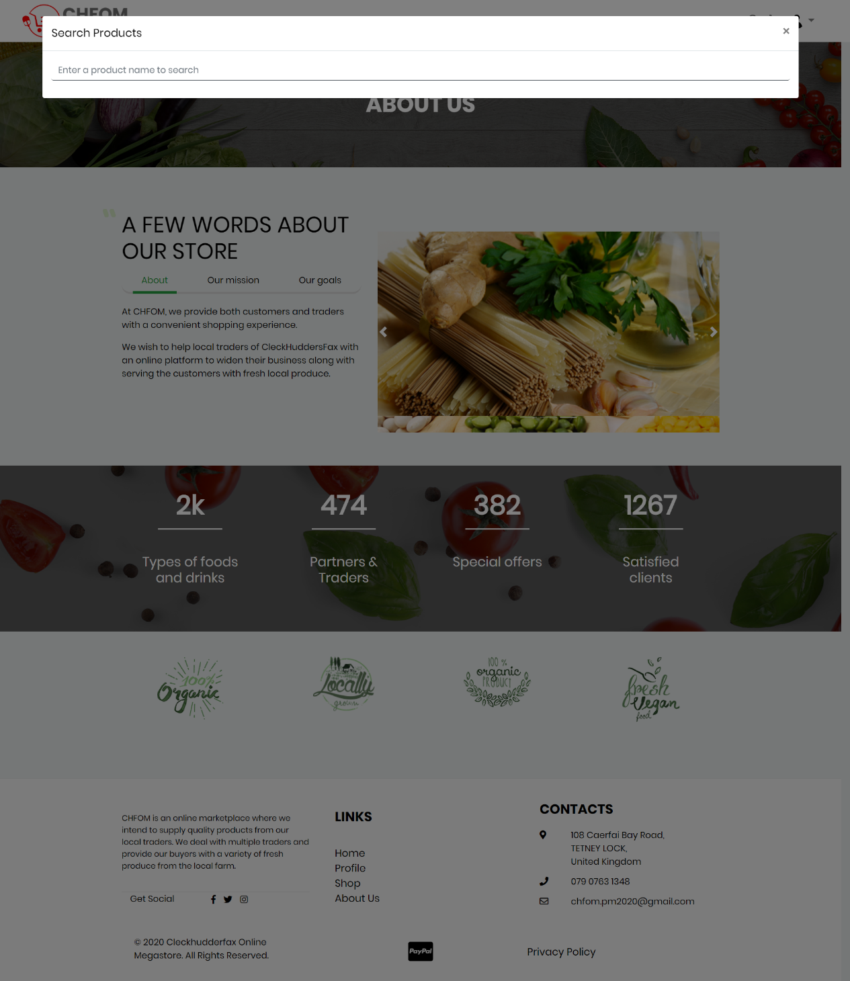

### Product Search Result

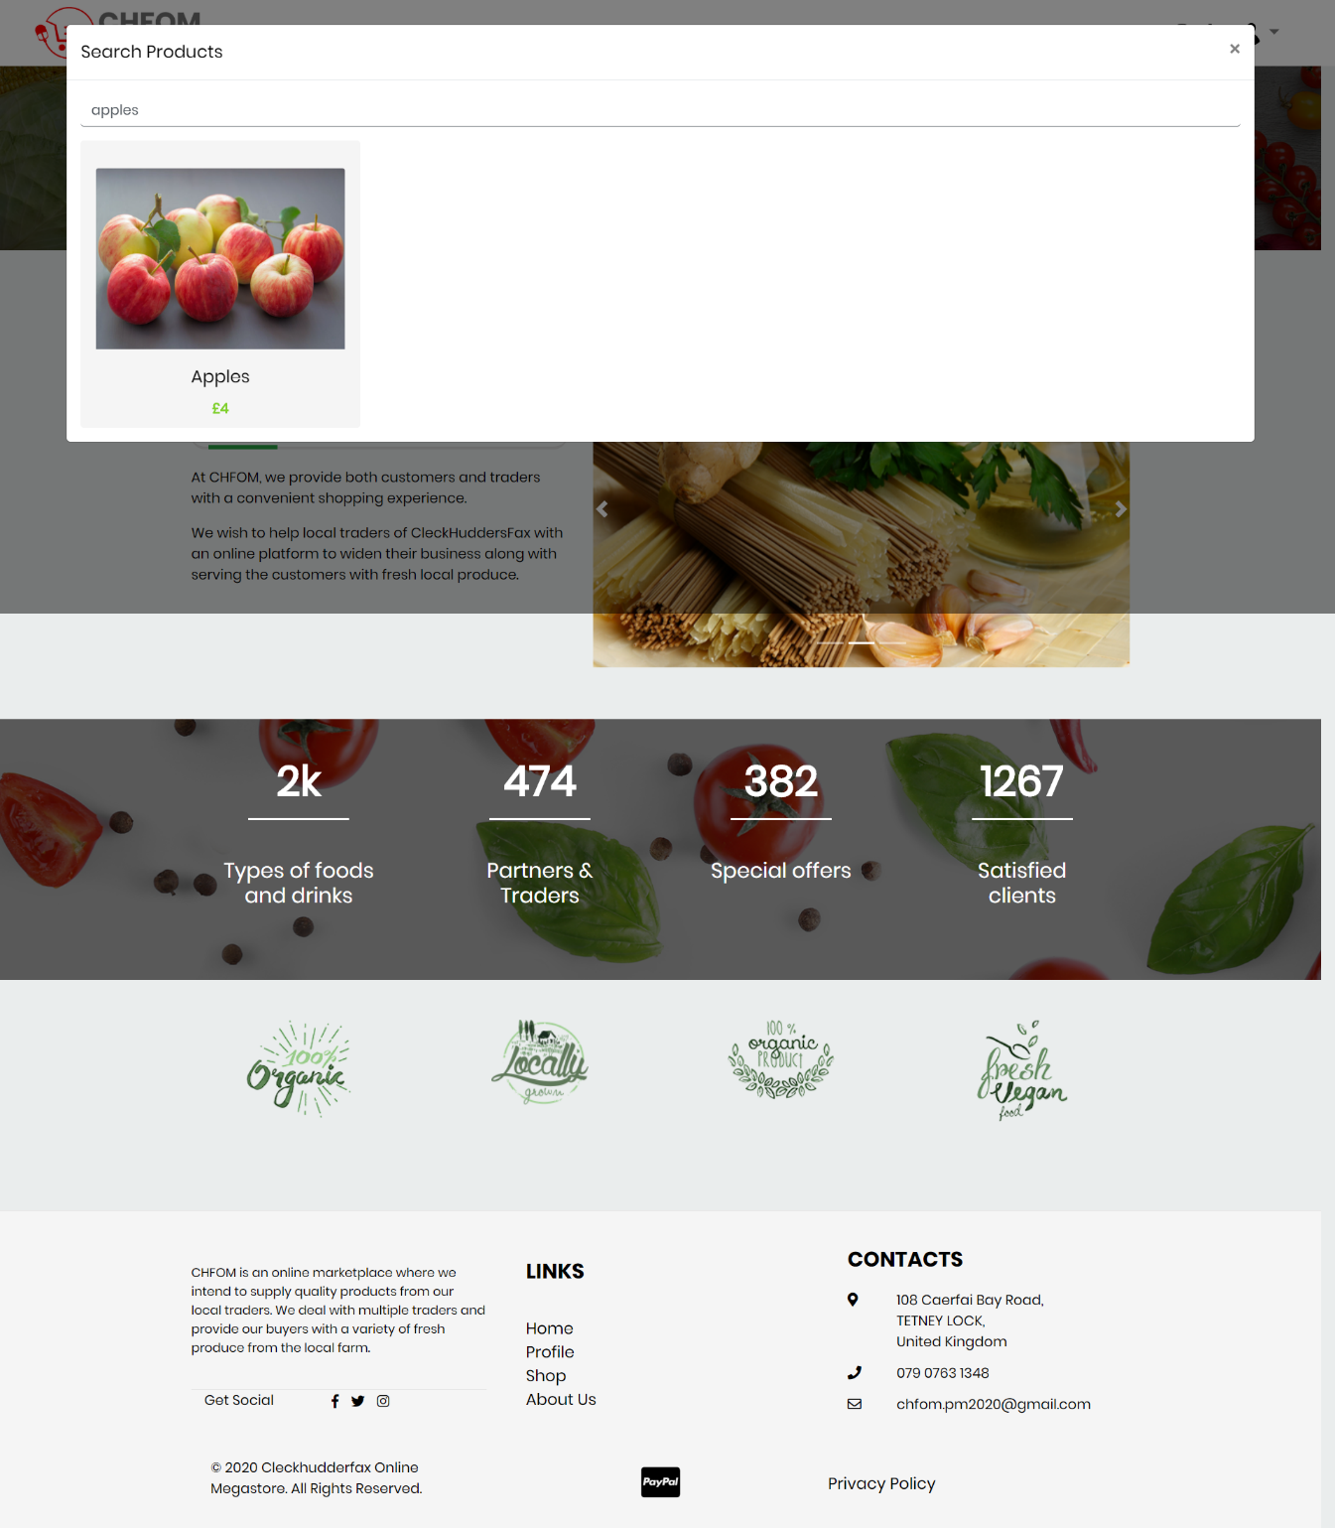

### Product Information

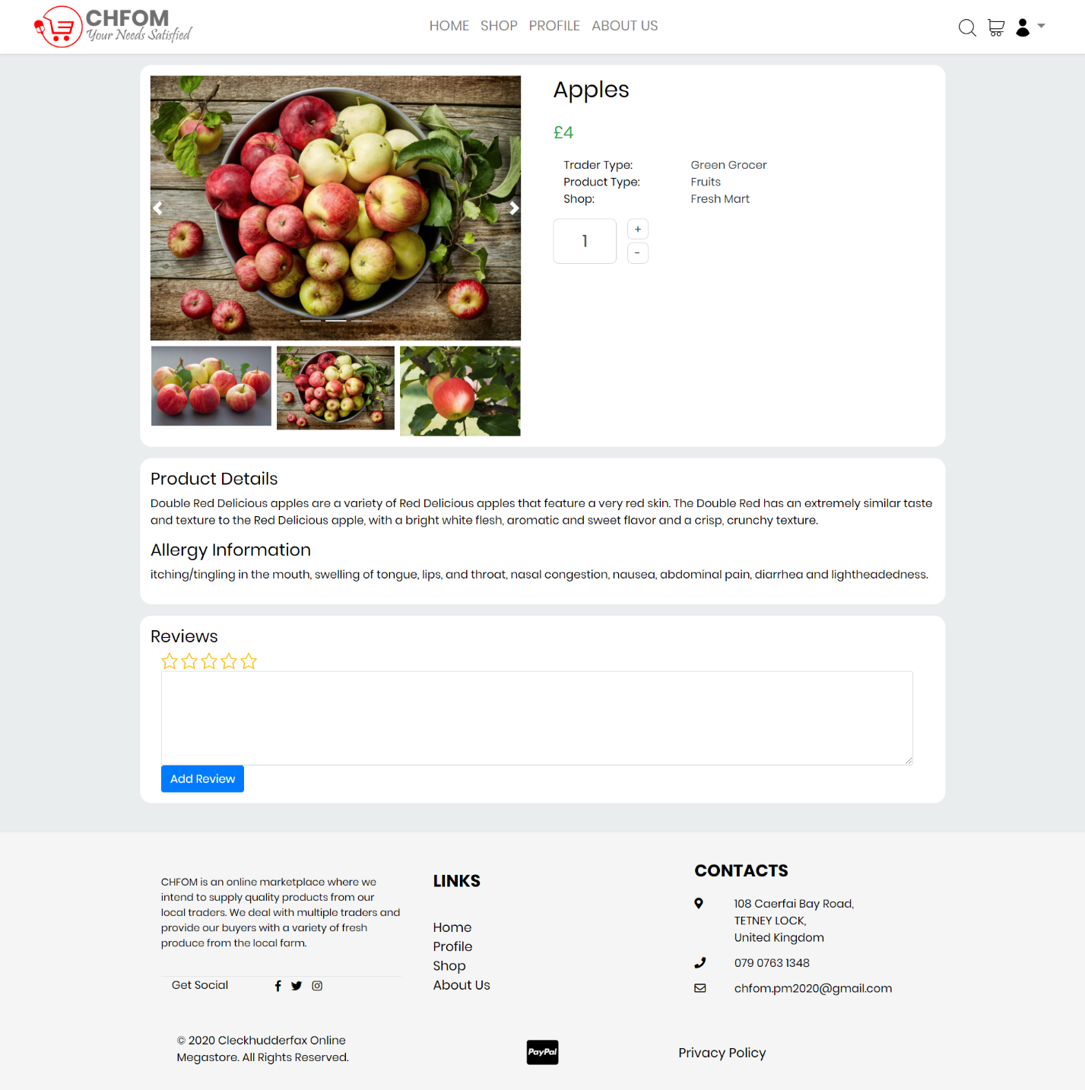

## Basket

### Basket Empty

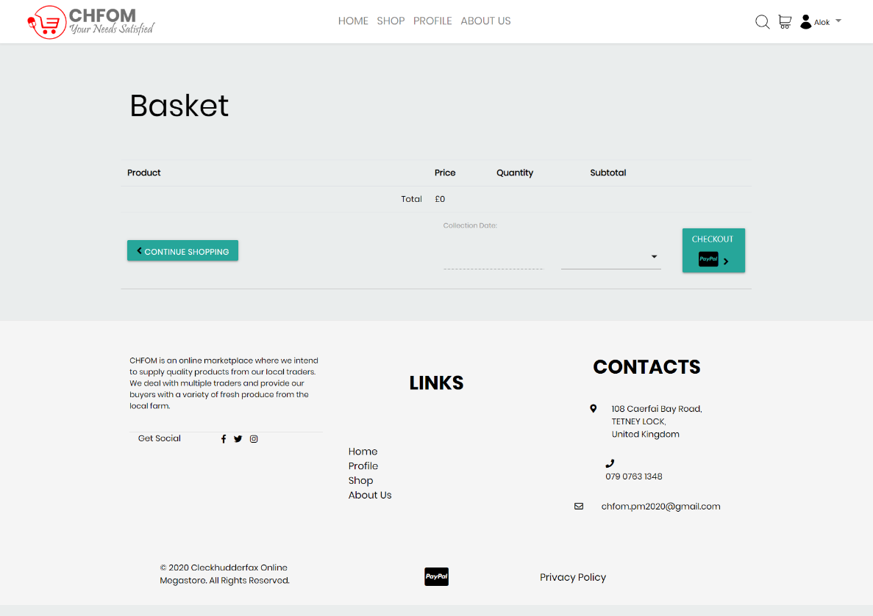

### Add to Basket

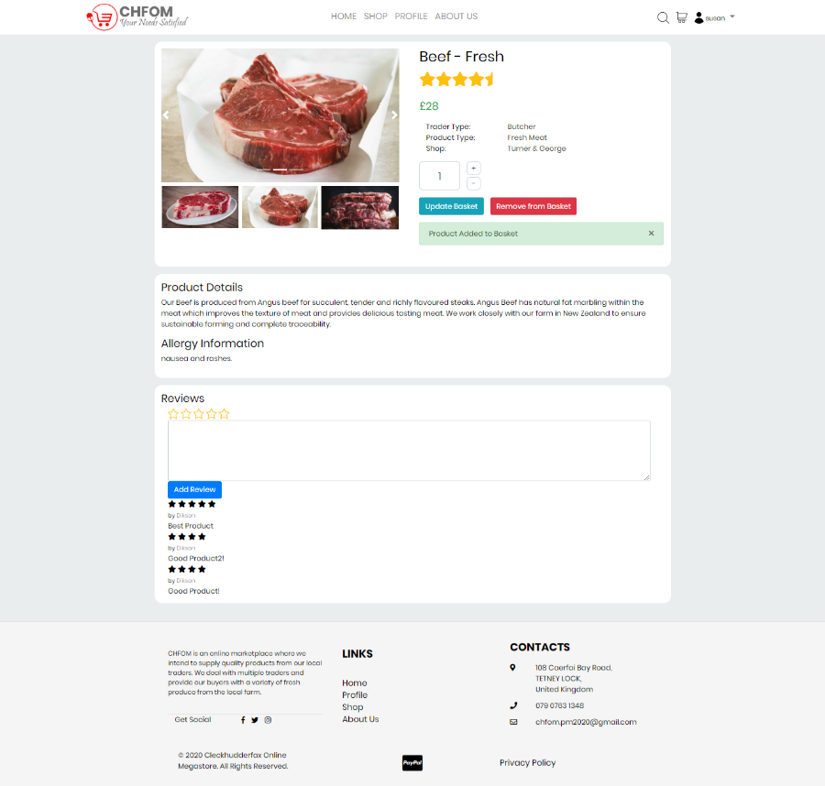

### Product Added

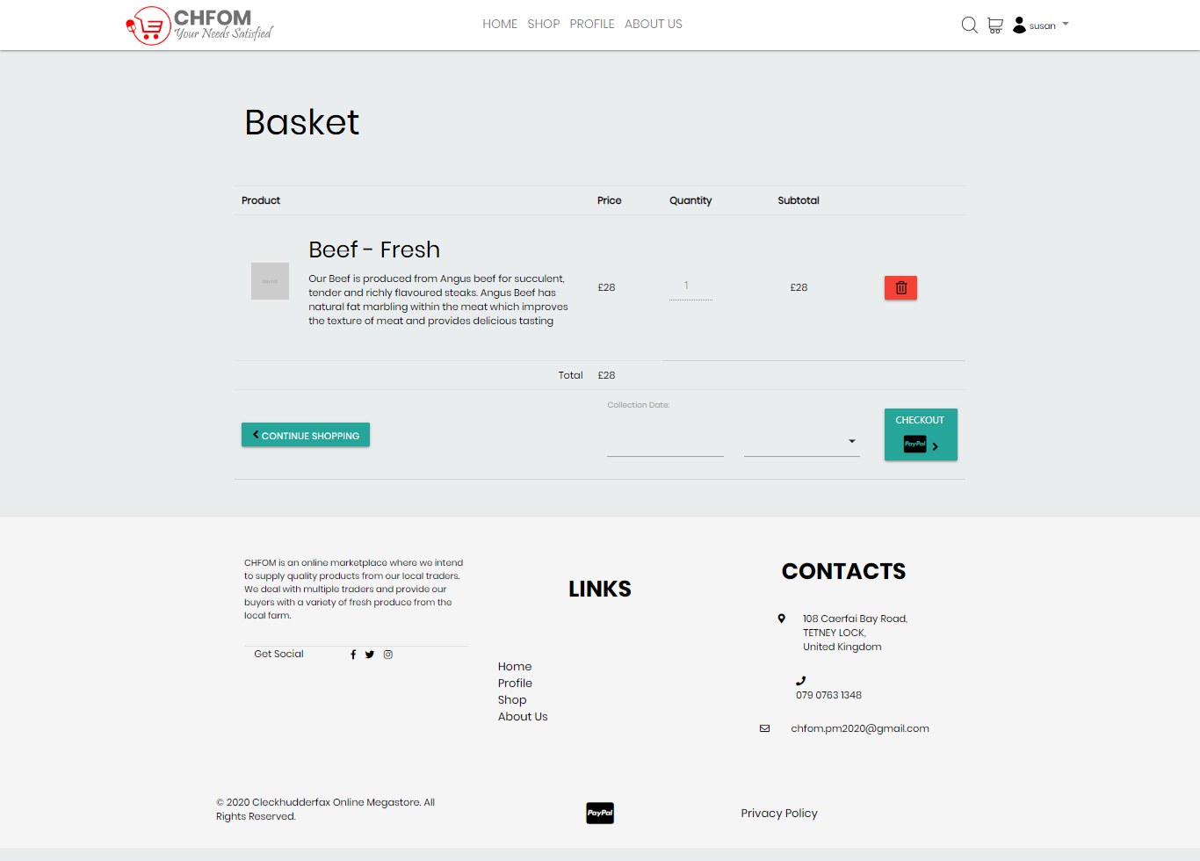

### Delivery Date

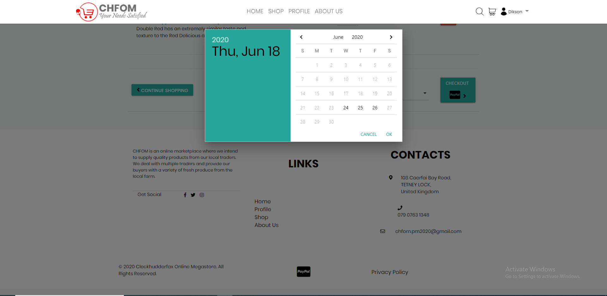

## Order

### Order Details

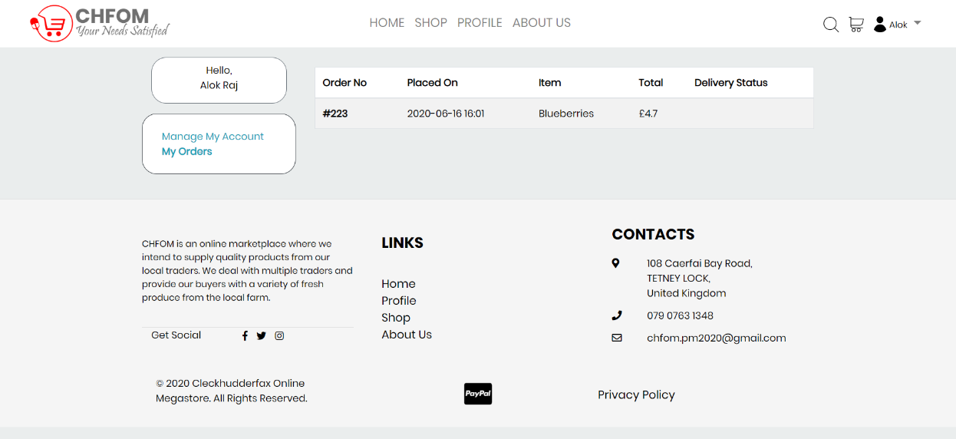

### Order Confirmation Receipt

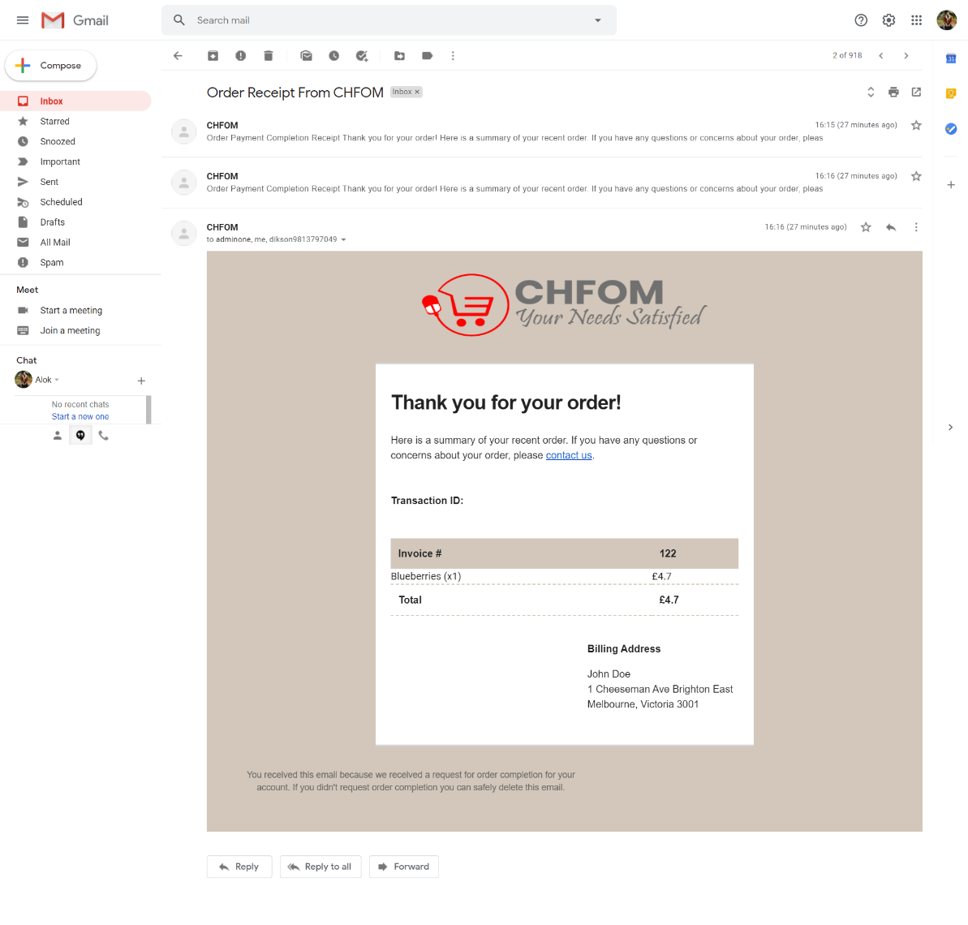

## PayPal Payment

### Payment Method

#### 

### Confirm Payments

#### 

### Payment Success

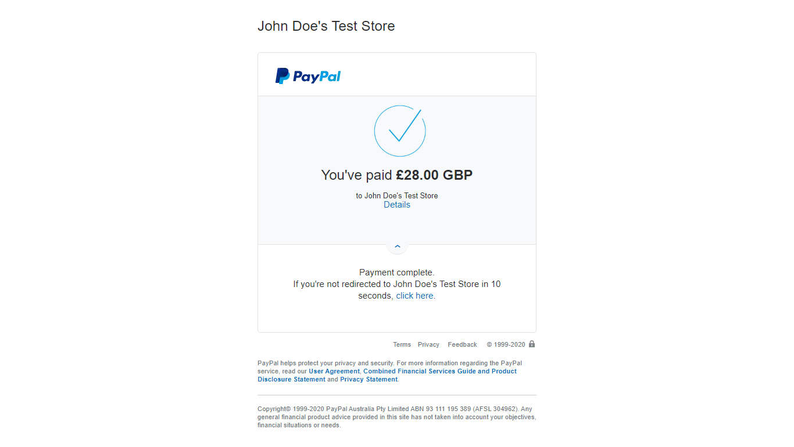

## Registration

### Registration Form

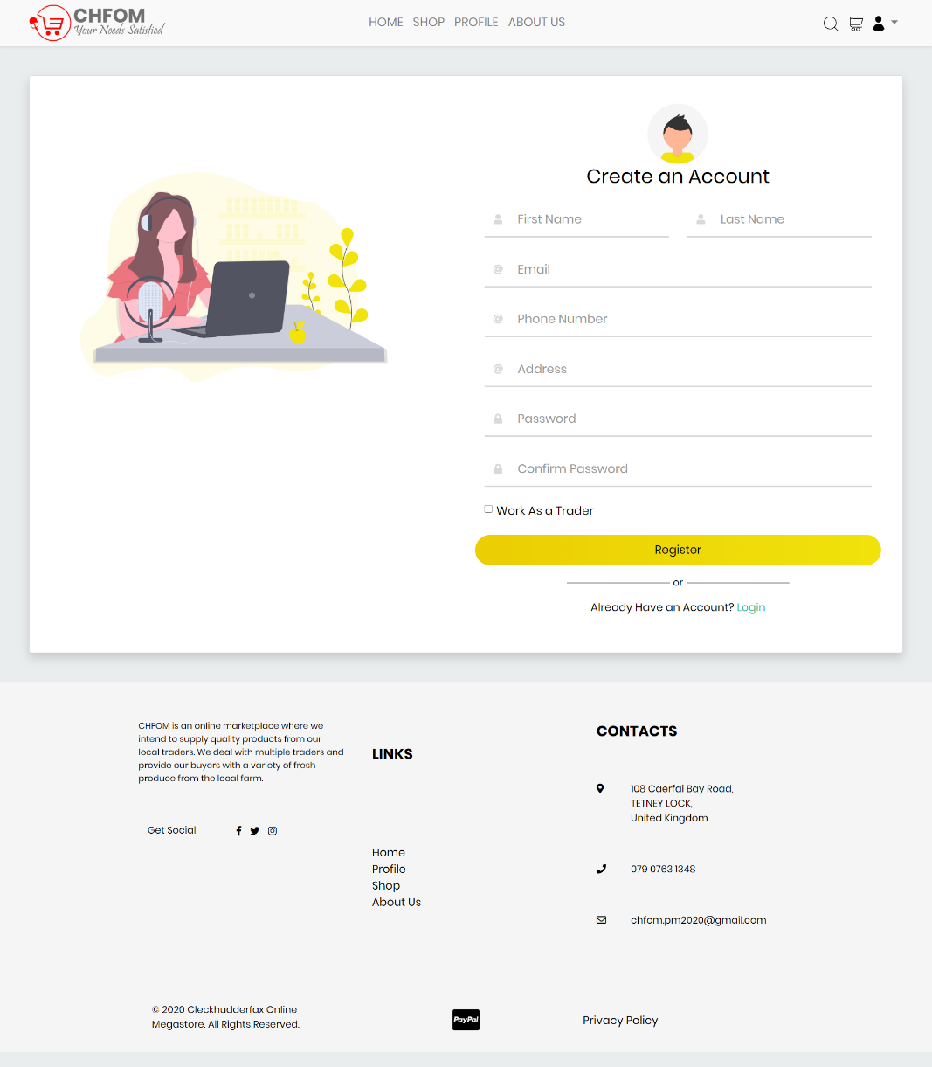

### Account Creation

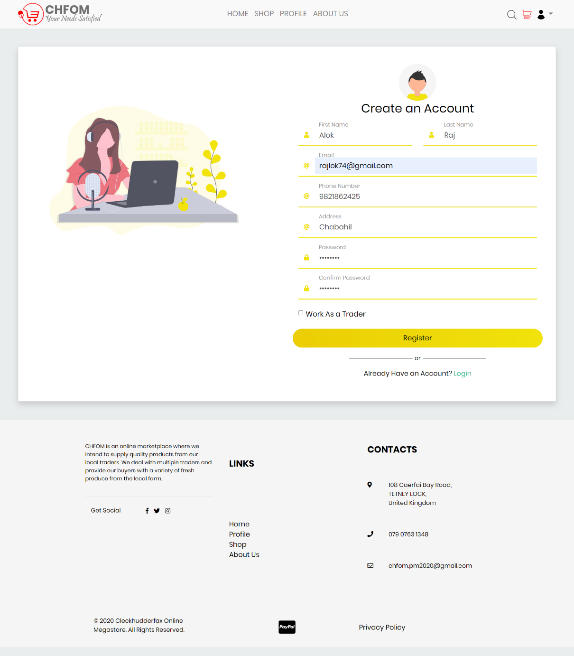

### Confirmation Email

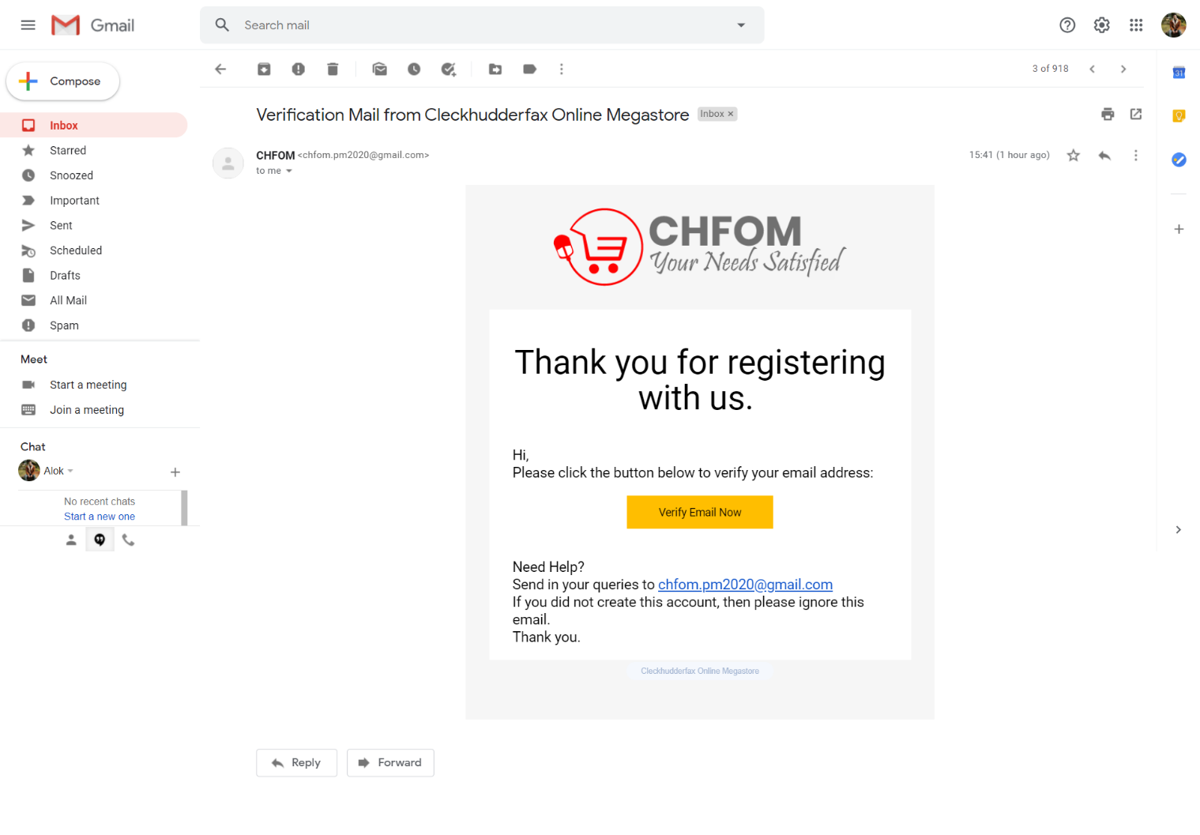

### Form Validation

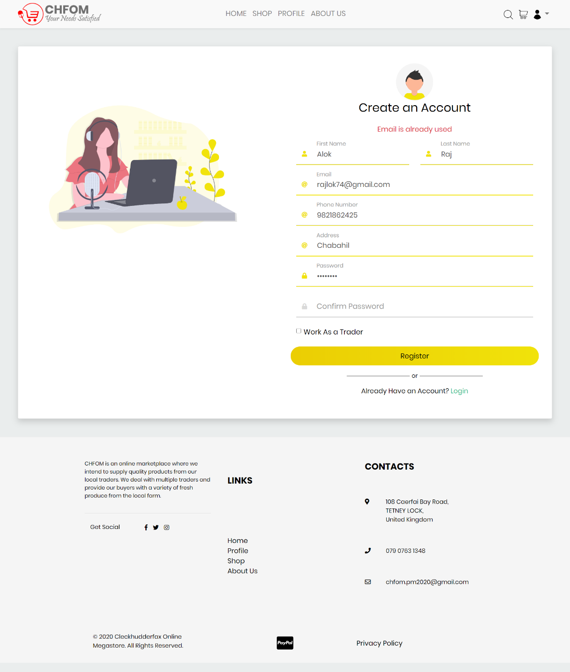

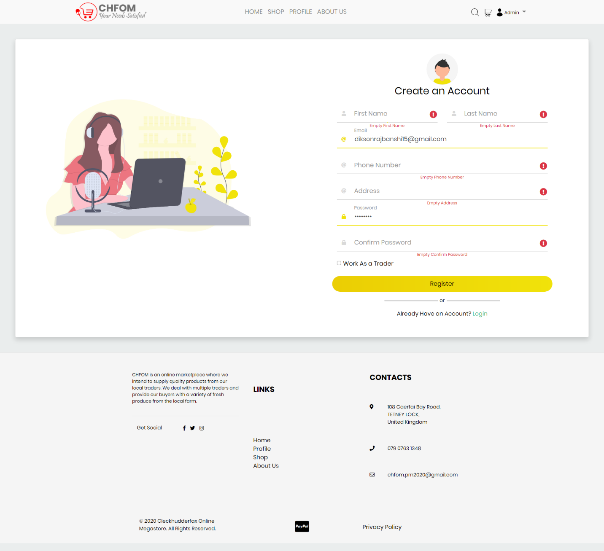

## Login

### Login Form

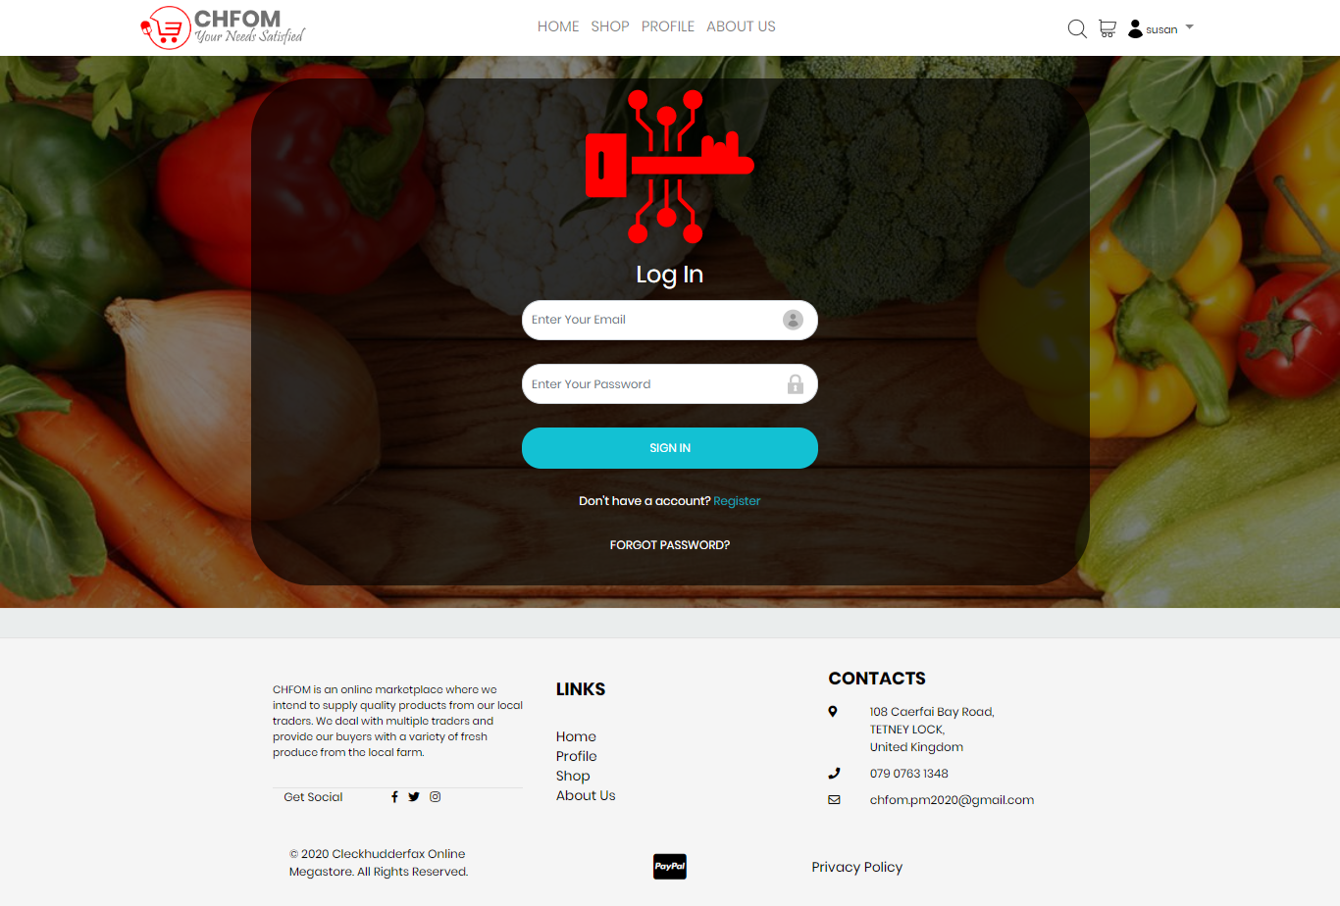

### Form Validation

##### Login to Continue

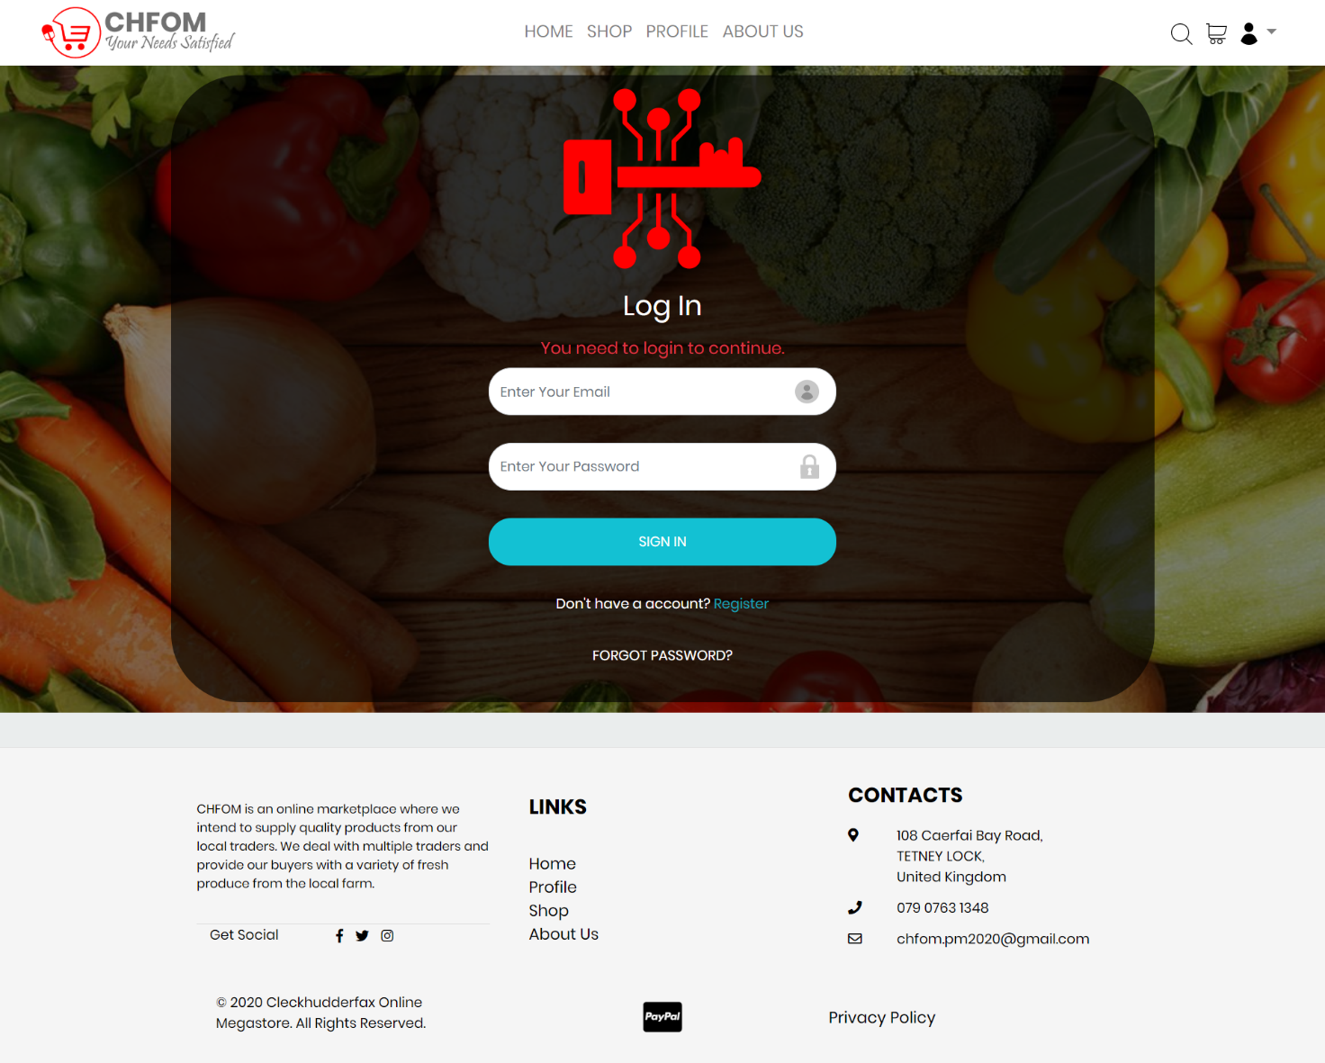

##### Incorrect Password

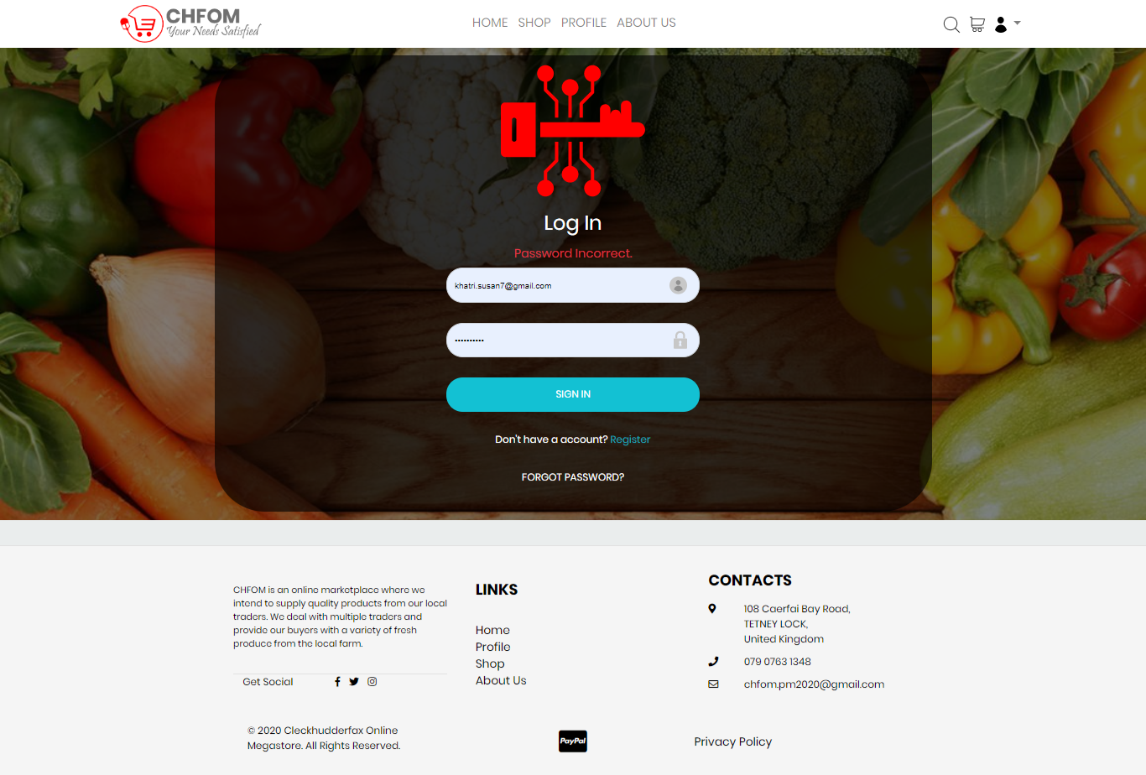

##### Empty Field

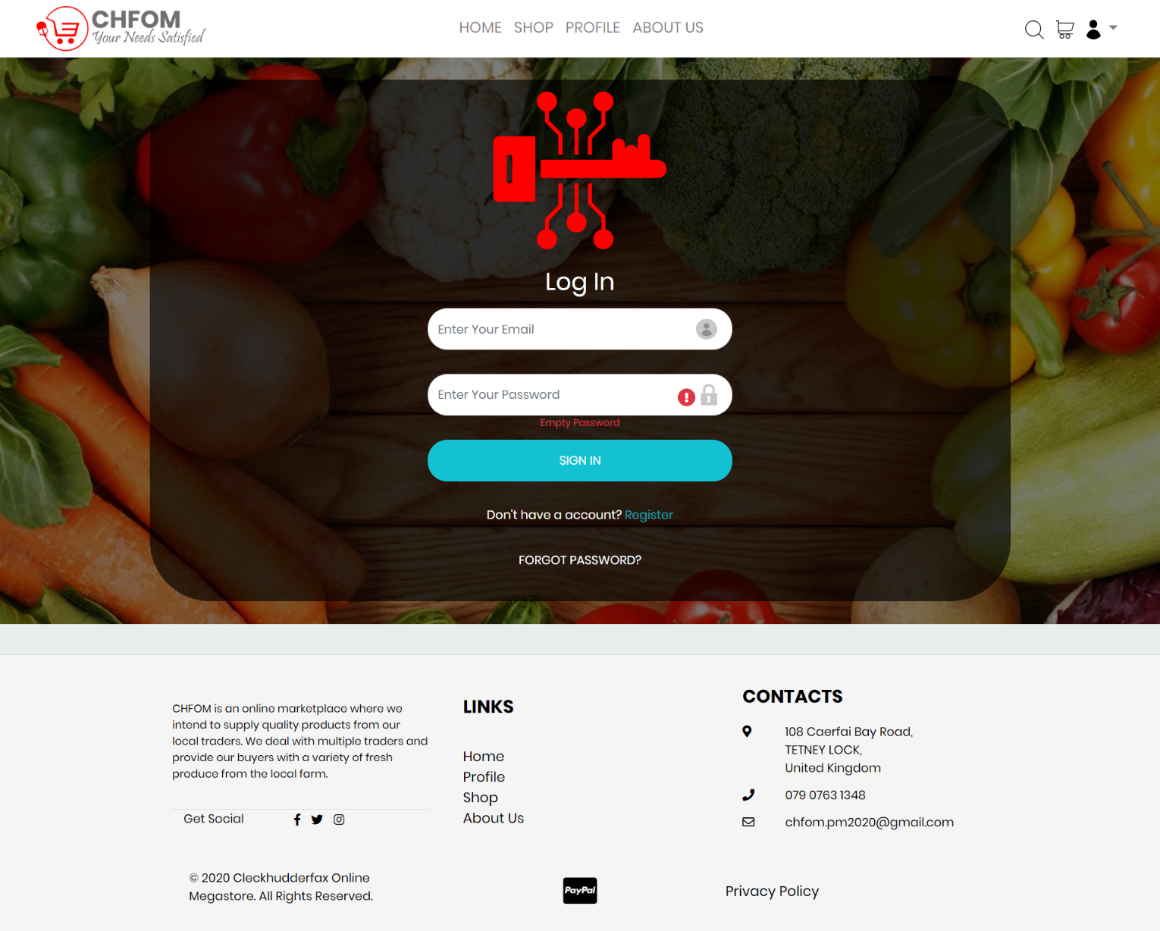

##### Redirecting for Traders and Admin

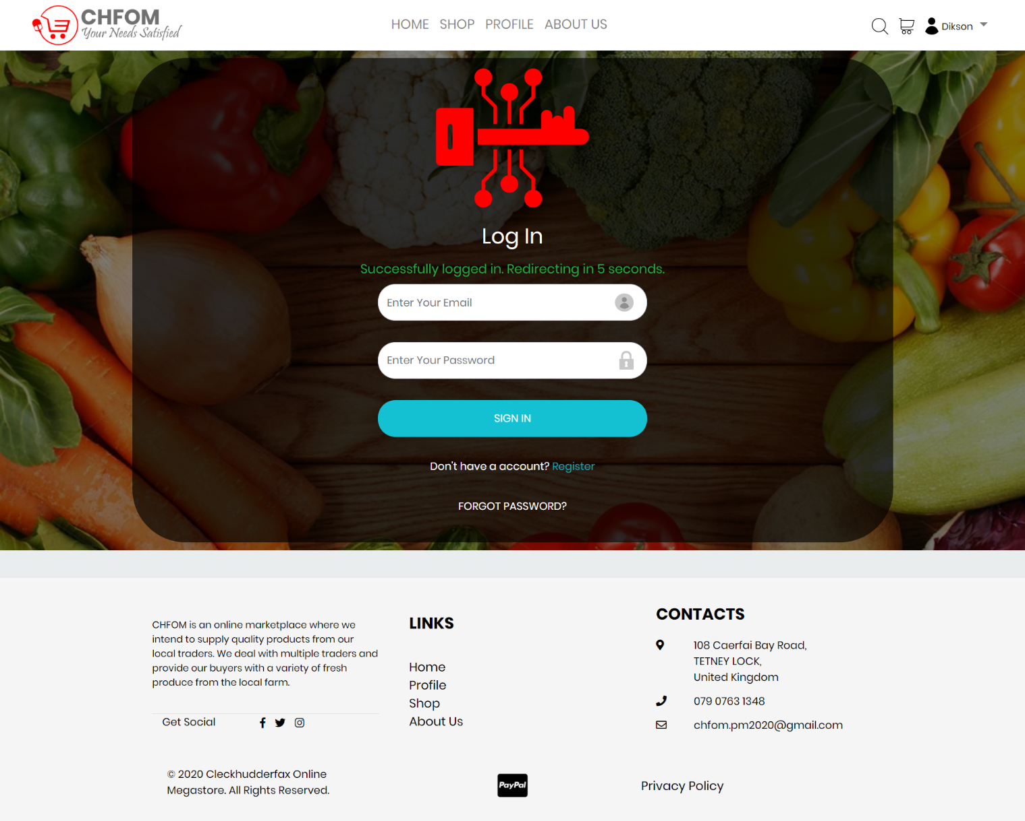

##### Invalid Email

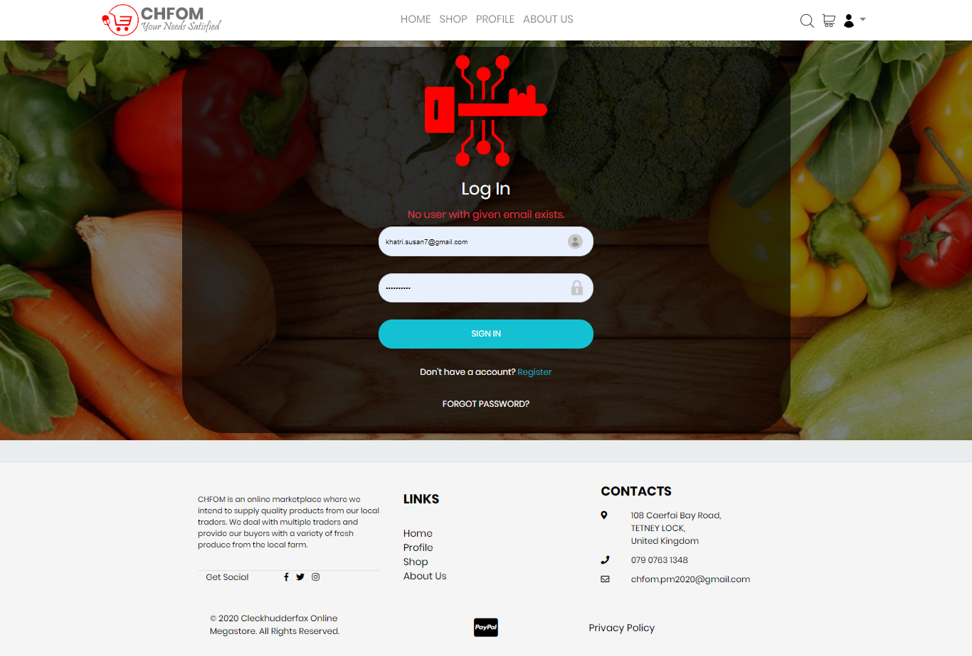

### Login Success

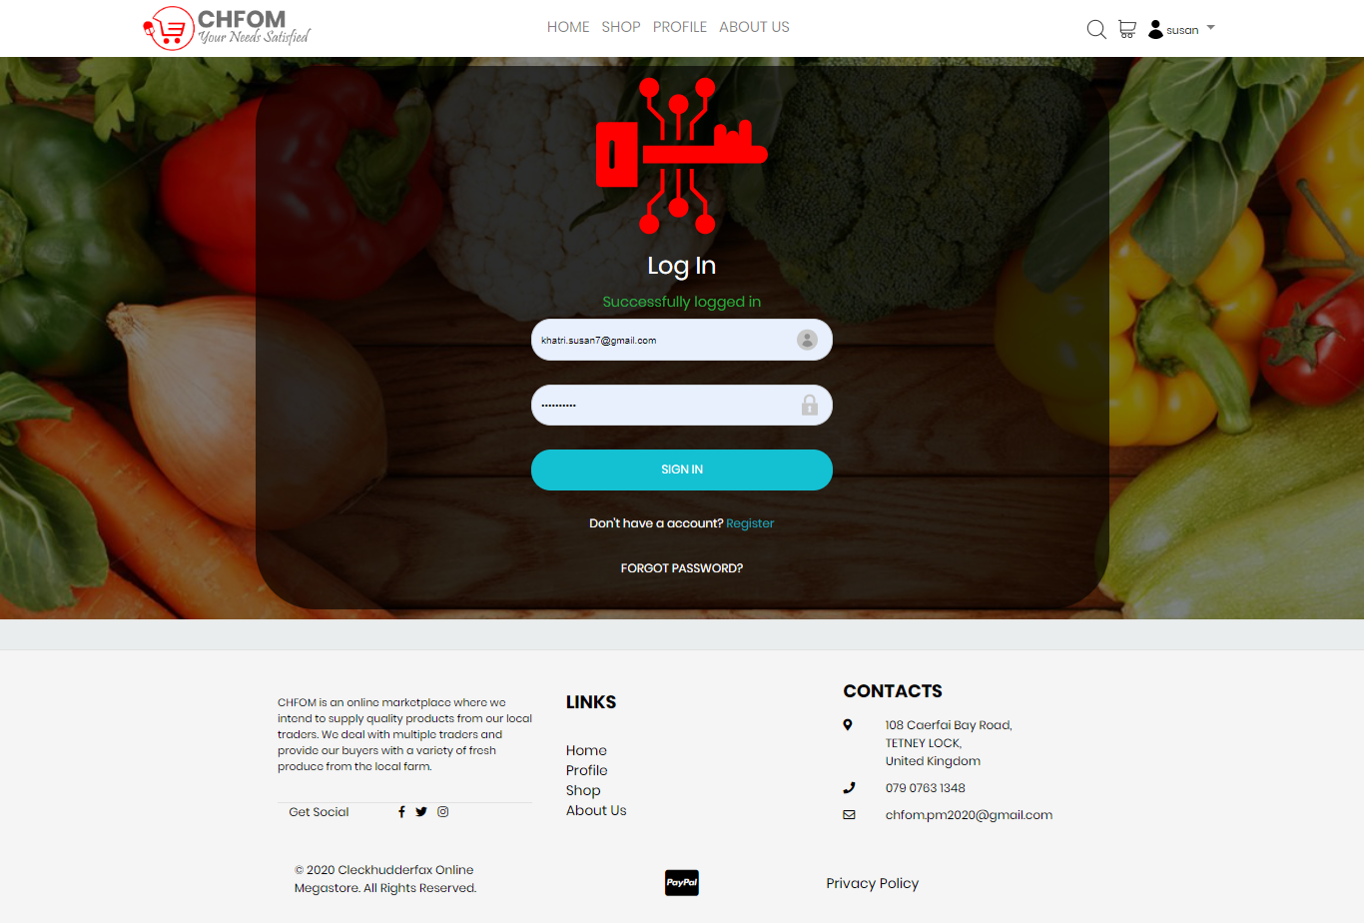

### Forgot Password

##### Password Reset

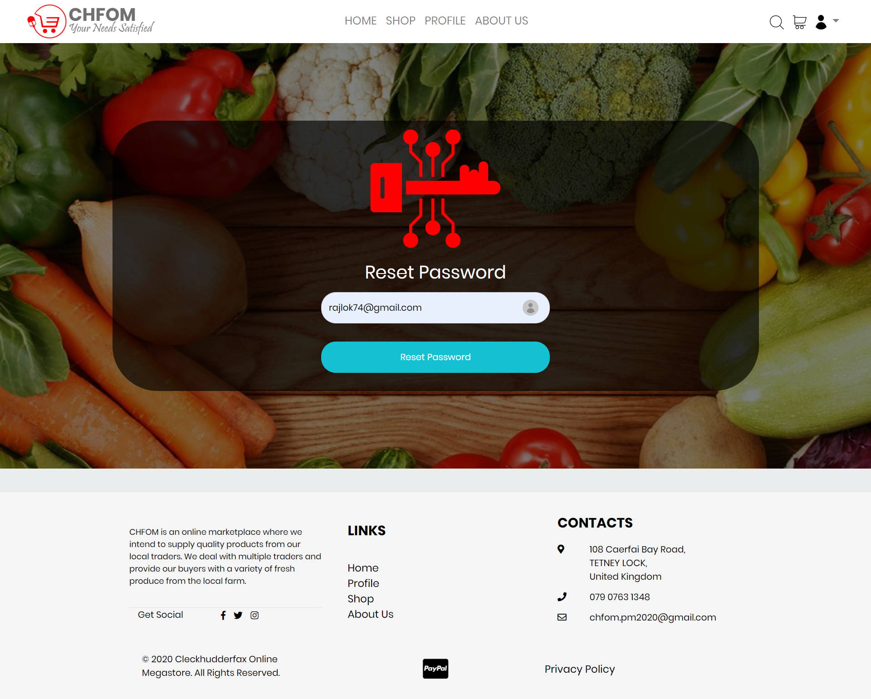

##### Password Reset Confirmation Email

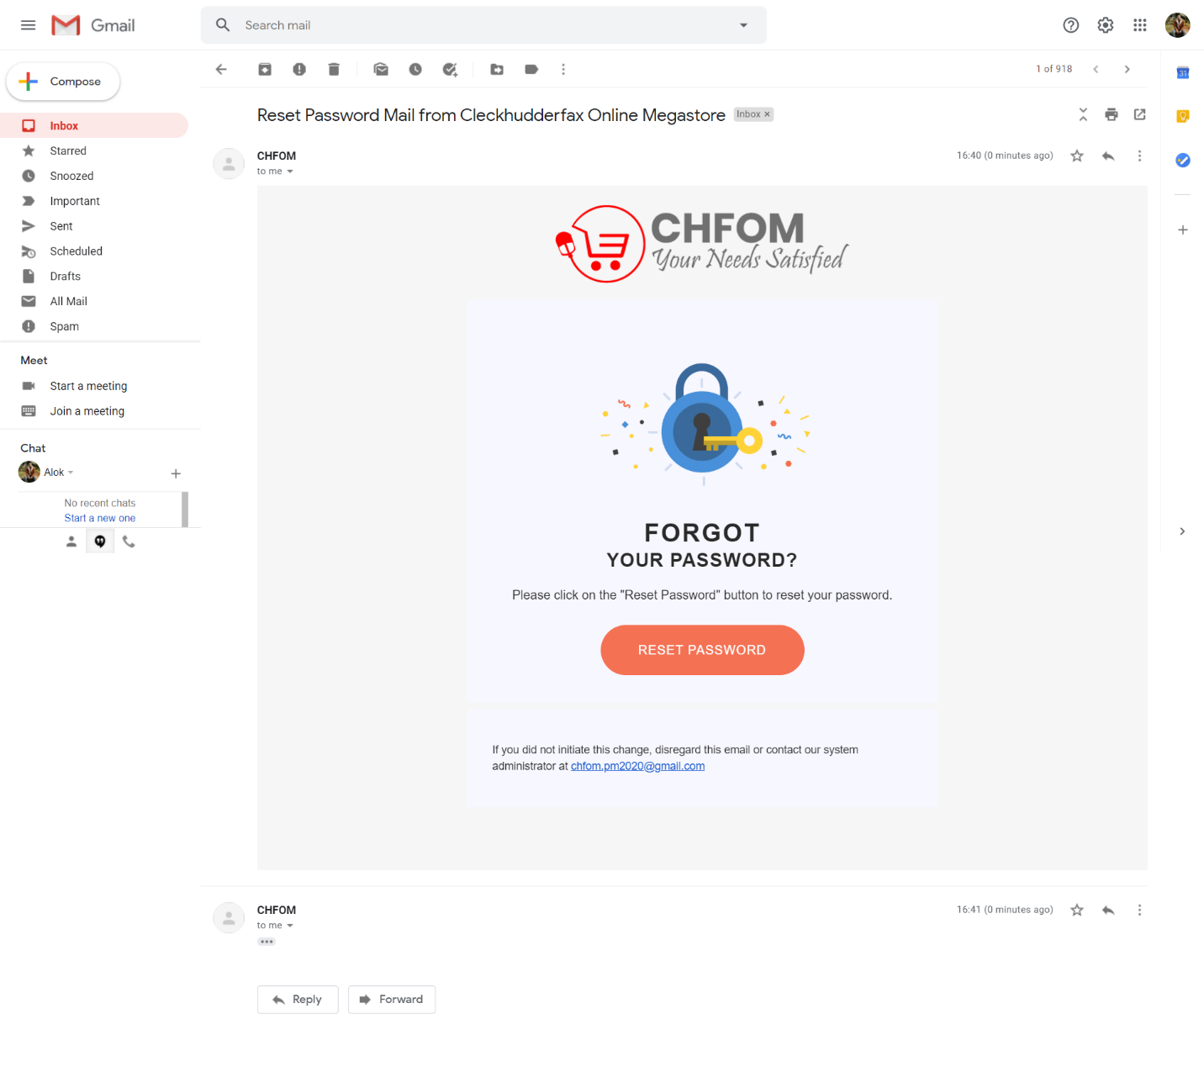

## Account Management

### Profile

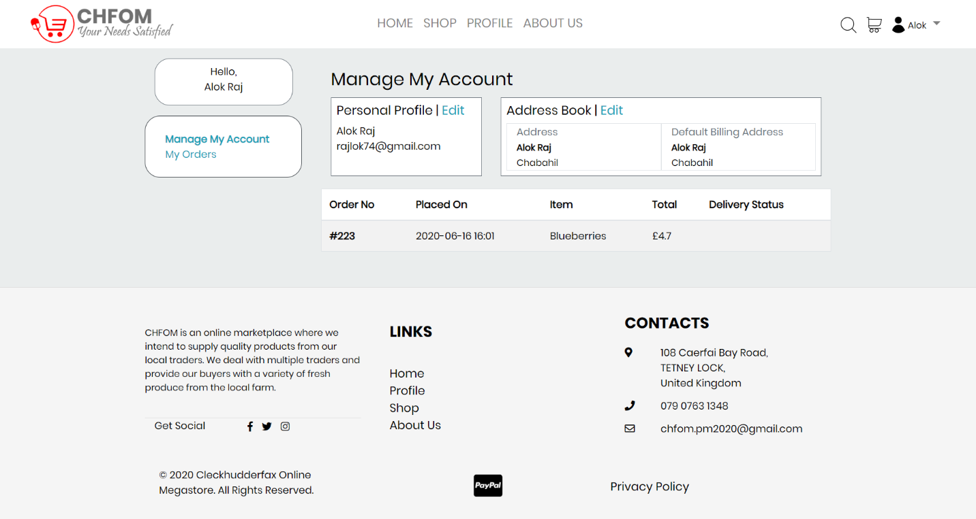

### Edit/Update Profile

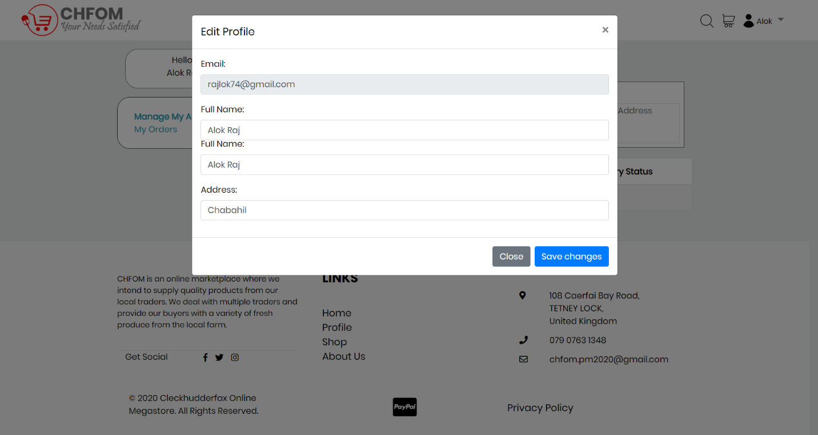

### Profile Update Success

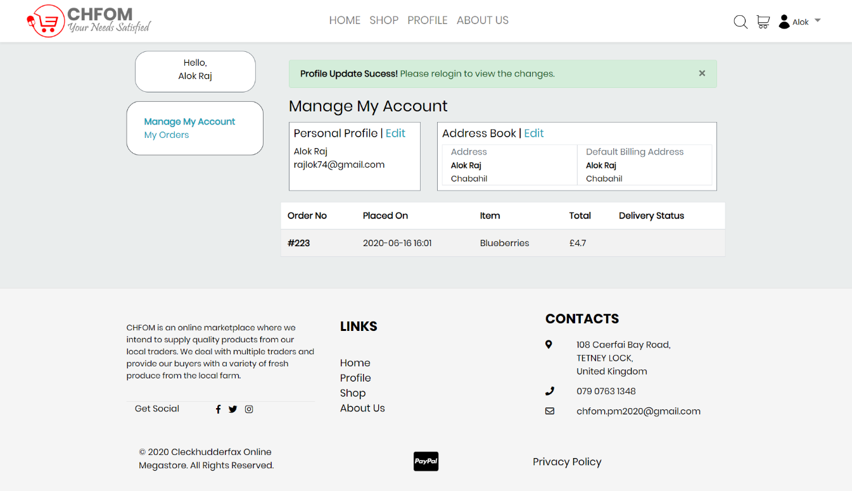

### Profile Update Notification Email

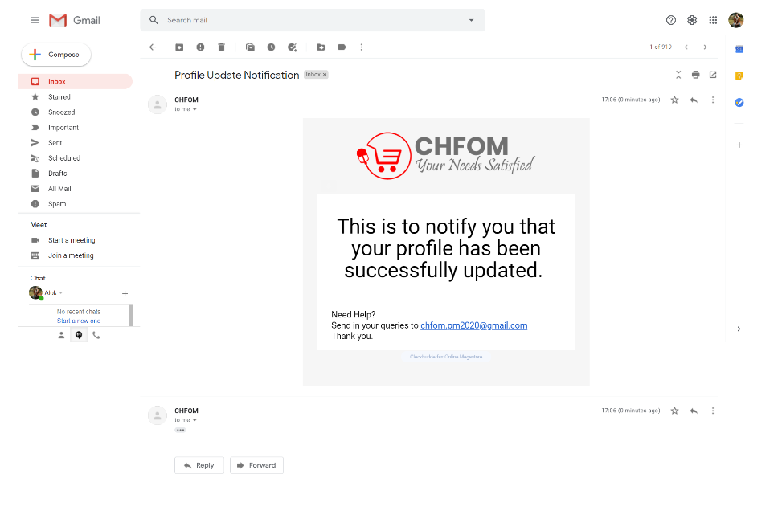

## Admin (PHP)

### Trader Details

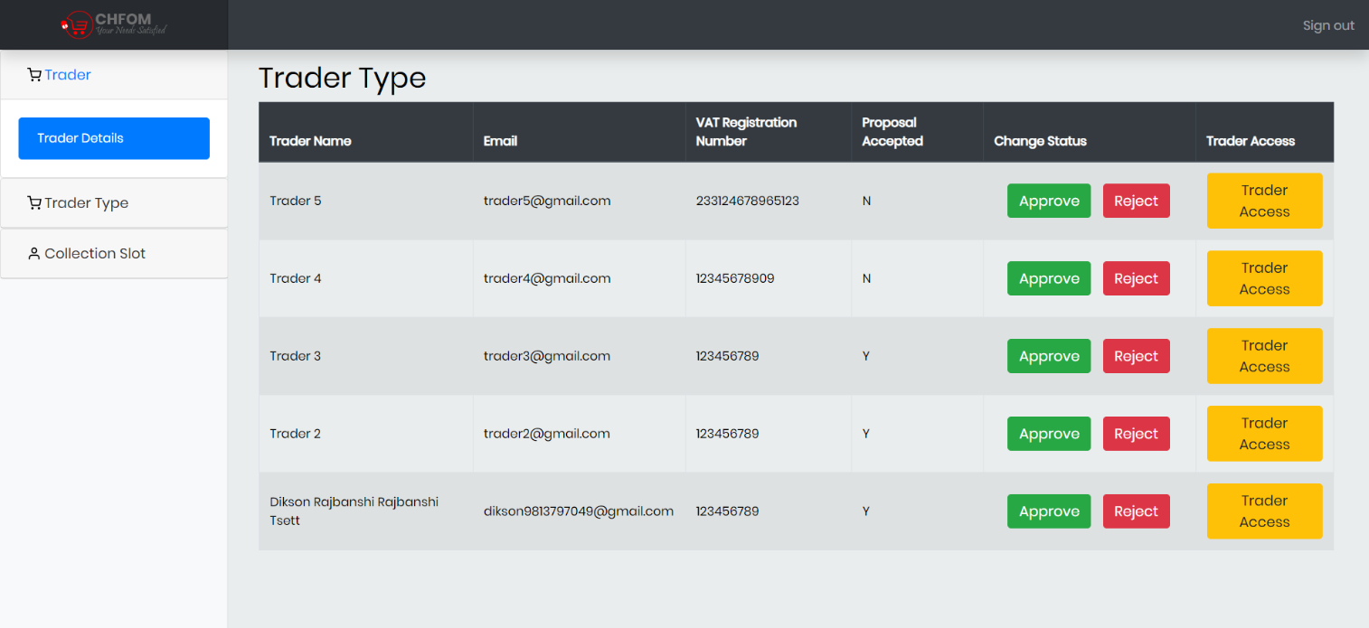

### Trader Status Update

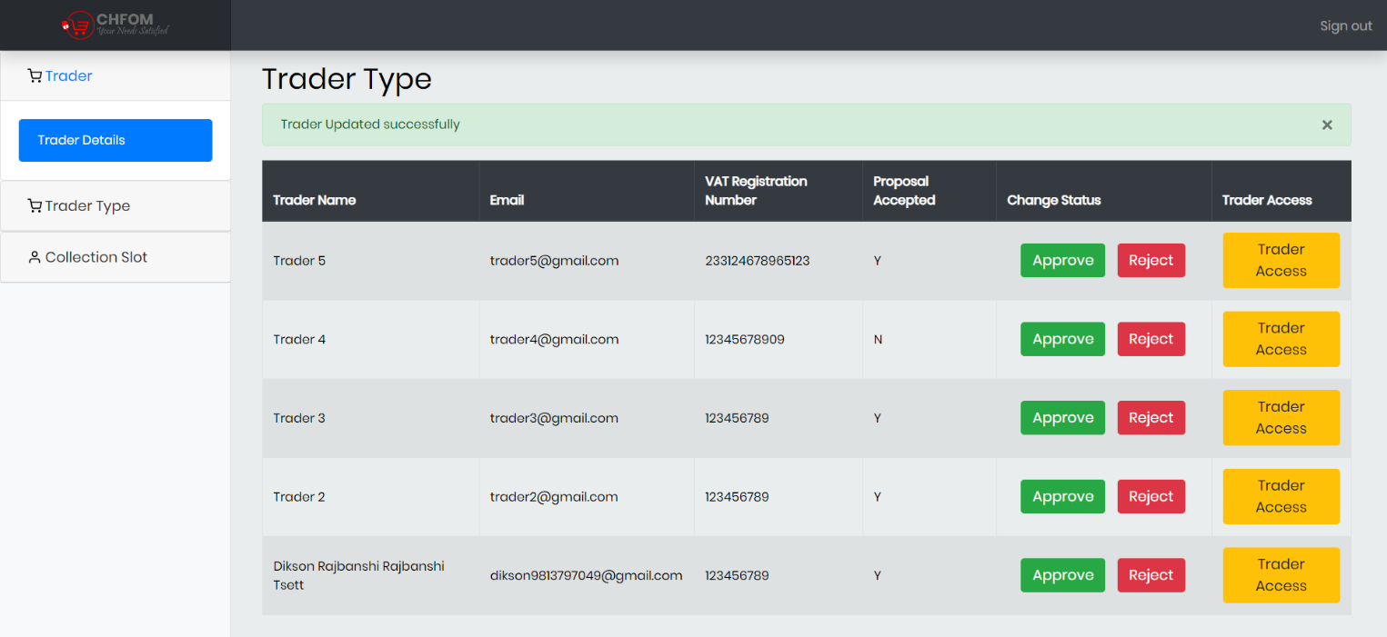

### Trader Type Details

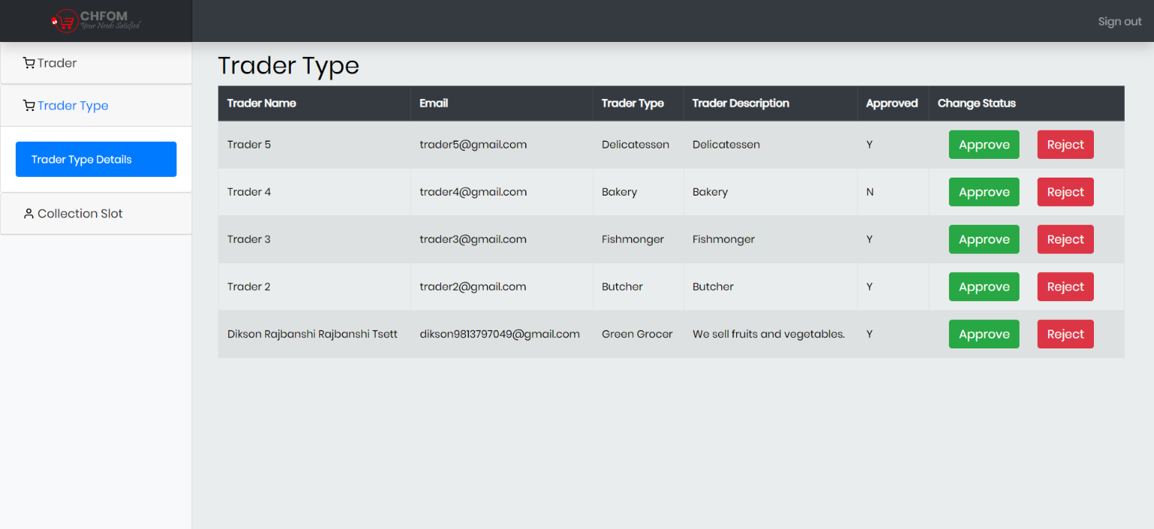

### Trader Type Status Update

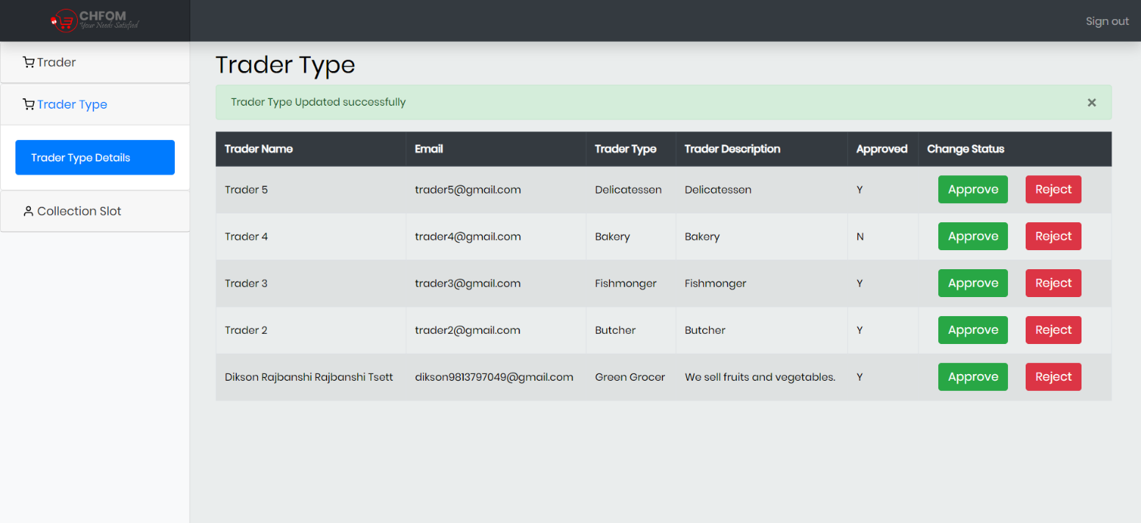

### Collection Slot Details

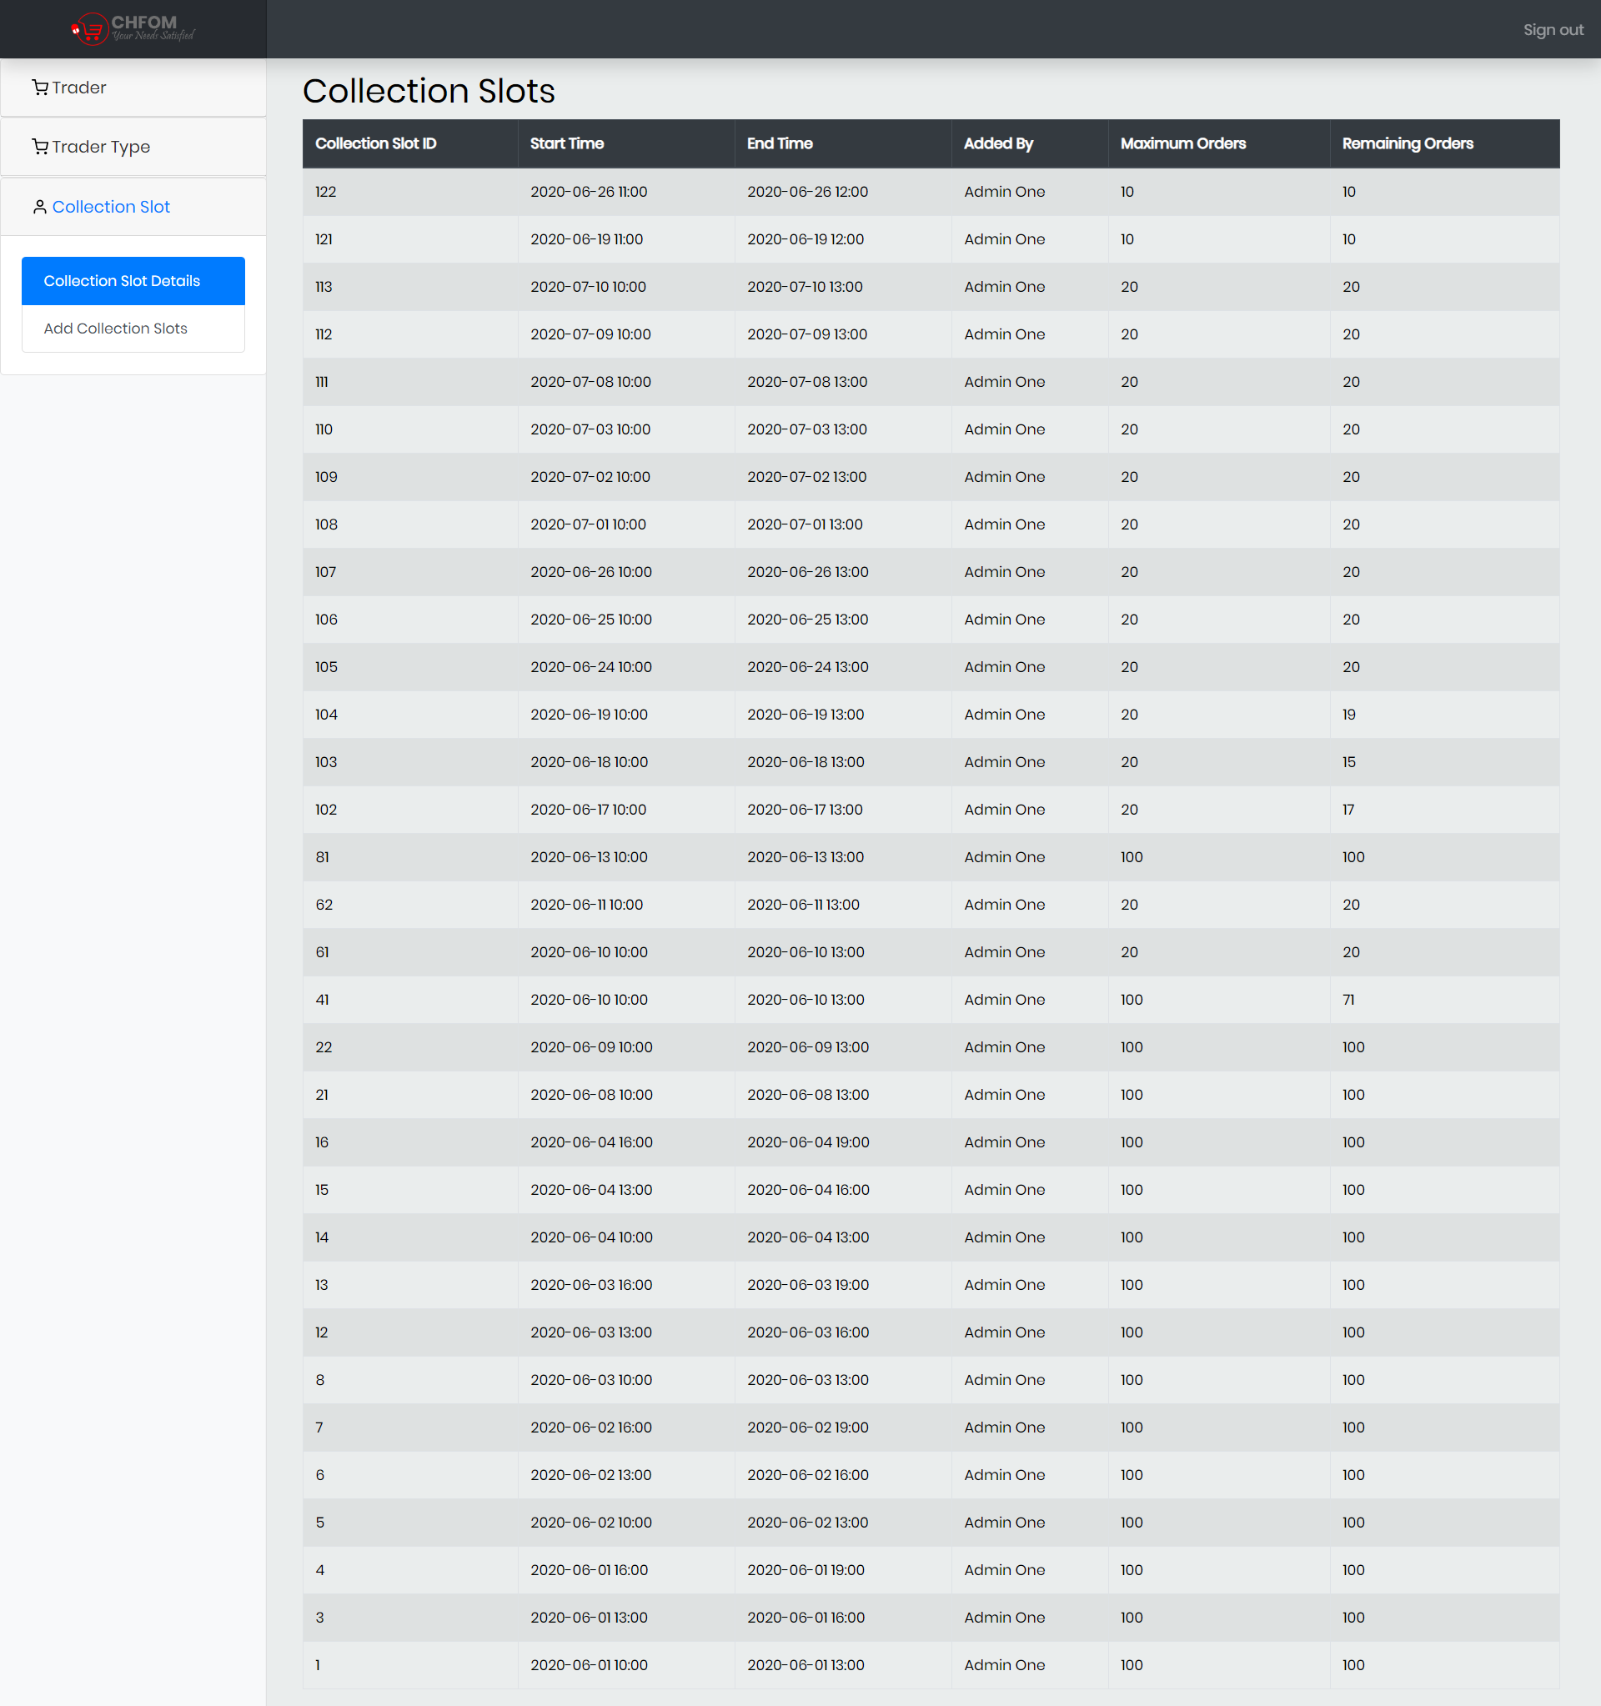

### Collection Slot

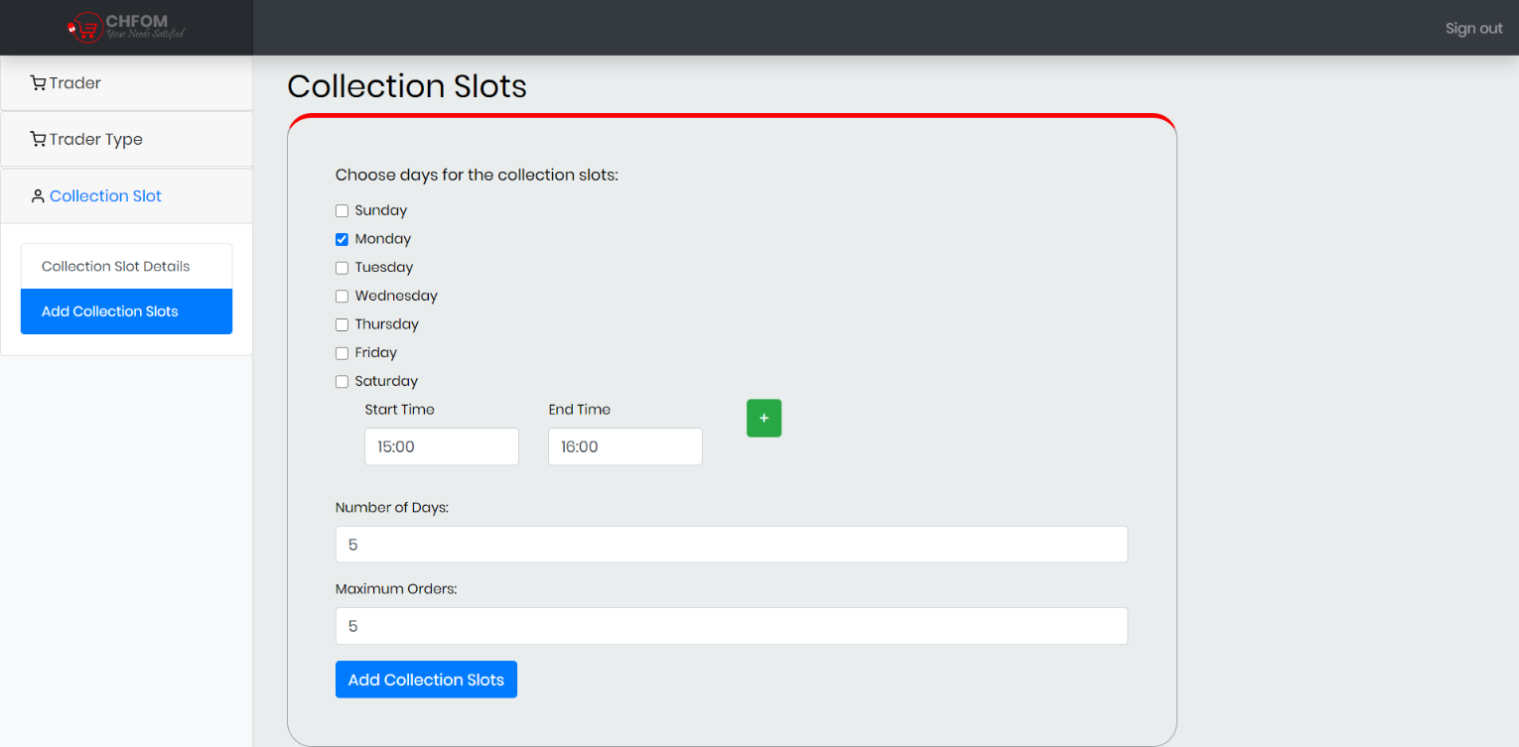

### Collection Slot Added

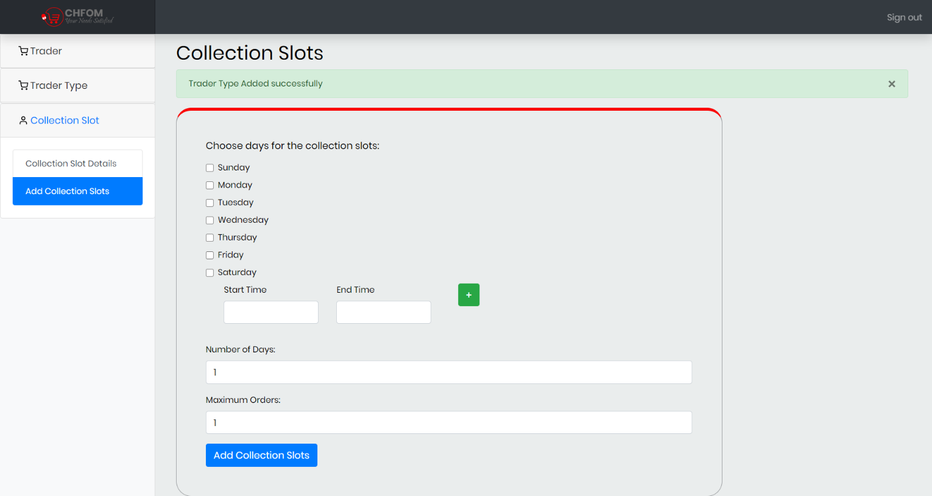

## Trader (PHP)

### Add Product

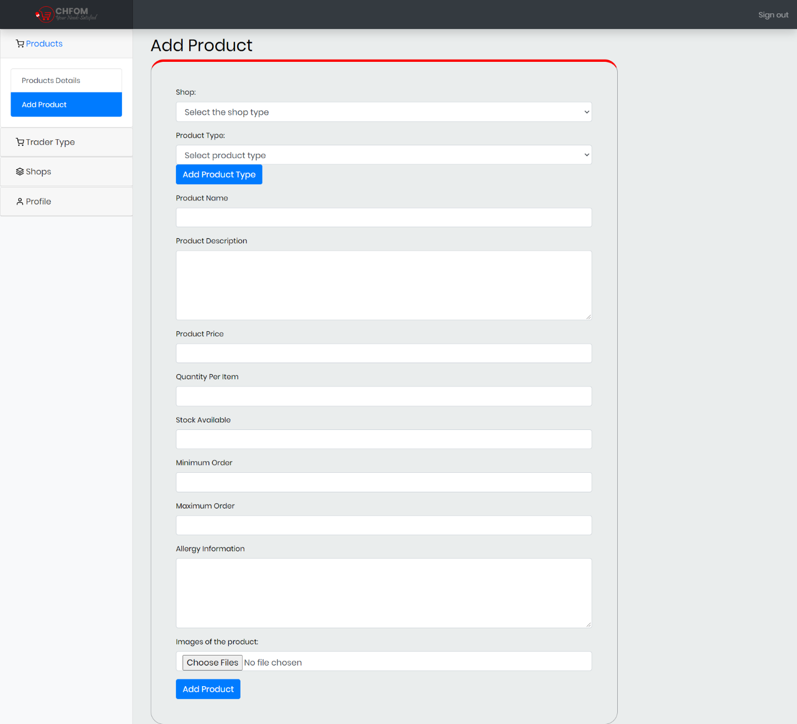

### Product Added

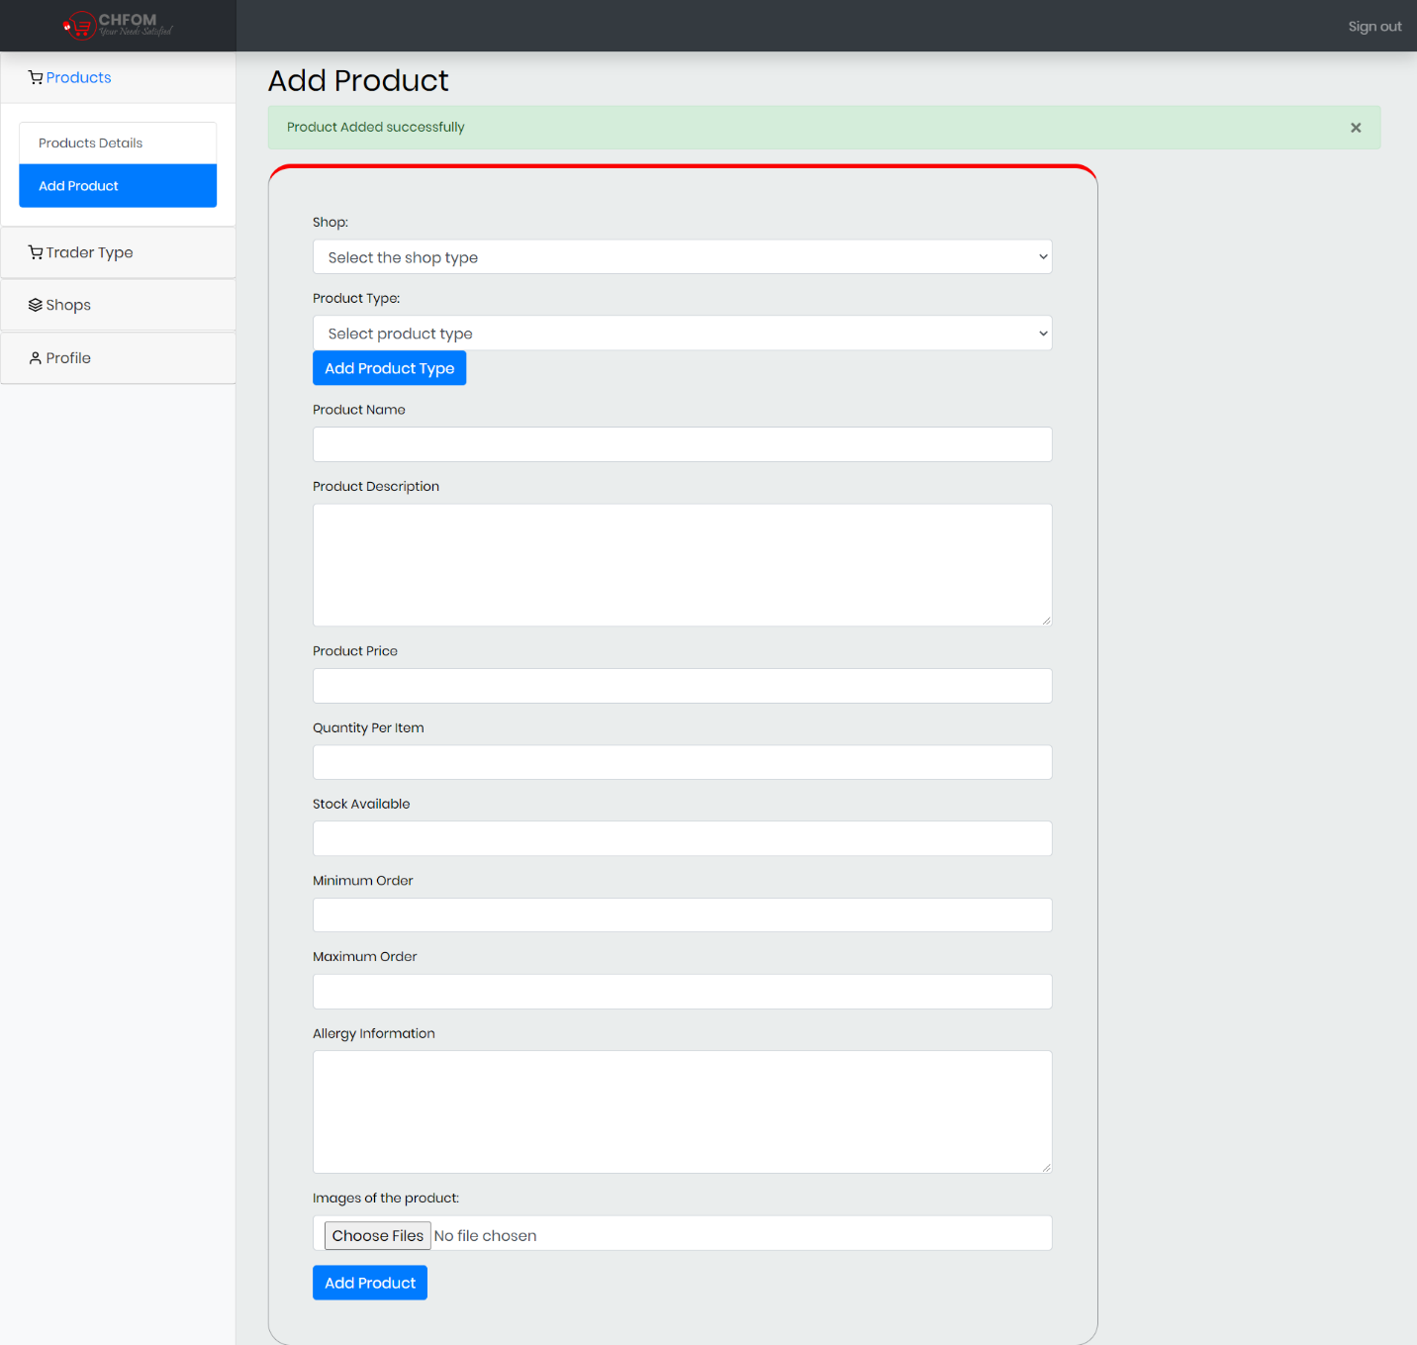

### Product Details

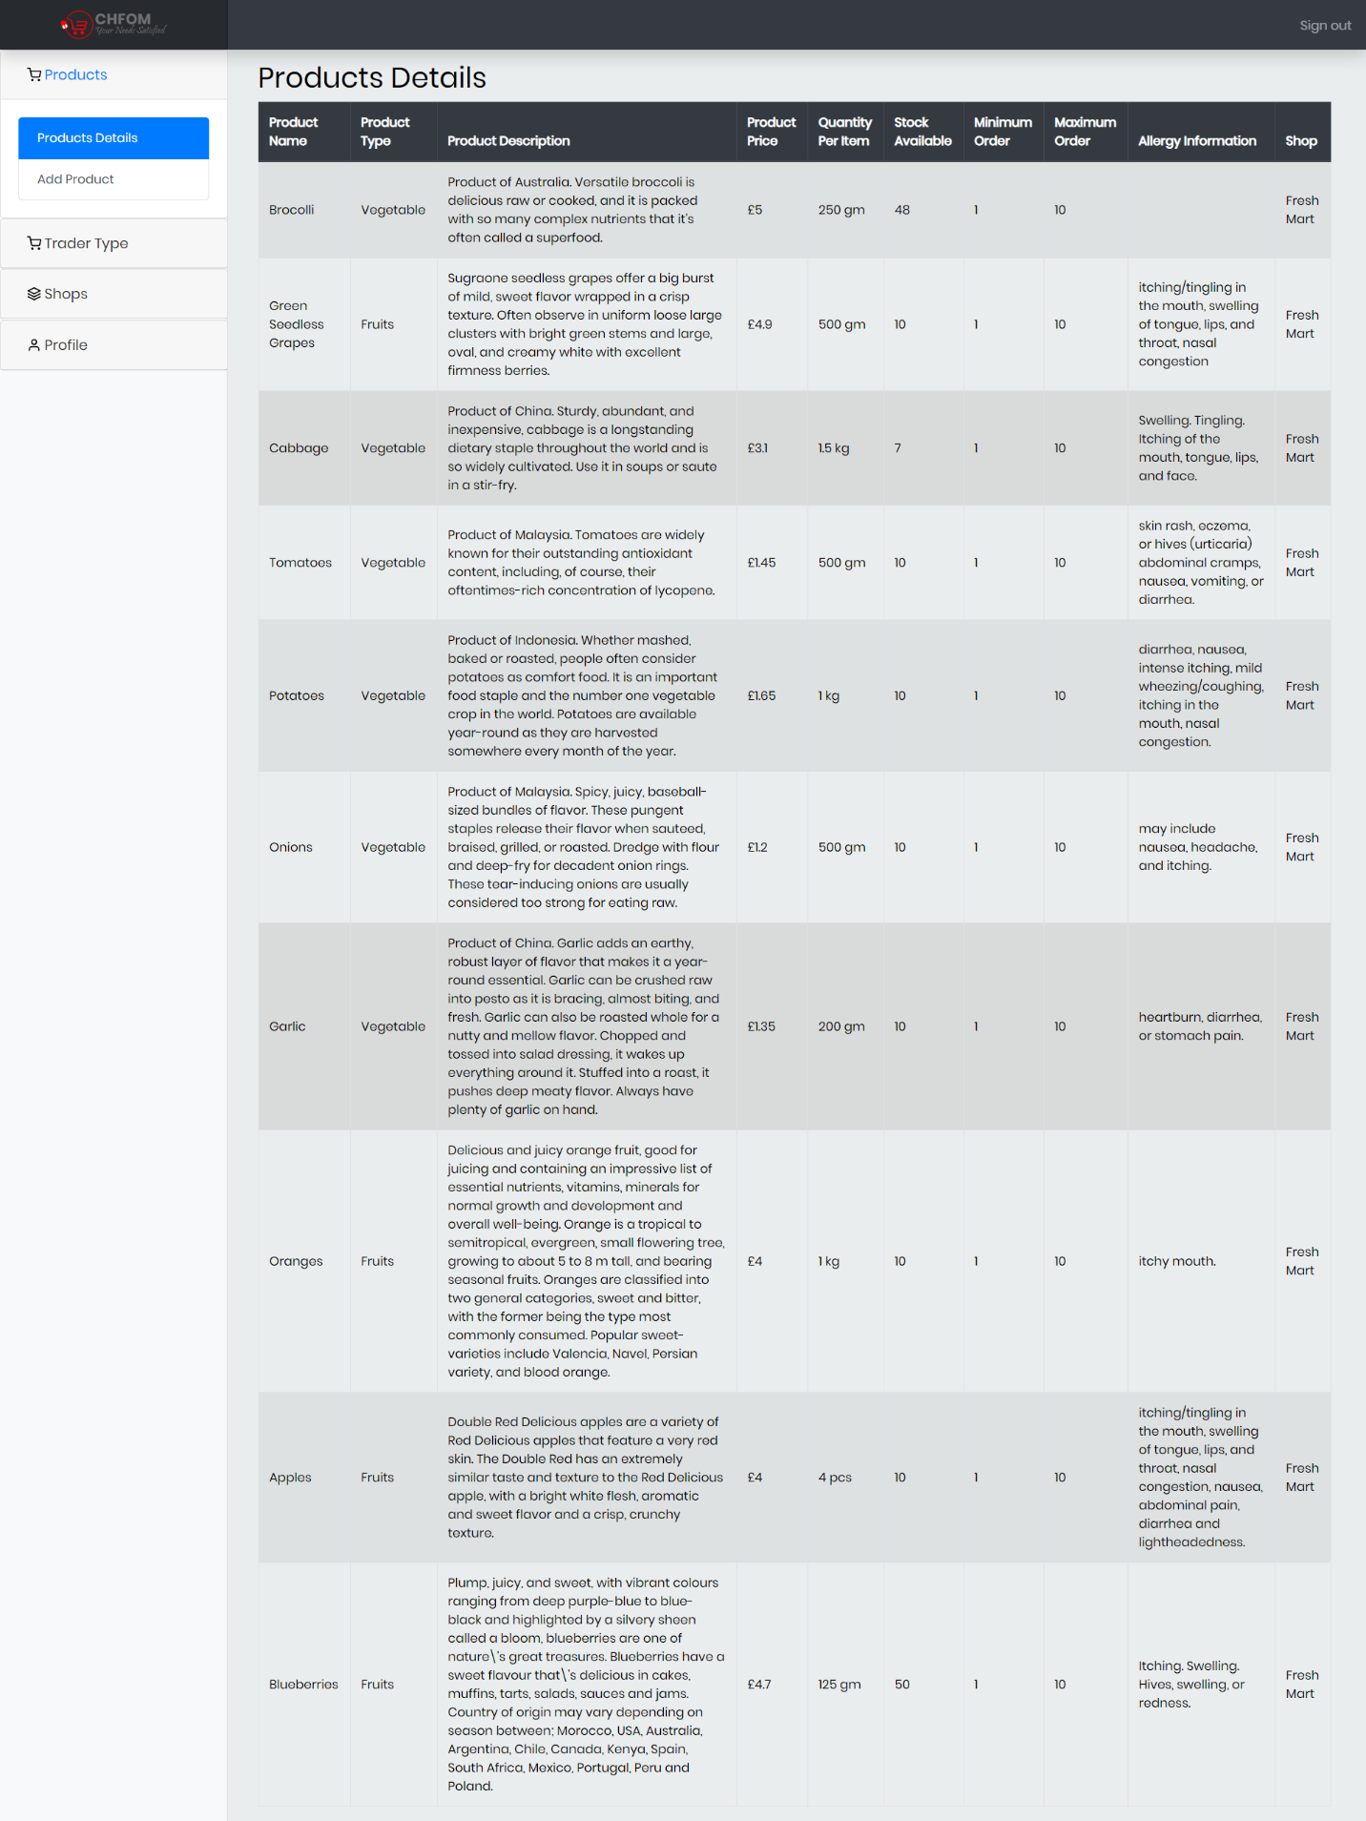

### Add Trader Type

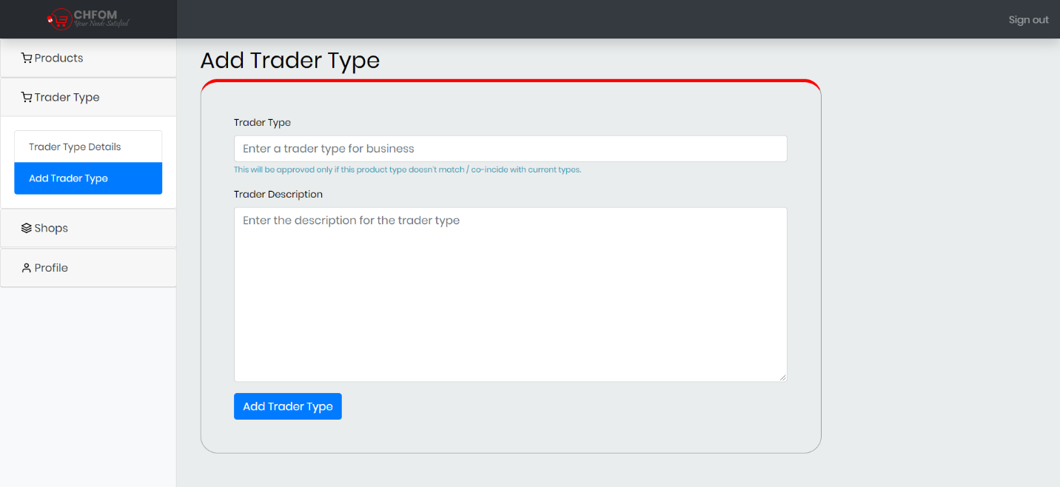

### Trader Type Details

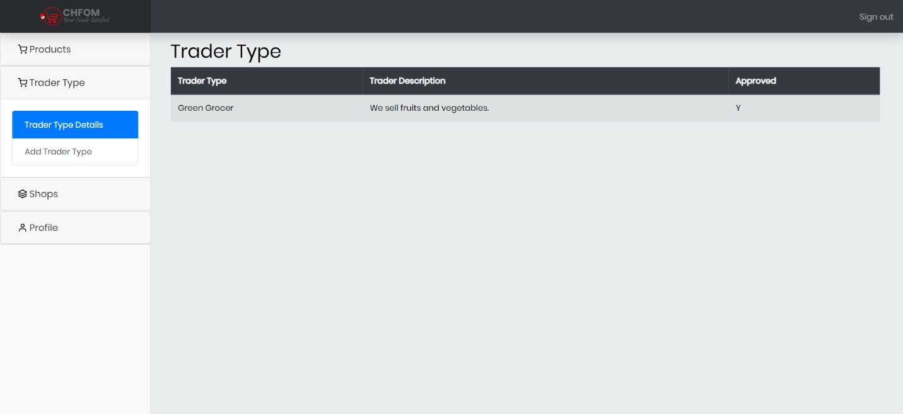

### Add Shop

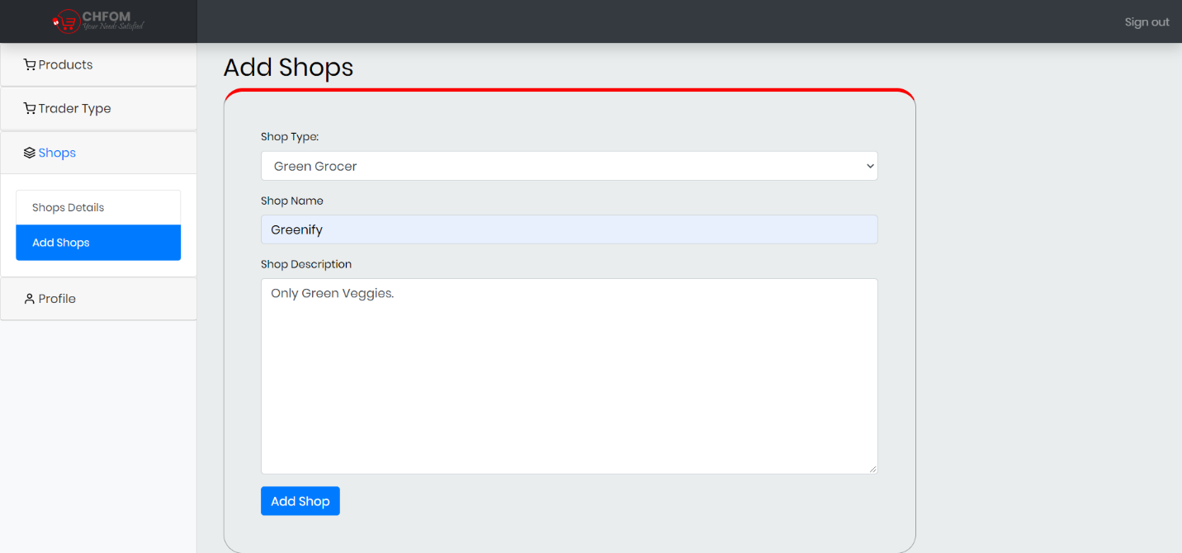

### Shop Added

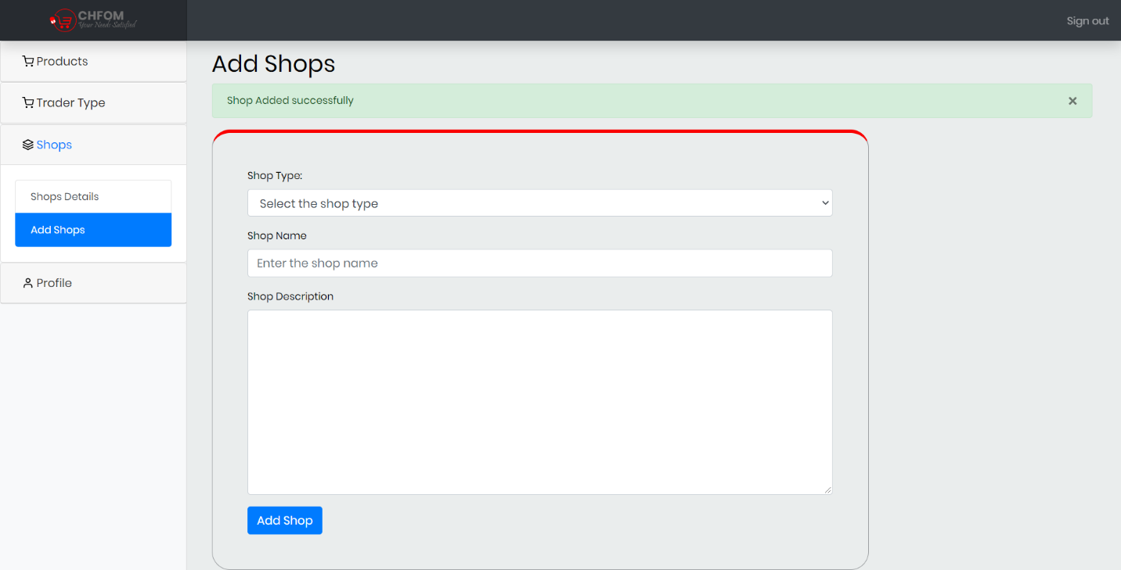

### Shop Details

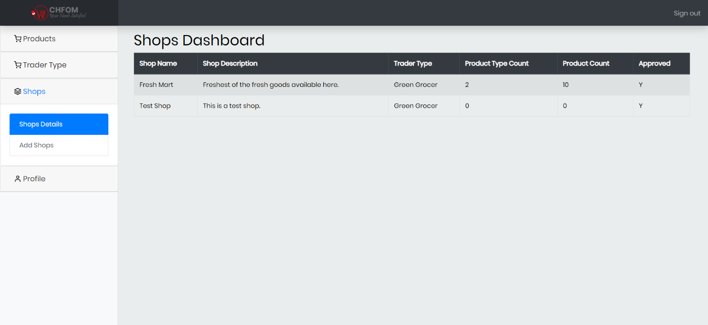

### Update Profile

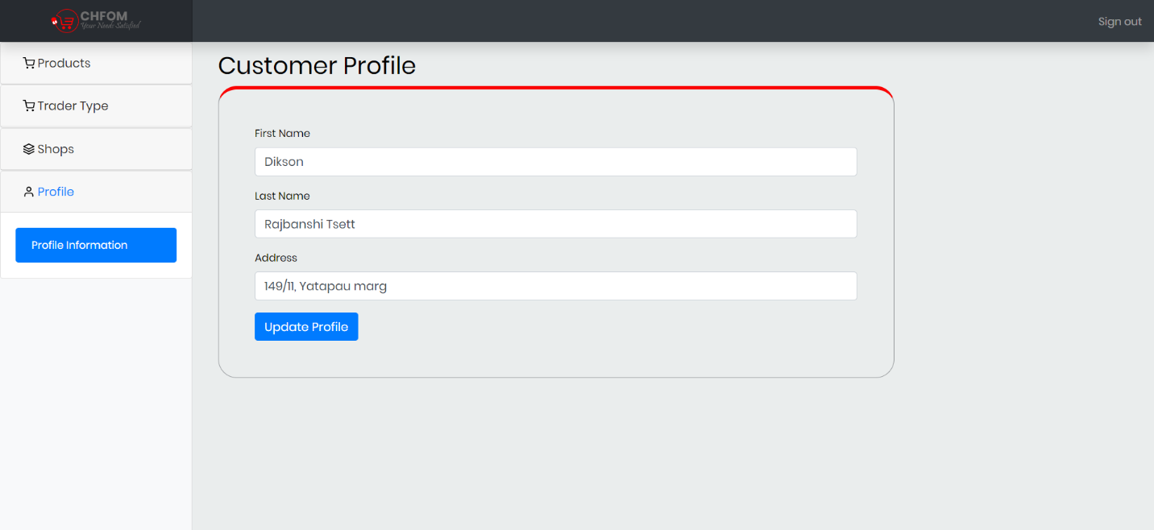

### Profile Update Success

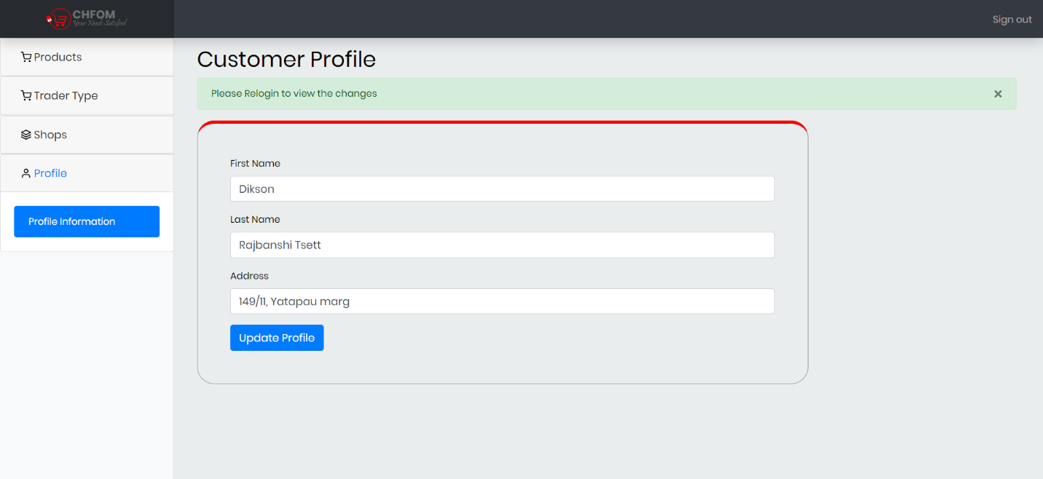

## Admin (Oracle)

### Login

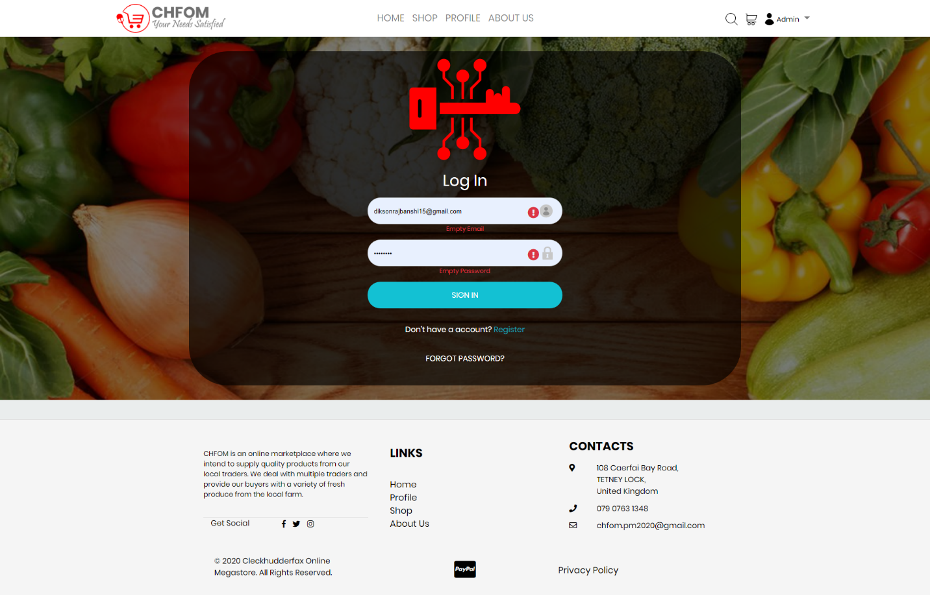

### Login(Invalid)

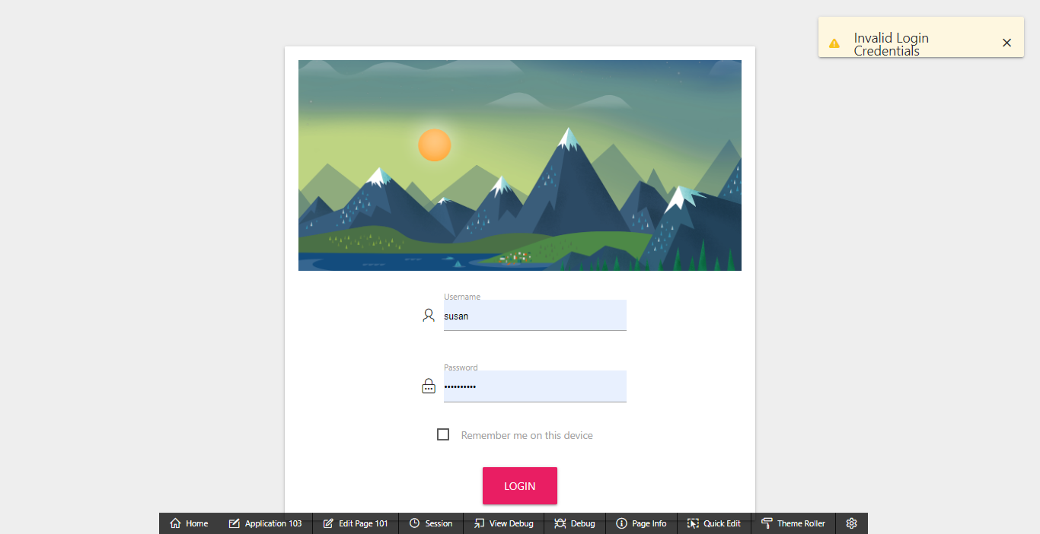

### Dashboard

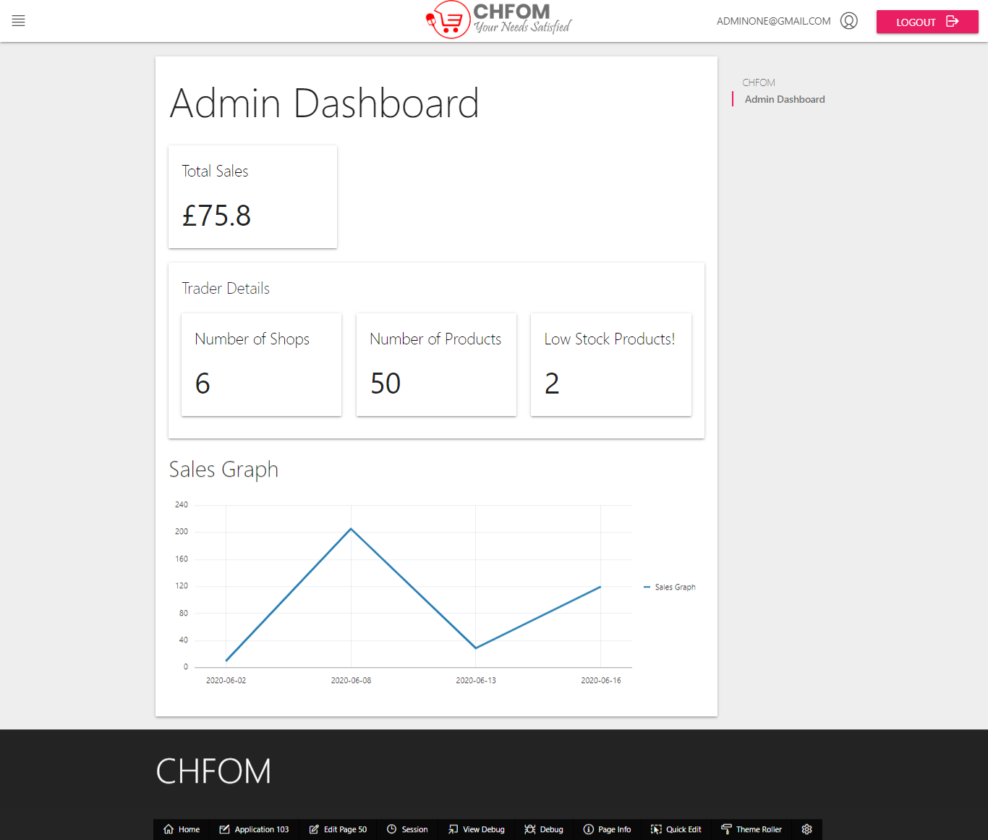

### Products

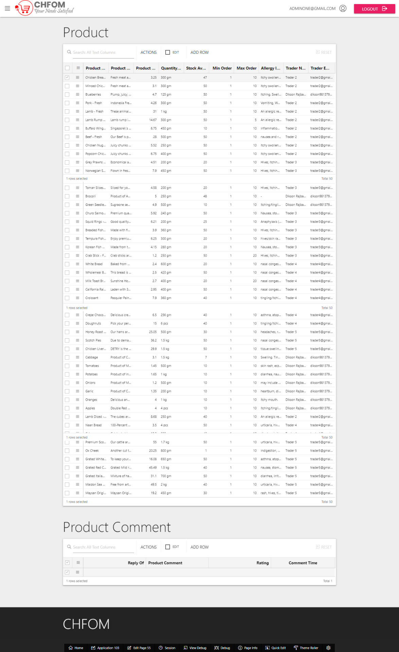

### Trader Details

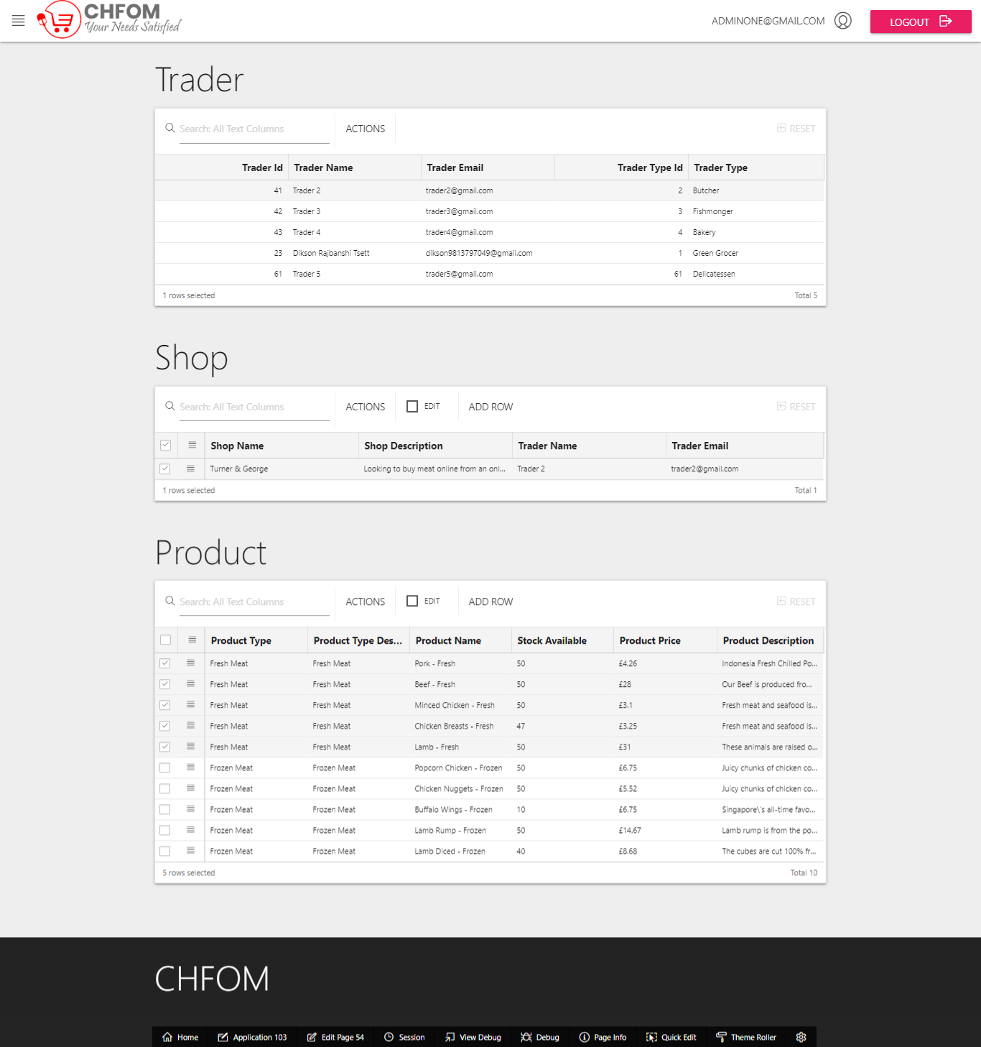

### Customer Information

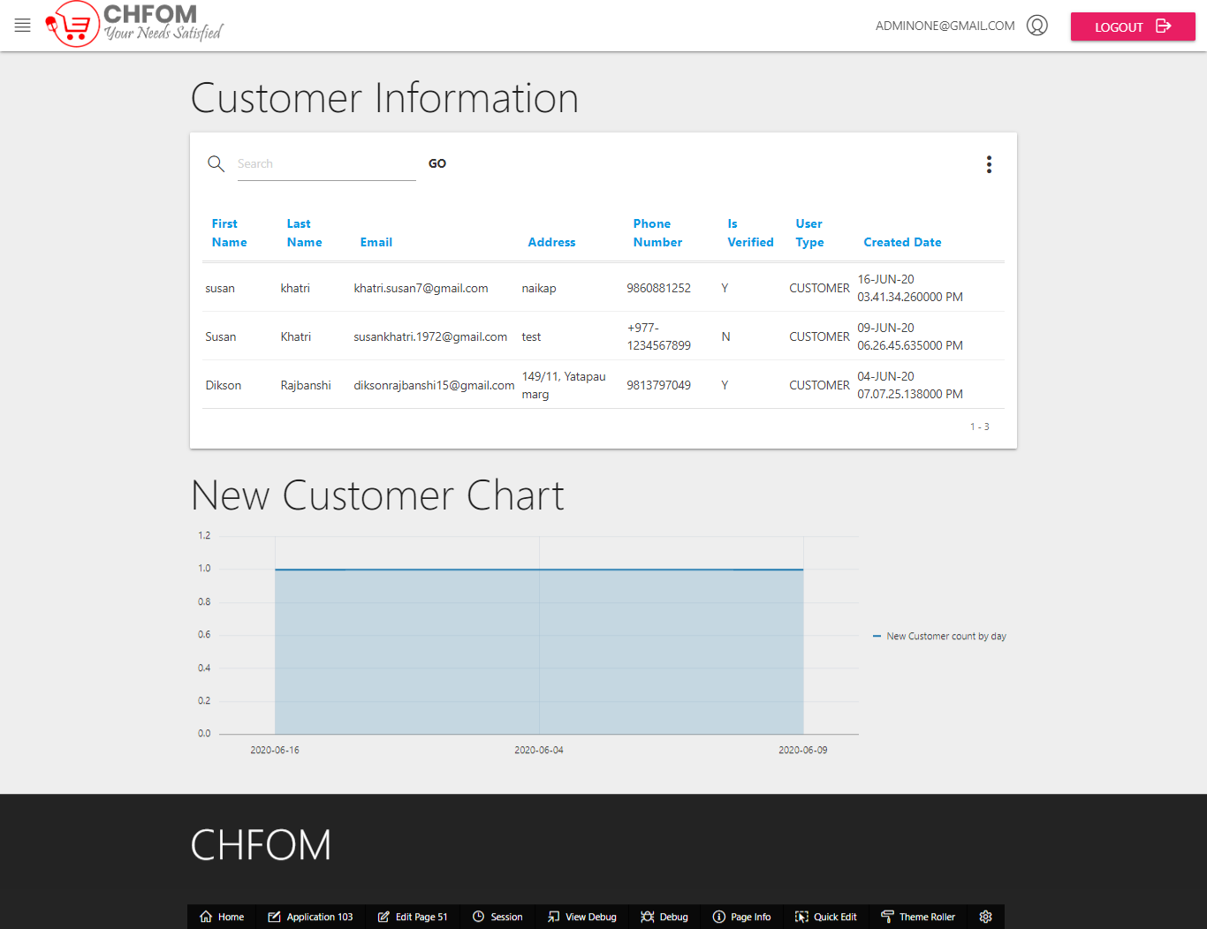

### Sales Report

##### Daily

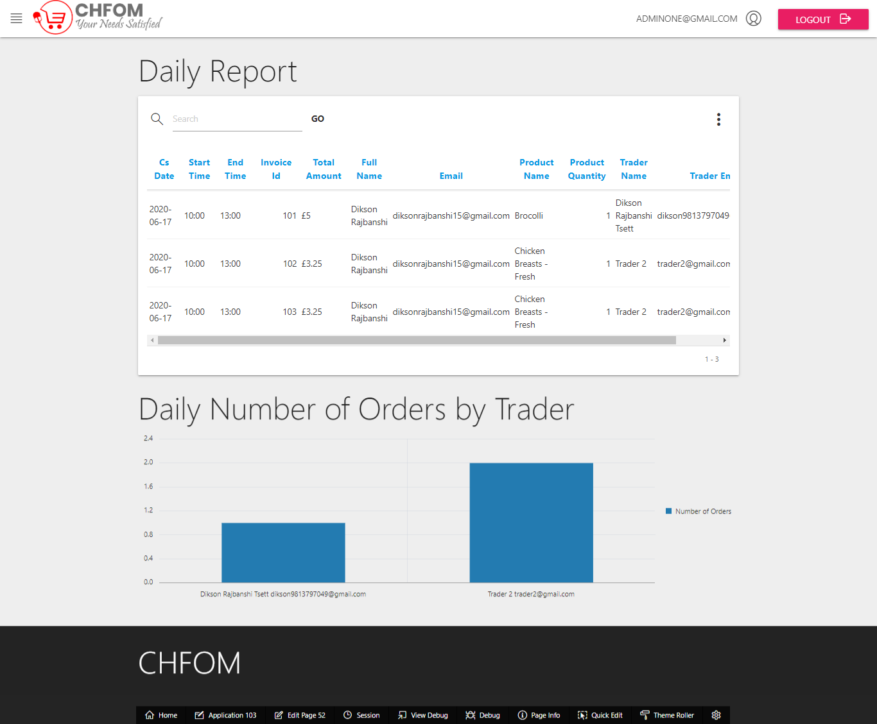

##### Monthly

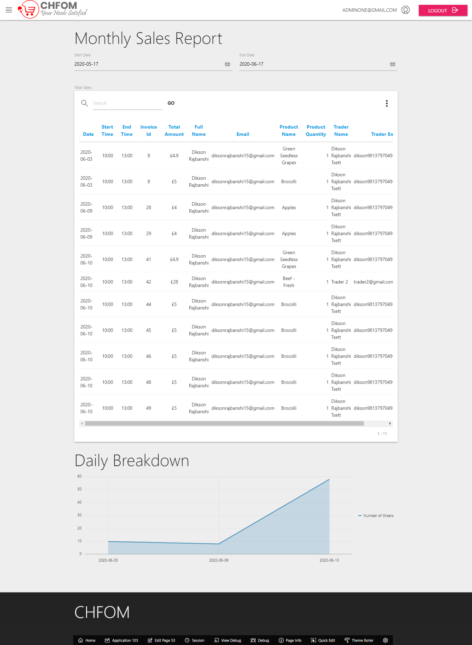

## Trader (Oracle)

### Dashboard

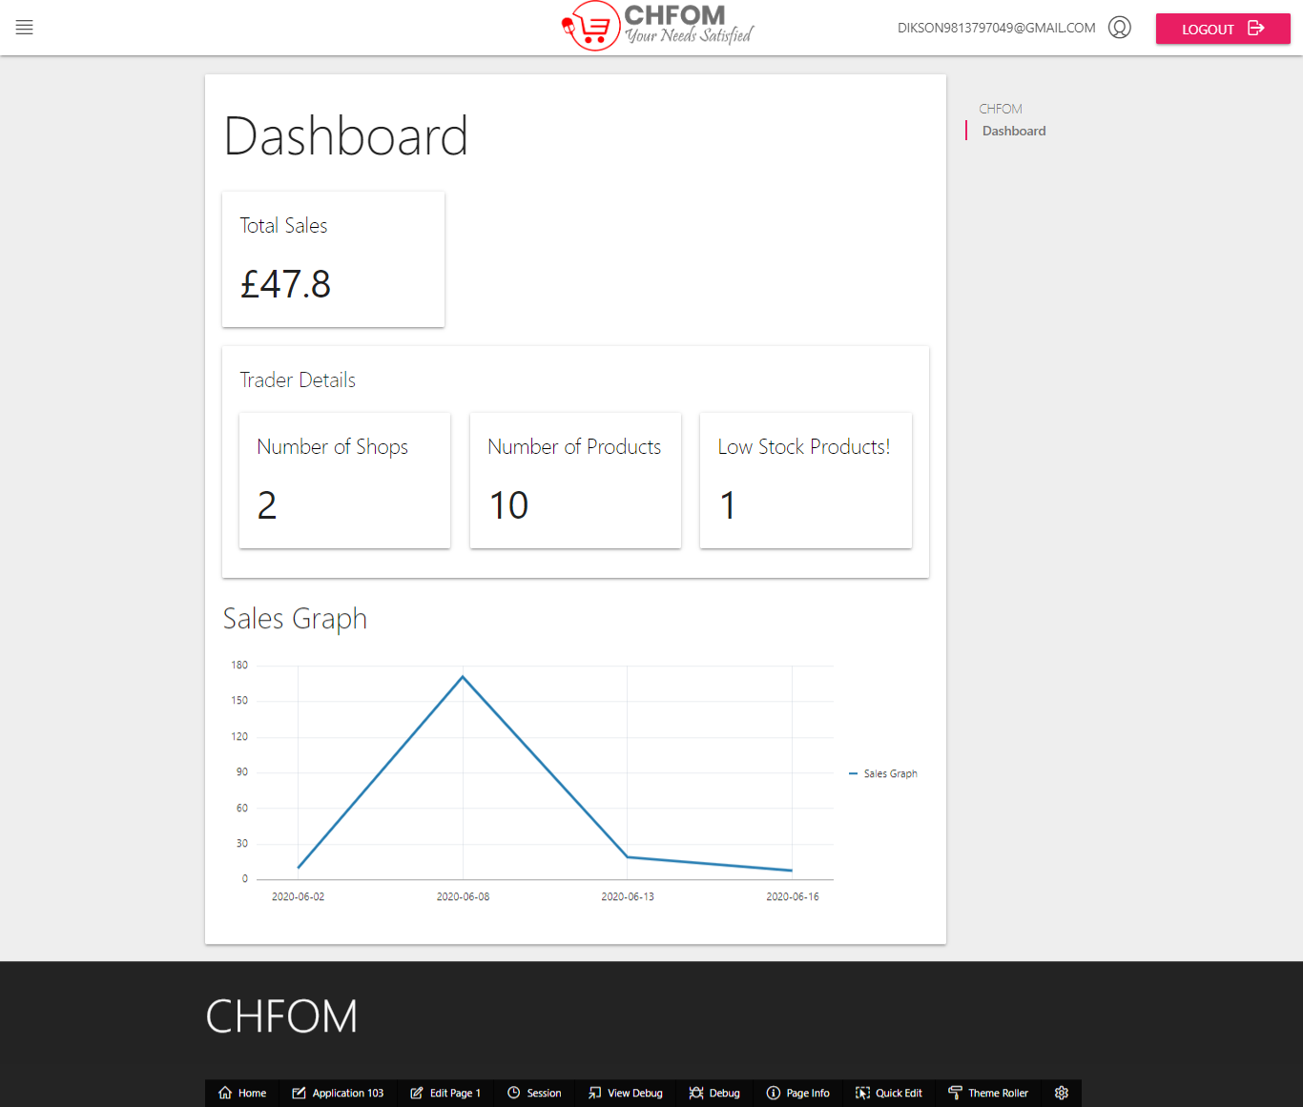

### Shop/Product Details

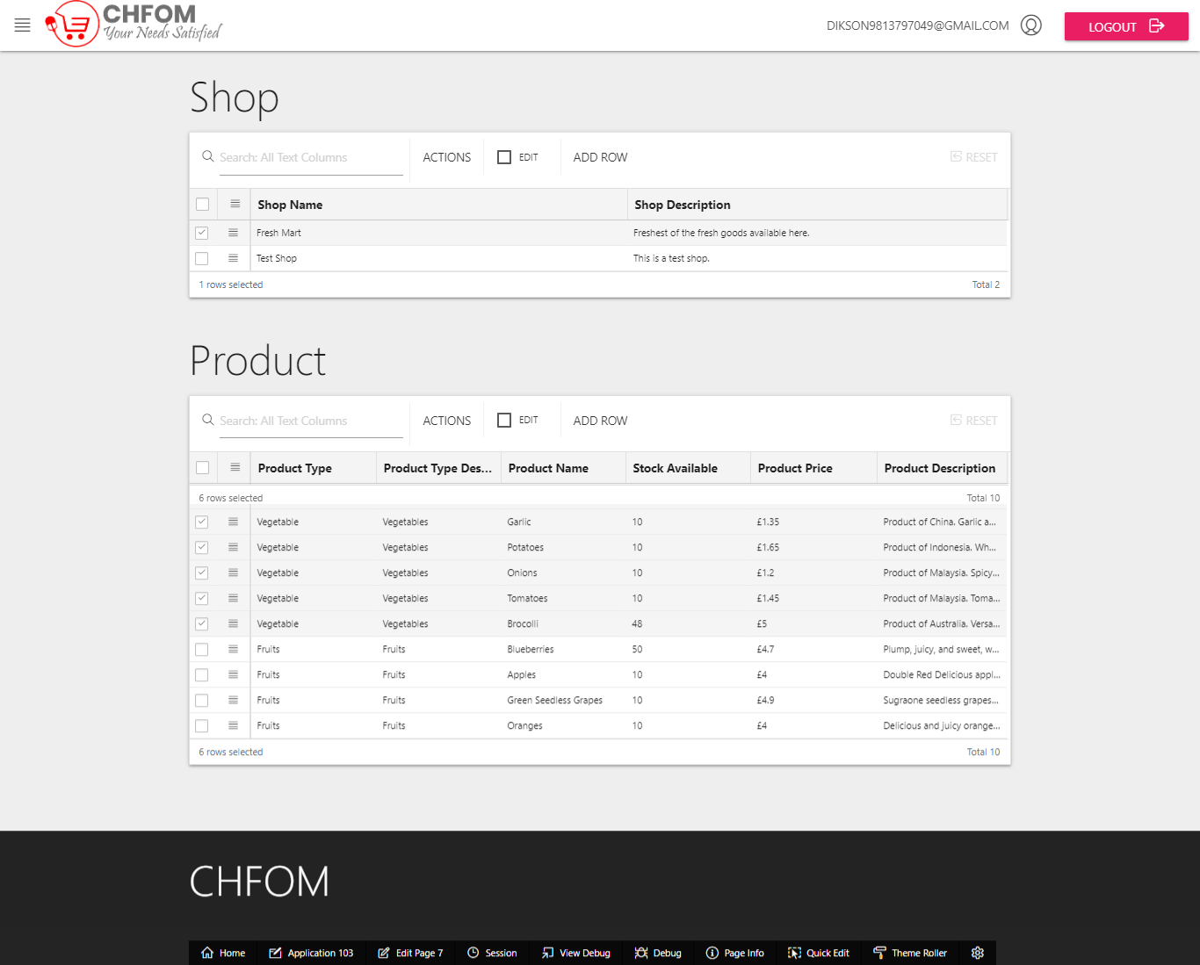

### Product/Product Comment

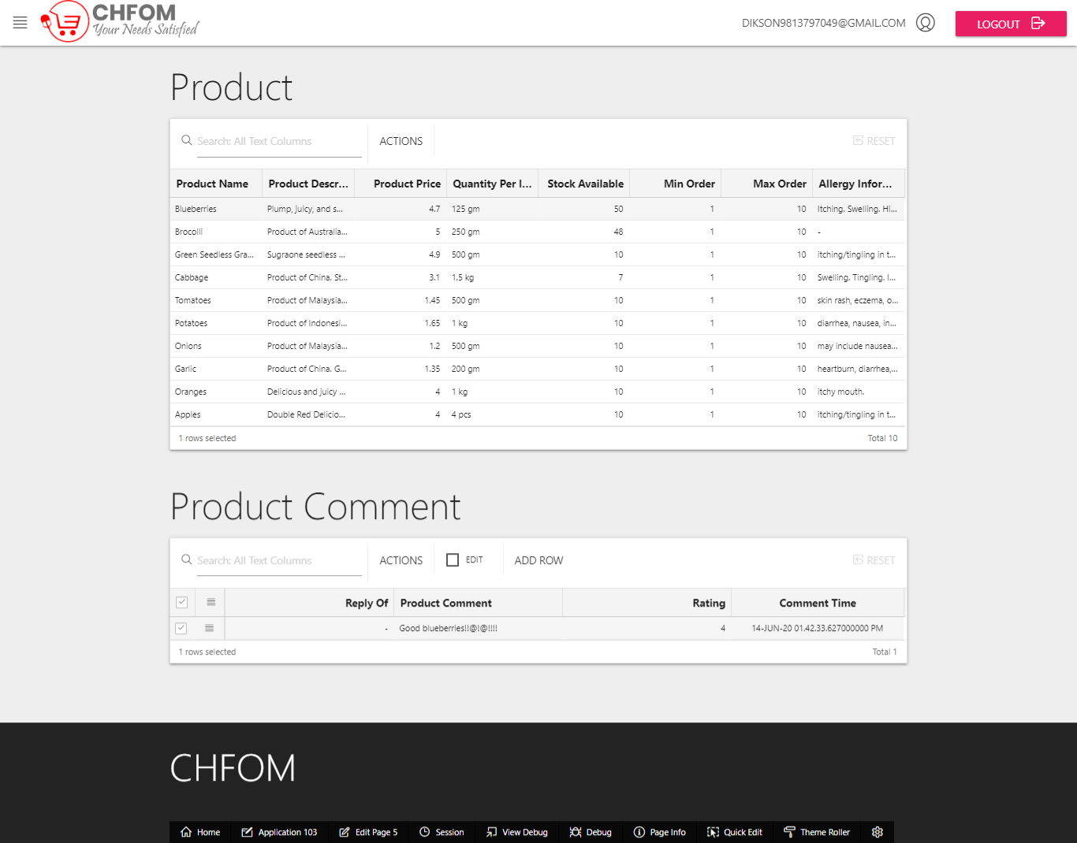

### Product Type Details

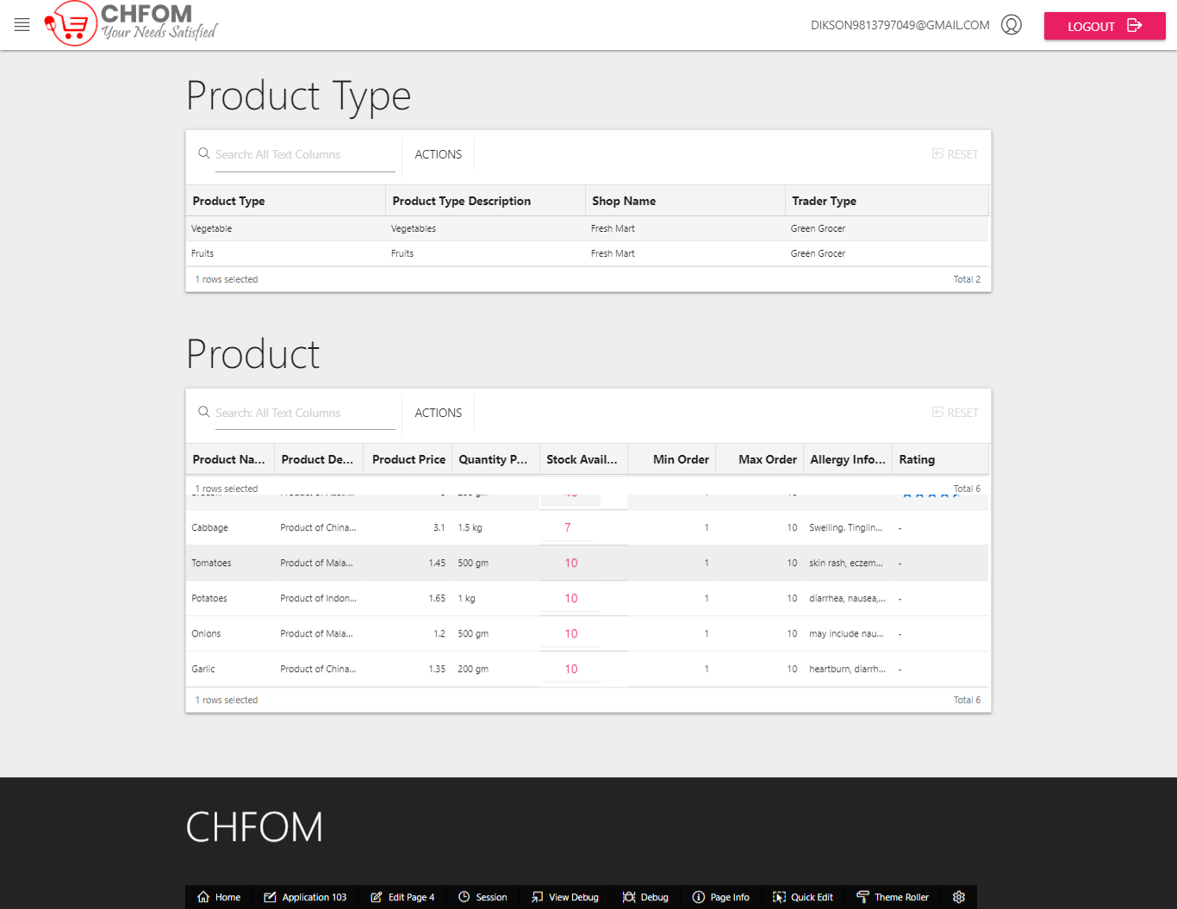

### Order Details

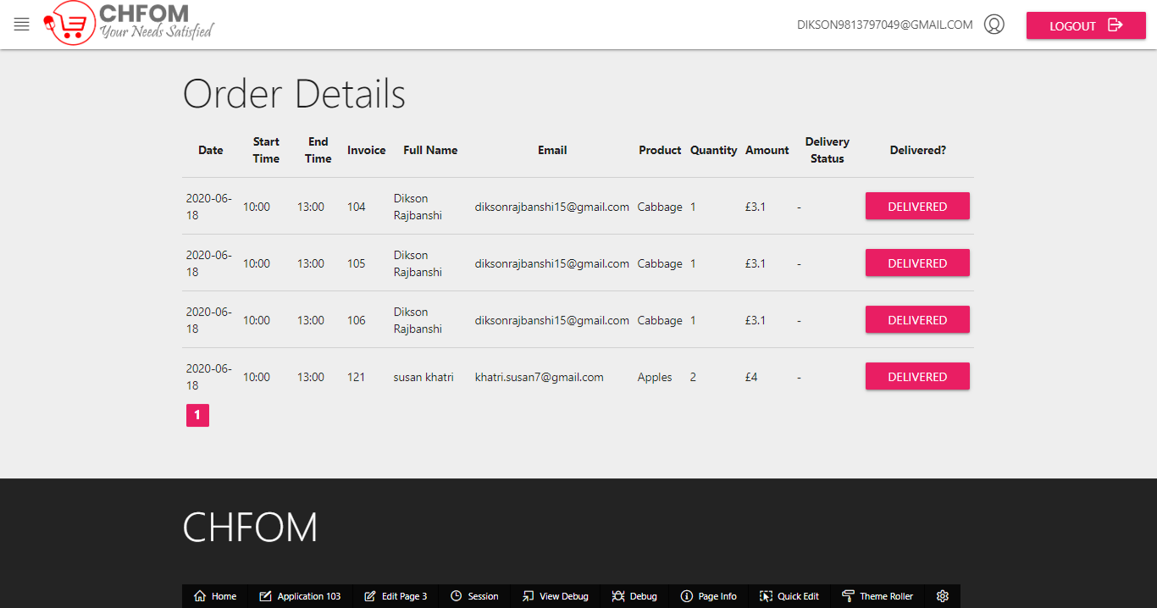

### Monthly Sales Report

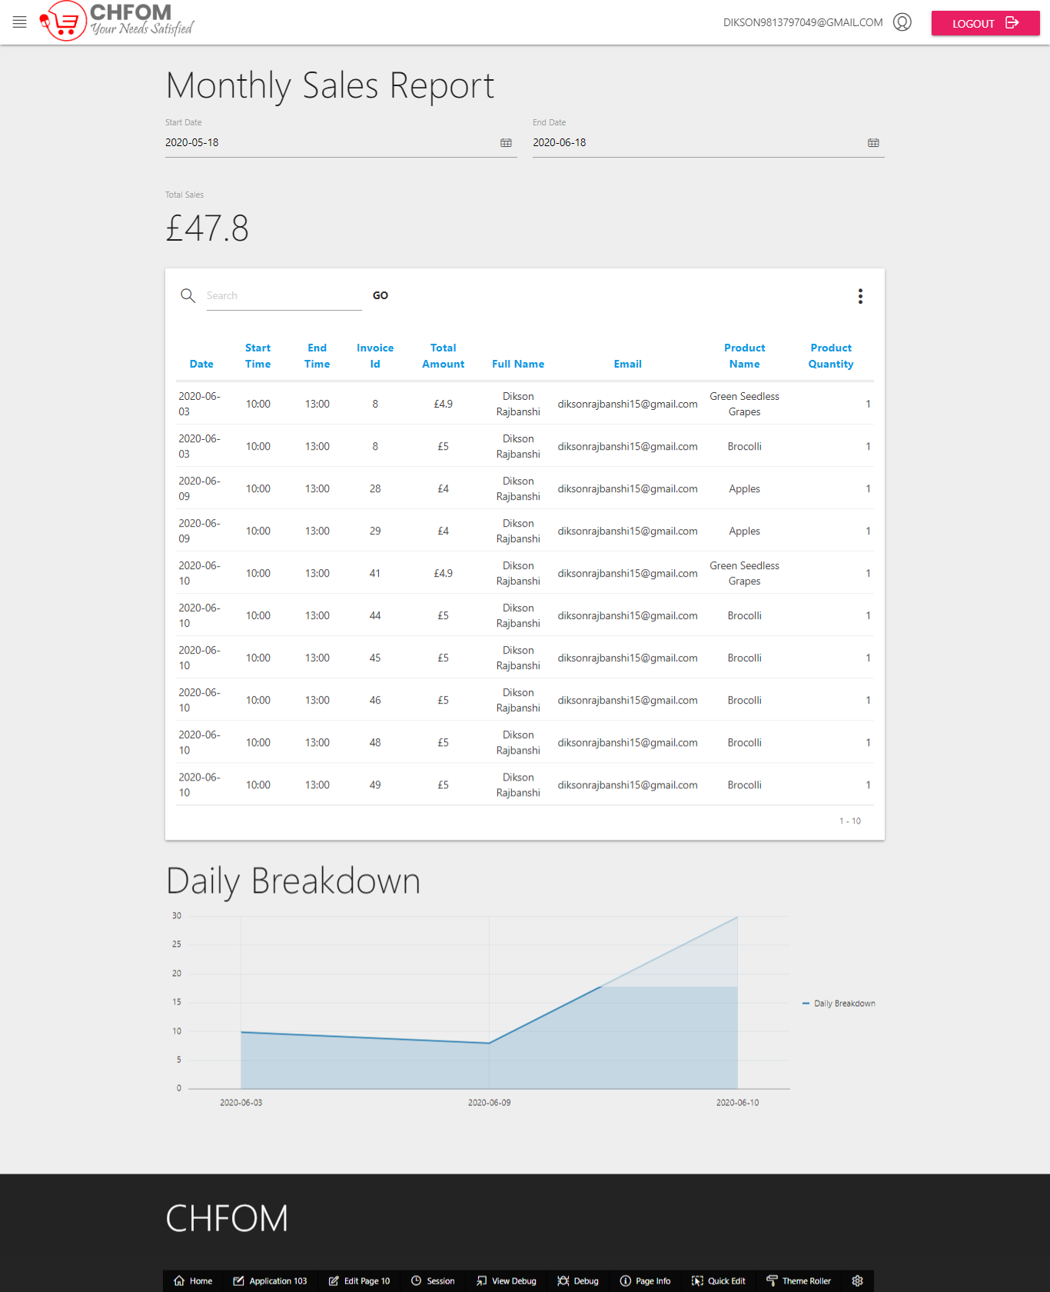

### Monthly Sales Report Chart

